JATTO FADEELAH ONIZE 19/MHS01/216 MBBS
- How are fungi important to mankind?
- Fungi e.g. yeast are important in food industry.
- Mushrooms serve as foods for humans.
- Species e.g. Penicillium notatum produce important antibiotics.
- Some fungi are parasites to some certain horrible obnoxious pests.

- Illustrate the cell structure of a unicellular fungus with a well labeled diagram.
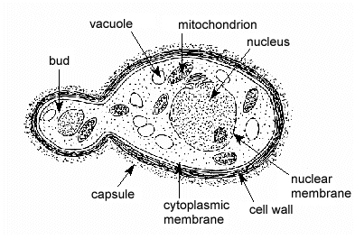
- Outline the sexual reproduction in a typical filamentous form of fungi.
Sexual reproduction occurs when two mating types of hyphae grow in the same medium. Chemical interaction in the two mating types of hyphae induces growths perpendicular to the hyphae in opposite directions. These growths are delimited by a wall such that many nuclei are isolated in what is called gametangium.
The gamentangia fuse (plasmogamy) and a zygote is formed which may undergo prolonged dormancy. The nuclei in the zygotes fuse in twos and undergo meiosis independently.
The zygote germinates under favourable conditions to produce a fruiting which at maturity liberates into haploid spores.

- How do Bryophytes adapt to their environment?
- They have two body divisions:
- The aerial portion: This part being exposed to the atmosphere has some modifications that prevents excessive loss of water through the body surface
- The subterranean portion: This possesses rhizoids which allows the bryophyte to absorb water and nutrients.
- The surface of their body sometimes have cuticles which prevents loss of water

- Describe with illustration the following terminologies: (a) eusteles (b) atactostele (c) siphonostele (d) dictyostele.
- Eusteles: It is a vascular organization in herbaceous dicotyledonous plants where the vascular bundles are discrete, concentric collateral bundles of xylem and phloem.

- Atactostele: It is a vascular organization in grasses and many monocotyledonous plants where the vascular bundles are scattered.
- Siphonostele: It is a vascular organization in stems of ferns and higher vascular plants where the stele is a cylinder enclosing a parenchymatous pith.
- Dictyostele: It is a vascular organization in leaves that is associated with a leaf gap and the conducting cylinder is a dissected one.

- Illustrate the life cycle of a primitive vascular plant.
