NAME: IGBAFE MAGDALENE AGUMELE
MATRIC NUMBER: 19/MHS03/005
DEPARTMENT: ANATOMY
COURSE CODE: BIO102
- How are fungi important to mankind?
- Fungi influence the well-being of human populations on a large scale because they are part of the nutrient cycle in ecosystems. They have other ecosystem roles also, as animal pathogens, fungi help to control the population of damaging pests.
- The mycorrhizal relationship between fungi and plant roots is essential for the productivity of farm land. Without the fungal partner in root systems, 80–90 percent of trees and grasses would not survive.
- Some fungi are equally edible and very rich in proteins, vitamin, iodine e.g the morel mushroom.
- Fungi helps in the fermentation—of grains to produce beer, and of fruits to produce wine through yeast.
- Antibiotics are also naturally produced by fungi from penicillium notatum to kill or inhibit the growth of bacteria.
- Fungi help to enhance the decay process.
- Fungi are model organisms for the study of eukaryotic genetics and metabolism.

- Illustrate the cell structure of a unicellular fungus with a well labeled diagram.
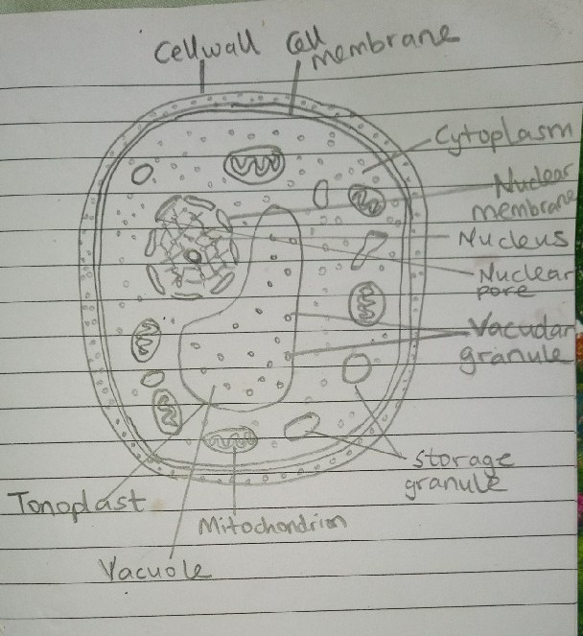
A well labelled diagram of Saccharomyces cerevisiae

- Sexual reproduction in a typical filamentous form of fungi;
- First, two mating types of hyphae grow in the same medium.
- A chemical interaction between them causes growth perpendicular to the hyphae in opposite directions, so they can meet with one another.
- The growths are the delimited by a wall just so the nuclei are isolated in differentiated sex organs called gametangia (plural).
- The gametangia fuse in a process called plasmogamy and together they form a zygote which may undergo dormancy for a period.
- The nuclei in the zygote fuse in twos and undergo meiosis independently, it then moves on to germinating under favorable conditions so as to liberate haploid spores at maturity through the production of a fruiting.
- In summary, sexual reproduction in fungi consists of three stages; plasmogamy, karogamy and meiosis.
- How Bryophytes adapt to their environment
- They have a waxy cuticle that prevents the body, the zygote, and the embryo from drying out through dessication
- Spores are dispersed by the wind.
- They possess definite structures for water and nutrient absorption from the soil.
- They possess gametangia that keep the plants gametes from drying out.

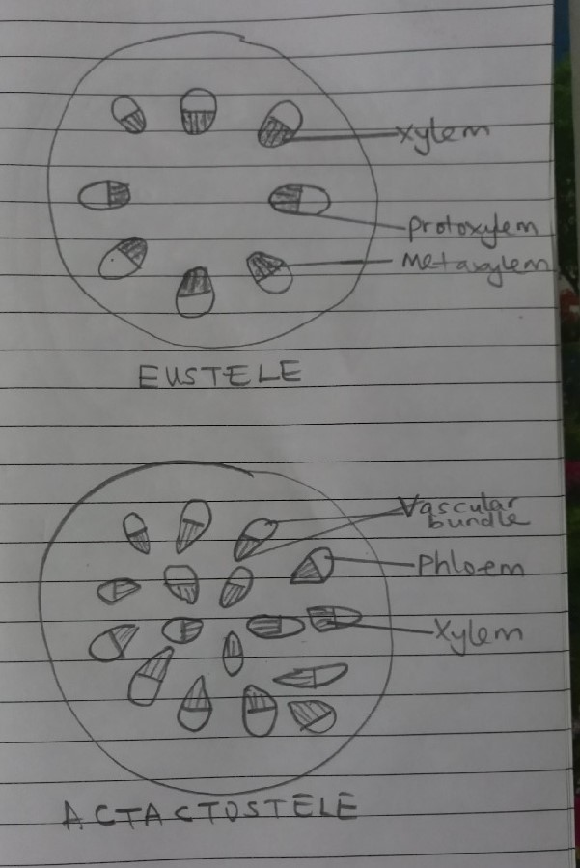
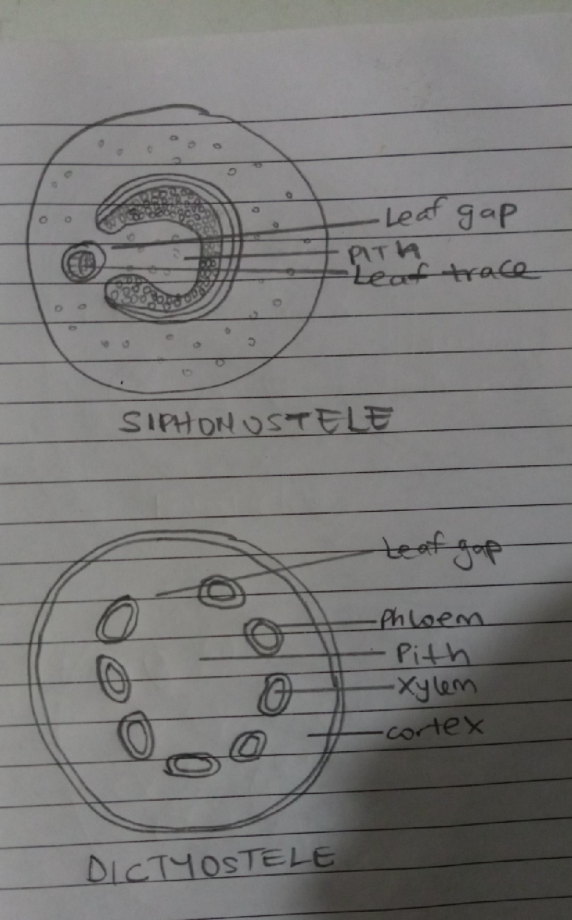
- Life cycle of a primitive vascular plant; (PSILOTUM)
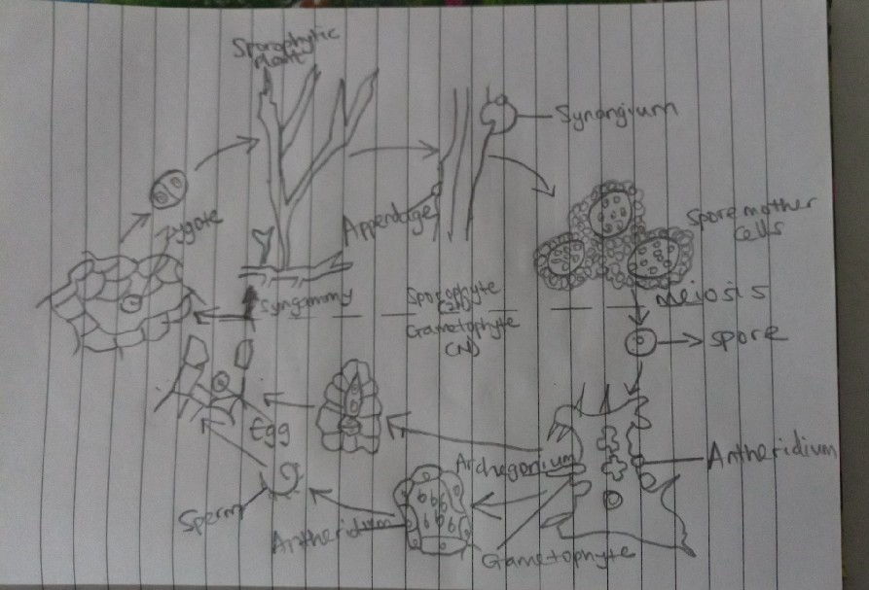
LIFE CYCLE OF A PSILOTUM

