Assignment on Mat 204 by Harim Bello Shehu matric No 19/sci01/100
Question 1:
Vector space can be defined as a vector space on which two operations (+) and (●) are defined called addition and scalar multiplication.

Question 3
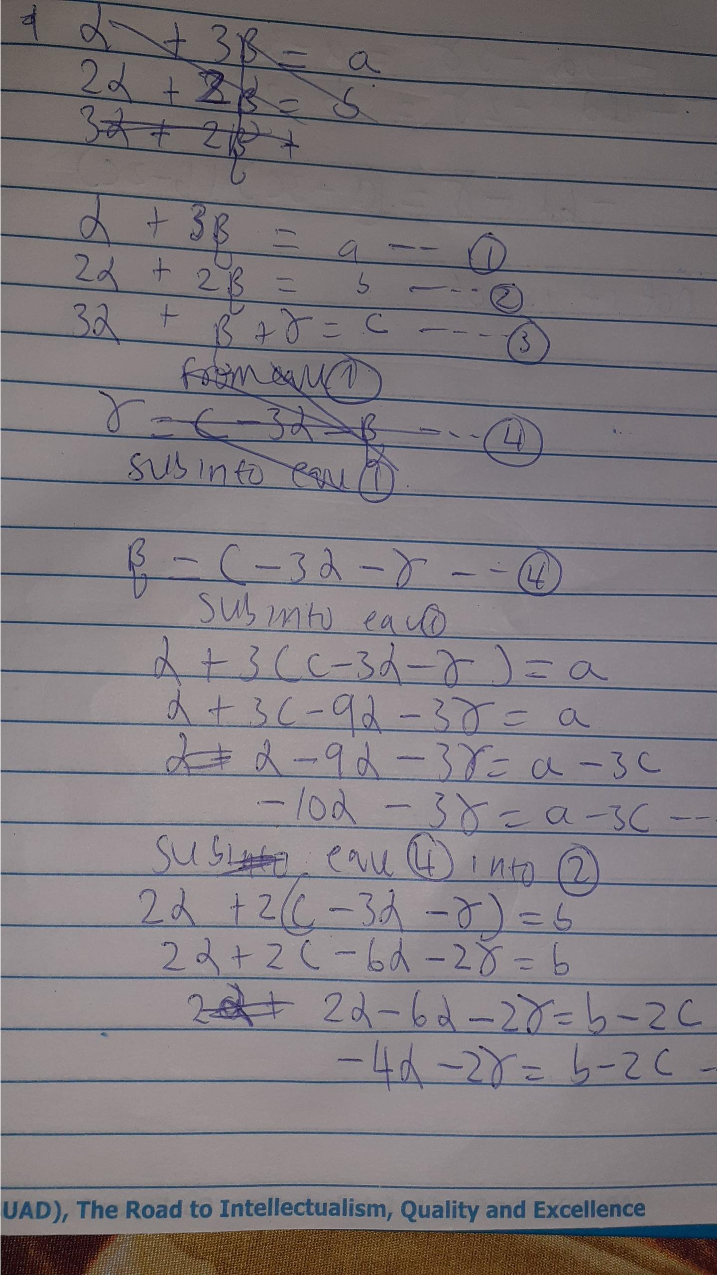
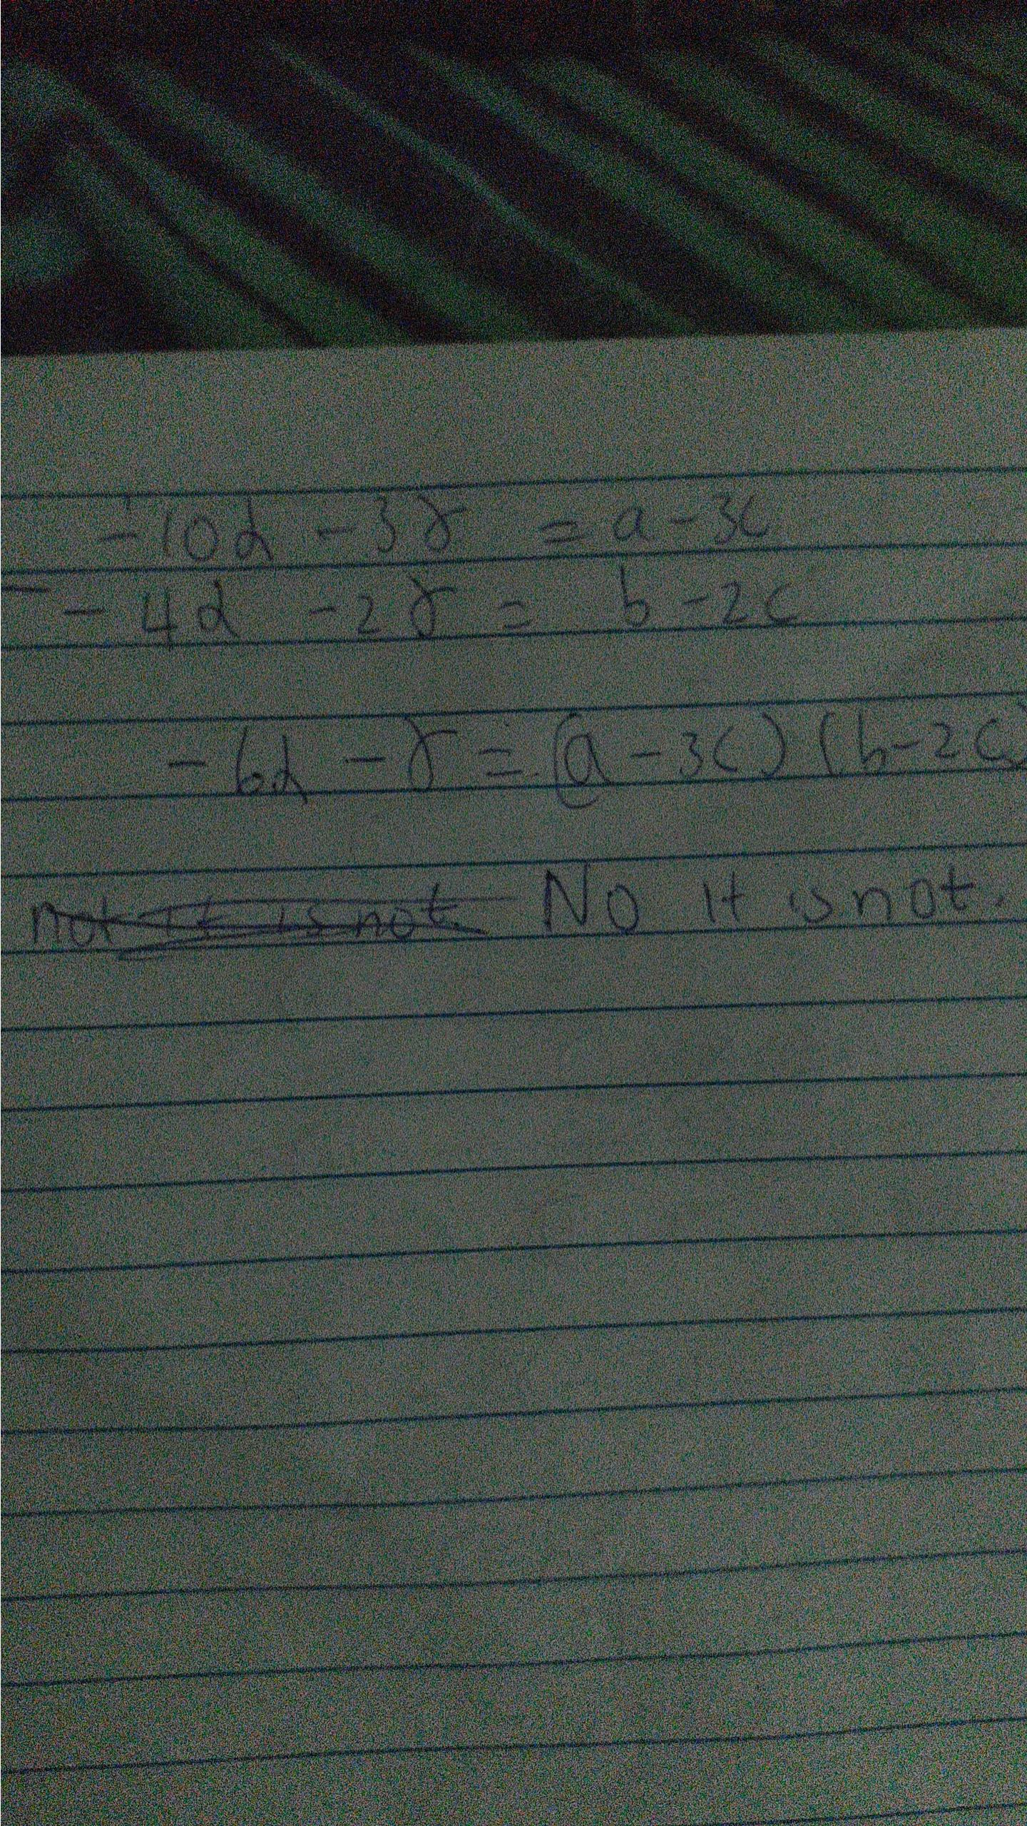
Question 2 answer

