Assignment on Linear transformation by Harim Bello Shehu Matric 19/sci01/100
Question 1:
Linear transformation is a function from one vector space to another that respects the underlying structure of each vector space.
Examples;
- For all x, y , £ V T (x + y) = T(x) + T(y) (T is addictive)
- X £ V r £ R T (Rx =rt(x) ( T is homogeneous).

Question2:
Given the linear transformation of matrix operator on a vector X compute T(x)
If A(1,9,3) (-2,6,7) (0,-1,3)

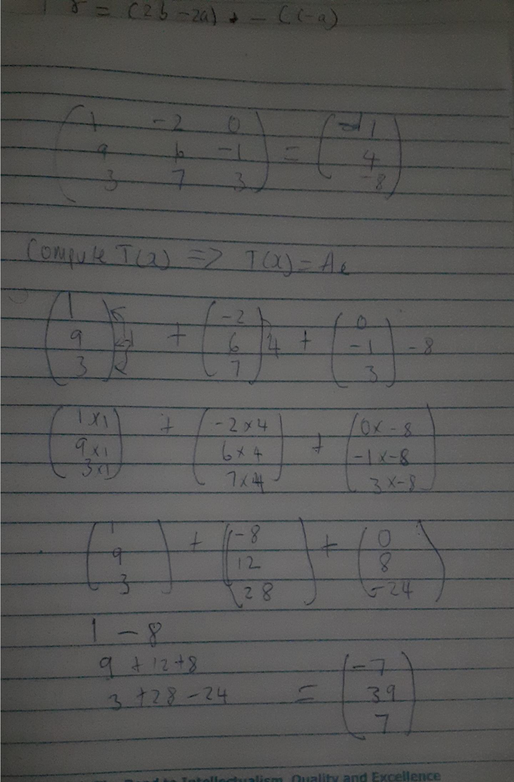
- X $Type equation here.$Question 3 ;

Rank of a matrix is the maximum number of linearly independent rows in a matrix A is called the row rank of A and the maximum number linearly independent columns in A is called the column rank of A. Example of a rank matrix

