NAME: ONYEMAOBI IFEANYICHUKWU OSCAR
COLLEGE: MHS
DEPARTMENT: PHARMACY
MATRIC NO- 19/MHS11/117
COURSE CODE: BIO 102
QUESTION 1: HOW ARE FUNGI IMPORTANT TO MANKIND?
- Together with bacteria, fungi are important because they are responsible for breaking down organic matter and releasing carbon, oxygen, nitrogen, and phosphorus into the soil and the atmosphere.
- They are important also because they are essential in many household and industrial processes such as making of bread, wine, beer, and cheese.
- Fungi are also used as food; for example, some mushrooms, morels, and tuffels are epicurean delicacies, and myco proteins (fungal proteins), derived from the mycelia of certain species of fungi, are used to make foods that are high in protein.
- Fungi can be useful also for studying cell and molecular biology, genetic engineering and other basic disciplines of biology.
- Some antibiotics can be gotten from fungus like penicillin which is gotten from Penicillium chrysogenum or Penicillium notatum.
- The fungus Claviceps purpurea know known formally as ergot is a source of several chemicals used in drugs that induce labour in pregnant women and contolls hemorrhage after birth.

QUESTION 2: ILLUSTATE THE CELL SRUCTURE OF A UNICELLULAR FUNGUS WITH A WELL LABELLED DIAGRAM.
Unicellular Fungus: Kingdom: Fungi
Division: Ascomycota
Class: Saccharomycetes
Order: Saccharomycetales
Family: Saccharomycetaceae
Genus: Saccharomyces
Species: S.cerevisae
Binomial name- Saccharomyces cerevisae

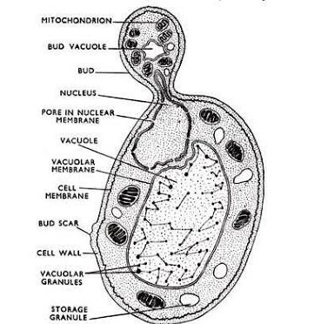

QUESTION 3:OUTLINE THE SEXUAL REPRODUCTION IN A TYPICAL FILAMENTOUS FORM OF FUNGI.
Form- Rhizophus stolonifer
It reproduces sexually by sexual spores such as ascospores and zygospores.
It occurs when two mating types of hyphae grow in the same medium.
Chemical interaction in the two mating types of hyphae induces growth perpendicular to the hyphae in opposite directions.
These growth are delimited by a wall suchthat many nuclei are isolated in what is called a gametanguim.
The two gamentangia fuse (plasmagamy) and a zygote is formed which may undergo prolonged dormaancy or what is also called a resting stage.
The nuclei in the zygote in twos and undergo meiosis independently.
The zygote germinates under favourable conditions to produce a fruiting which at maturity liberates the hapliod spores.
QUESTION 4: HOW DO BRYOPHYTES ADAPT TO THEIR ENVIRONMENT?
- They have a waxy cuticle that prevents the body, zygote and embryo from drying out.
- They have gamentangia which is for further protection against drying out specifically for the plants gamete.
- Bryophytes like mosses have a thick cell wall that that provides support and also a special storage area for water and nutrients.
- They have definate structure for water and nutrients absorption from the soil.
- Their body is divided into two parts and the aerial part which is exposed to the atmosphere demands some modifications that prevents excessive loss of water through the body surface which is known as (dessication)
- There are other modifications that allow removal of excess water from the body of the plant and not only exchange of gases between the internal partsof the atmosphere, therefore there are openings on the aerial part of the plant.
QUESTION 5: DESCRIBE WITH ILLUSTRATION THE FOLLOWING TERMINOLOGIES:
- Eusteles- this is a type of siphonostele.
In which the vascular tissue in the stem forms a central ring of bundules around the pith. They have discrete vascular bundles, concentric collateral bundles of xylem and phloem.
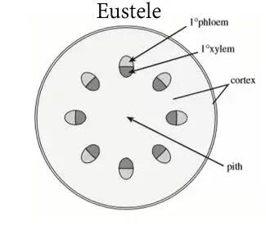
- Atactostele- this is a type of eustele thatis found in monocots.
The vascular tissue in the stem exists in scattered bundles.
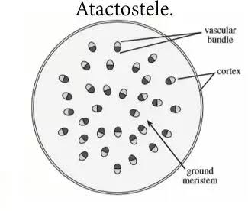

- Siphonostele- this is a stele consisting of a core of pith surrounded by concentric layers of xylem and phloem.

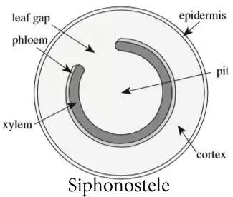

- Dictyostele- a stele which the vascular cylinder is broken up into a longitudinal series or network of vascular strands around a central pith.
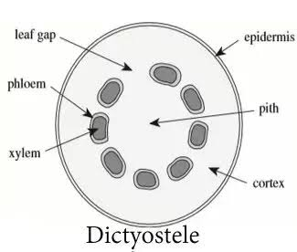

QUESTION 6: ILLUSTRATE THE LIFE CYCLE OF A PRIMITIVE VASCULAR PLANT.
