Name: Atemie-Hart Kevia
Department: MBBS
Matric no: 19/MHS01/106

- Fungi serves as biological insecticides
Fungi is used in the production of food for humans
Fungi serves as medicine
Fungi is used for farming
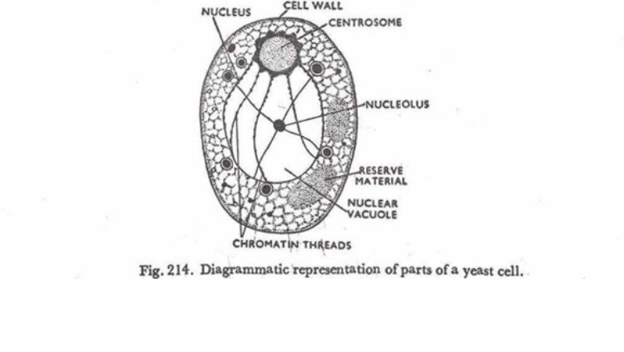
- Sexual reproduction in fungi consists of three sequential stages: plasmogamy, karyogamy, and meiosis. The diploid cells, each containing a single set of chromosomes ( a haploid state) … In most fungi the zygote is the only cell in the entire life cycle that is diploid.
- Two adaptations made the move from water to land possible for Bryophytes: a waxy cuticle and gametangia. The waxy cuticle helped to protect the plants tissue from dying out and the gametangia provided further protection against drying out specifically for the plants gametes.
- Eusteles: A type of siphonostele, in which the vascular tissue in stem forms a central ring of bundles around a pith.
Atactostele: A type of eustele, found in monocots, in which the vascular tissue in the stem exists as scattered bundles.
Siphonostele: A stele is which the vascular tissue is in the form of a cylinder surrounding the pith, as in the stems of most ferns and other seedless vascular plants.
Dictyostele:A stele in which the vascular cylinder is broken up into a longitudinal series or network of vascular strands around a central pith

