**NAME : IGBOYI MARY EJELUMBI**

**COLLEGE : MEDICAL AND HEALTH SCIENCES**

**DEPARTMENT : NURSING**

**MATRICULATION NUMBER : 19/MHS02/064**

**COURSE : BIO 102**

1. **Fungi are important to mankind in the following ways:**
2. **Fungi e.g. yeast (*Saccharomyces cerevisiae*) are important in food industry. Mushrooms are eaten by many human societies. Species e.g. *Penicillium notatum* produce important antibiotics.**
3. **Many fungi species mediate the spoilage of wood, food, clothes and paper.**
4. **Some fungi are parasites to some certain horrible obnoxious (i.e. offensive or unbearable) pests e.g. houseflies, grasshoppers and therefore constitute important biological control agents in regard to such pests.**
5. **Without fungi and other microbes, the surface of the earth would have been clogged up with dead matters with all the various elements locked up in them instead of returning into various cycles.**
6. **Medical and Veterinary mycology deals with fungal diseases and infections in human beings and animals. Skin diseases e.g. ringworm and dermatitis are caused by fungal agents.**

**2.**

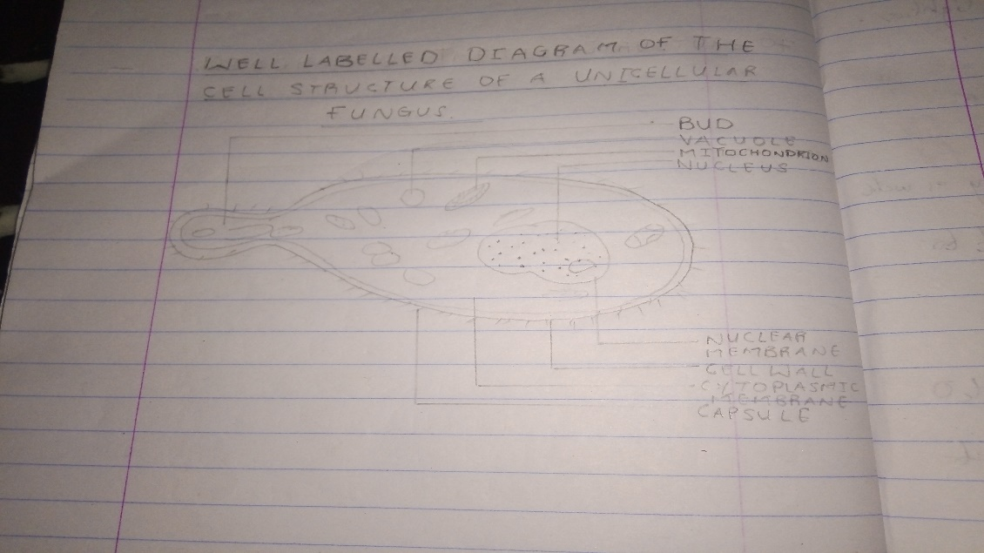

1. **The Sexual Reproduction in a Typical Filamentous Form of Fungi :**

**It occurs when two mating types of hyphae grow in the same medium. Chemical interaction in the two mating types of hyphae induces growths perpendicular to the hyphae in opposite directions. These growths are delimited by a wall such that many nuclei are isolated in what is called a gametangium. The two gametangia fuse (plasmogamy) and a zygote is formed which may undergo prolonged dormancy or resting stage. The nuclei in the zygotes fuse in twos and undergo meiosis independently. The zygote germinates under favourable conditions to produce a fruiting which at maturity liberates the haploid spores.**

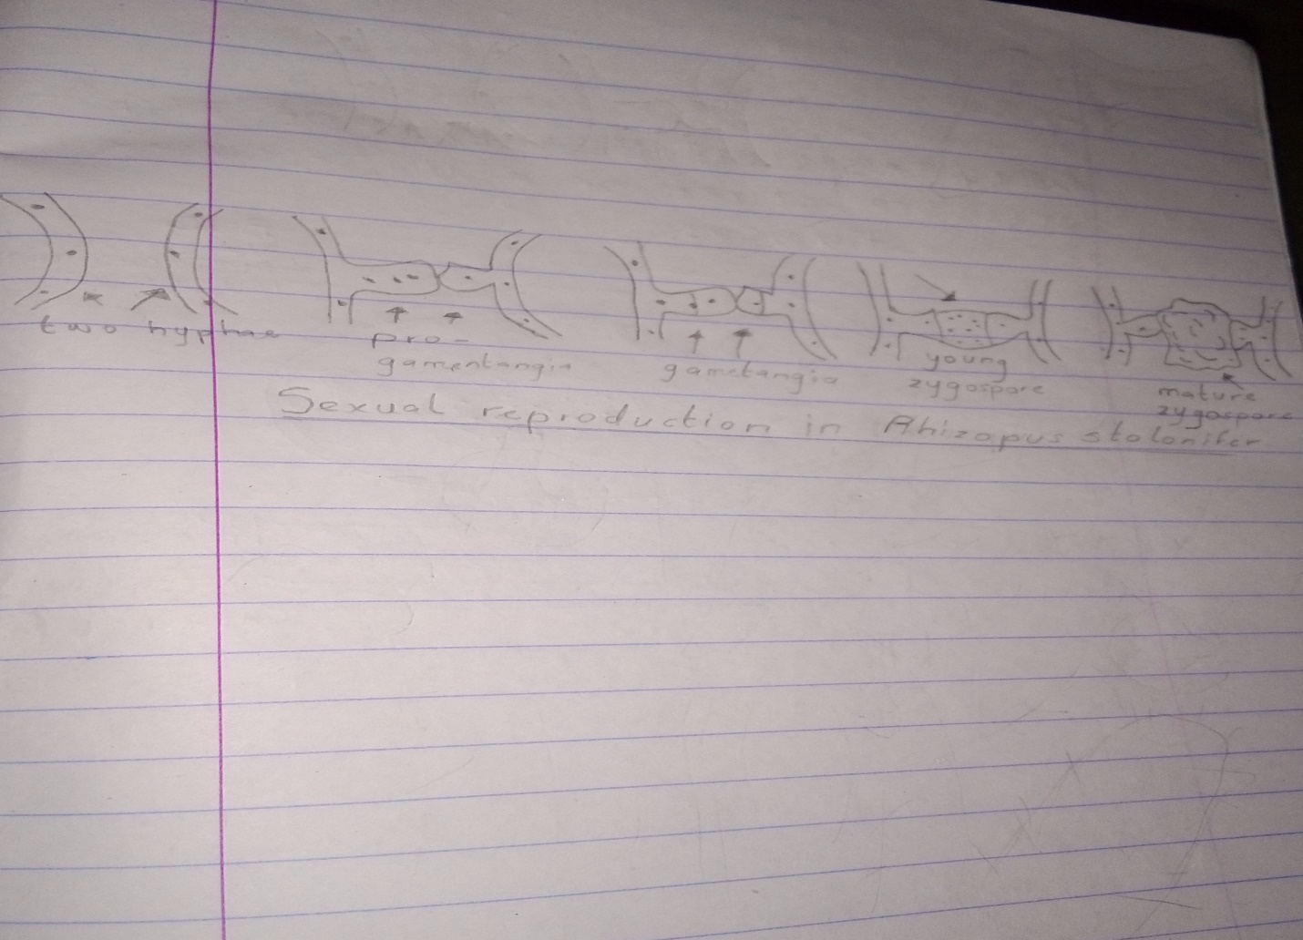

1. **Bryophytes adapt to their environment in the following ways:**



**5.**

**a)Eusteles: The vascular bundles are discrete, concentric collateral bundles of xylem and phloem.**

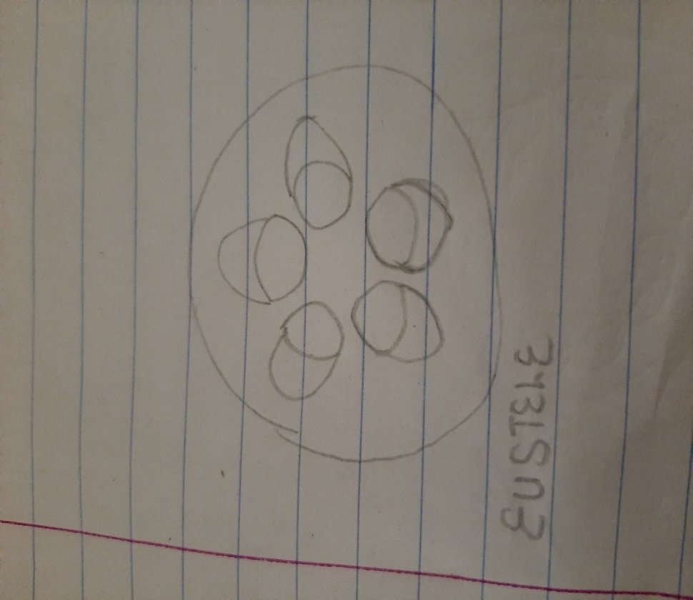

1. **Atactostele : In grasses and monocotyledonous plants the vasacular bundles are scattered.**

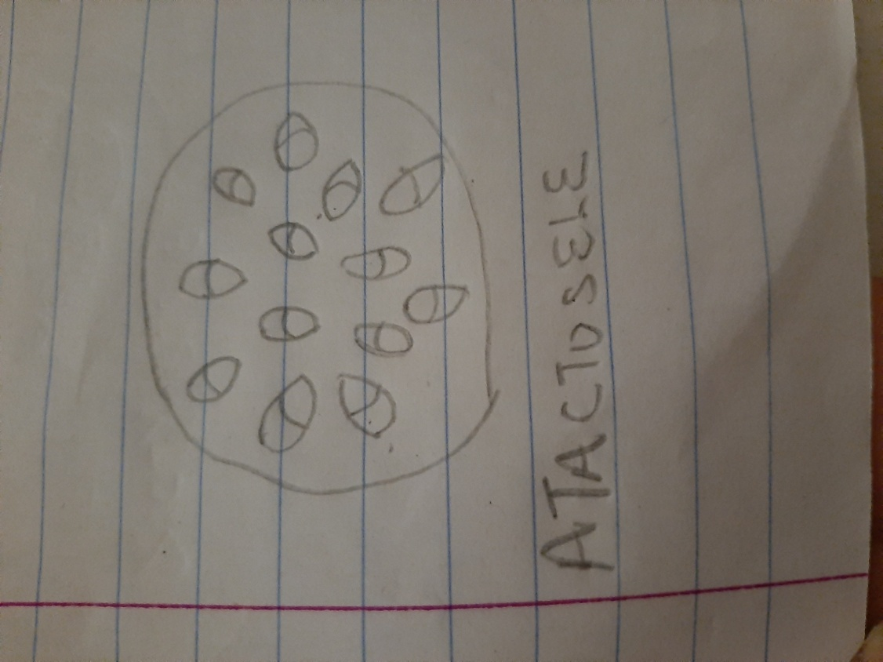

**c) Siphonostele: In more advanced vascular systems e.g stems of ferns and higher vascular plants, the stele is a cylinder enclosing a parenchymatous pith.**

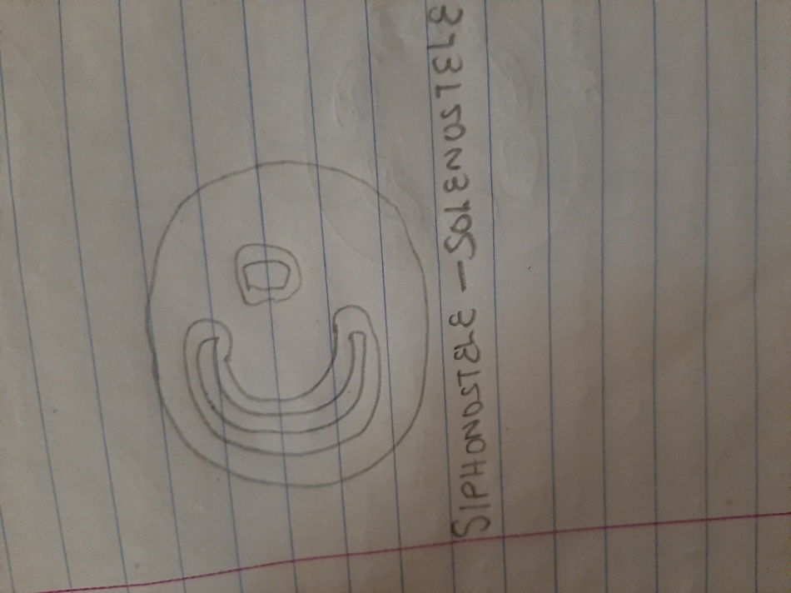

1. **Dictyostele: In siphonosteles, vascular supply to leaves is associated with leaf gaps and the conducting cylinder is a dissected one.**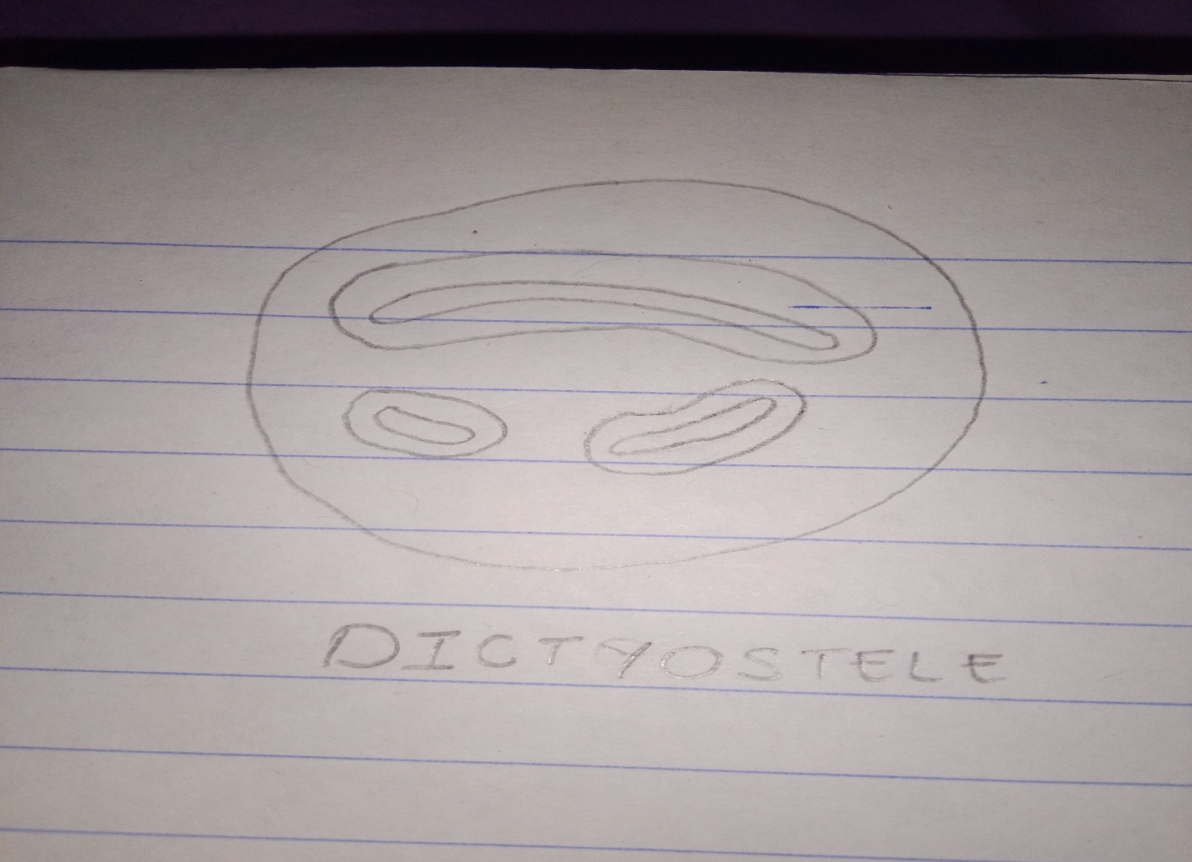

**6. The life cycle of a primitive vascular plant**