NAME: AKWIDO EWOMAZINO MERCY
DEPARTMENT: MBBS
MATRIC NUMBER: 19/MHS01/080
COURSE CODE: BIO 102
1.) Importance of Fungi to mankind.
- Fungi e.g. yeast (SACCHAROMYCES CEREVISIAE) are Important in the food industry.
- Species e.g. Penicillium Notatum produces important antibiotics.
- Mushrooms serves as food to human species.
- Some fungi are parasites to some certain horrible obnoxious pests e.g. houseflies, grasshoppers and therefore constitute important biological control agents in regards to such pests.
2.) Unicellular Fungus.
Brewer’s yeast is one of the best-known examples of unicellular forms of fungi. It is known as bread yeast SACCHAROMYCES CEREVISIAE, Baker’s yeast which causes bread to rise by releasing CO₂ which gets trapped in the dough.
Yeast cells are found on exposed sugary fluids e.g. Palm wine and sugary fruits where fermentation processes are mediated. The cell exists in diploid/haploid states. Under favorable environmental conditions, in both states, they multiply rapidly by simple mitotic cell divisions-budding involving nuclear division and division of the cytoplasm in such a way that one segment of the constricted cytoplasm is smaller than the others.
Diploid cells arise from haploid cells by processes of plasmogamy and karyogamy (some kind of fertilization). A diploid cell may undergo meiosis under certain conditions to produce 4 haploid spores-ascospores (contained in simple structure – an ascus).
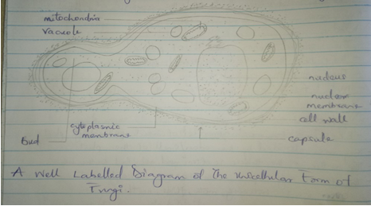
A WELL LABELLED DIAGRAM OF A UNICELLULAR FUNGUS (SACCHAROMYCES CEREVISIAE)
3.) Sexual Reproduction of the Filamentous from of Fungi.
Sexual reproduction occurs when two mating types of hyphae grow in the same medium. Chemical interaction in the two mating types of hyphae induces growths perpendicular to the hyphae in the opposite directions. These growths are delimited by a wall such that many nuclei are isolated in what is called GAMETAGIUM.
The two gametangia fuse (plasmogamy) and a zygote is formed which may undergo prolonged dormancy or resting stage. The nuclei in the zygotes fuse in the twos and undergo meiosis independently.
The zygote germinates under favorable conditions to produce a fruiting which at maturity liberates the haploid spores.
4.) Adaptation of Bryophytes to their environments.
- They have definite structures for water and nutrient absorption from the soil; therefore, the plant body is divided into two (an aerial portion and a subterranean portion). The subterranean portion is the rhizoid and is not a true root at the case of land plants that are advanced.
- The aerial portion being exposed to the atmosphere demands some modification that prevents excessive loss of water through the body surface (i.e. desiccation) and
- Some other modifications that permit elimination of excess water from the plant body and not only exchange of gases between the internal parts of the plant and the atmosphere therefore openings are available on the aerial parts of the plant.
5.) Terminologies
I.) Eusteles- A typical vascular cylinder of a dicotyledonous plant or a gymnosperm consisting of a ring of collateral bundles of xylem, cambium and phloem.
II.) Atactostele- A type of eustele found in monocots in which the vascular tissue in the stem exists as scattered bundles.
III.) Siphonostele- A type of vascular system consisting of a ring of vascular bundles surrounding a central pith.
IV.) Dictyostele- A type of siphonostele in which the vascular tissue in the stem forms a central cylinder around a pith but with closely spaced leaf gaps.
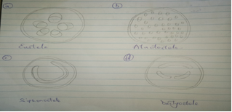
6.) Life Cycle of a Primitive Vascular Plant.
Whisk ferns in the genus Psilotum lack true roots but are anchored by creeping RHIZOMES. The stems have many branches with paired enations, which look like small leaves but have no vascular tissue. Above these enations there are synangia formed by the fusion of three sporangia and which produce the spores. When mature, the synangia release yellow to whitish spores which develop into a gametophyte less than 2mm (0.008 in) long. The gametophyte lived underground as a saprophyte, sometimes in a mycorrhizal association. When the gametophyte is mature, it produces both egg and sperm cells. The sperm cells swim using several flagella and when they reach an egg cell, they unite with it to form the young sporophyte. A mature sporophyte may grow to a height of 30 cm (10 in) or more but lacks true leaves. The stem has a core of thick-walled protostele in its center surrounded by an endodermis which regulates the flow of water and nutrients. The surface of the stem is covered with stomata which allows gas exchange with surroundings.
The gametophyte of PSILOTUM is unusual in that it branches dichotomously, lives underground and possesses vascular tissue. The nutrition of the gametophyte appears to be myco-heterotrophic, assisted by endophytic fungi.
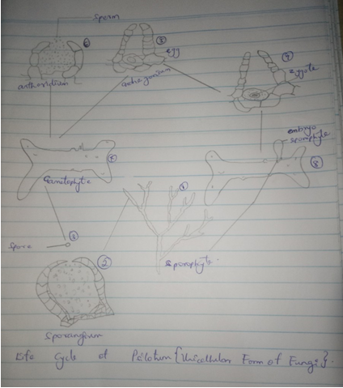
A DIAGRAM OF THE LIFE CYCLE OF A PSILOTUM.

