NAME: ETUK INYANG LILIAN
COLLEGE: MEDICINE AND HEALTH SCIENCES
DEPARTMENT: MEDICINE AND SURGERY
MATRIC NUMBER: 19/MHS01/163
COURSE CODE: BIO 102

- The importance of fungi include:
- Fungi are responsible for the mediation of decay of organic matter.
- Some fungi are parasites to some certain obnoxious pests e.g houseflies, grasshoppers and therefore constitute important biological control agents in regards to such pests.
- Many fungi species mediate the spoilage of wood, food, clothes and paper.
- Many fungi are plant pathogens causing blight and smut in cereal
- Some fungi species e.g Penicillium notatum produce important antibiotics.
- Yeast is important in the food industry for baking and brewing industry for fermentation.
- Mushrooms are eaten by many human societies, therefore serving as a source of food.

- Below is the cell structure of a unicellular fungus (Yeast – Saccharomyces cerevisae):

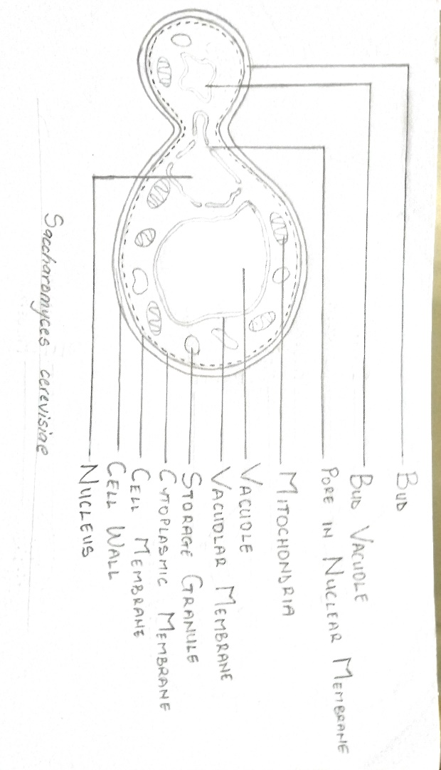

- Sexual Reproduction in Rhizopus stolonifer:
Sexual reproduction occurs when two mating types of hyphae grow in the same medium. Chemical interaction in the two mating types of hyphae induces growth perpendicular to the hyphae in opposite directions. These growths are delimited by a wall such that many nuclei are isolated in what is called a gametangium. The two gametangia fuse (plasmogamy) and a zygote is formed which may undergo prolonged dormancy or resting stage. The nuclei in the zygotes fuse in twos and undergo meiosis independently. The zygote germinates under favourable conditions to produce a fruiting, which at maturity liberates the haploid spores.

- Adaptation of Bryophytes to their environment:
- They have definite structures for water and nutrient absorption from the soil. Therefore, the plant body is divided into two (an aerial portion and a subterranean portion). The subterranean portion is the rhizoid and is not a true root as the case of land plants are advanced,
- They have a waxy cuticle that prevents the body, the zygote and the embryo from drying out.
- Spores are dispersed by wind.
- They have air pores for the absorption of carbon dioxide from the atmosphere for photosynthesis.
- The aerial portion, being exposed to the atmosphere is modified to prevent desiccation.
- Some other modifications that permit elimination of excess water from the plant body and not only exchange of gases between the internal parts of the plant and the atmosphere. Therefore, openings are available on the aerial parts of the plant.

- The following are various organizations in the vascular system:
- Eustele:
They exist in herbaceous dicotyledonous plants. In eusteles, the vascular bundles are discrete, concentric collateral bundles of xylem and phloem.
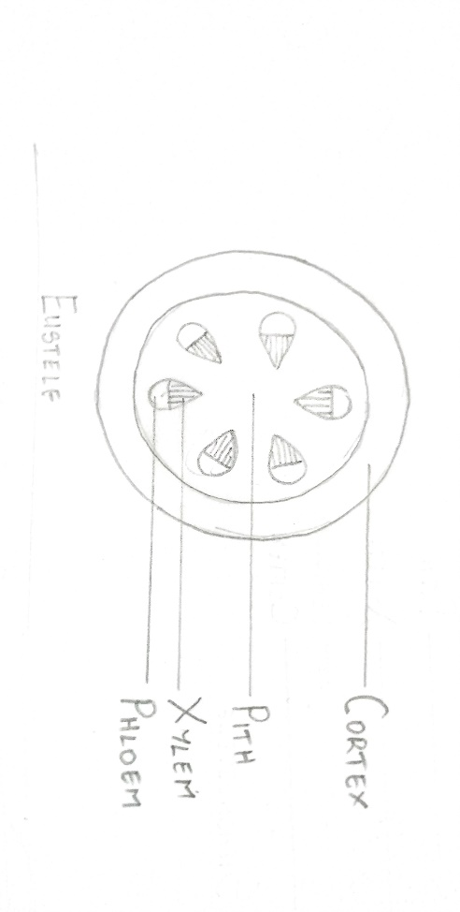
- Atactostele:
They are found in grasses and many monocotyledonous plants. In atactostele, the vascular bundles are scattered.

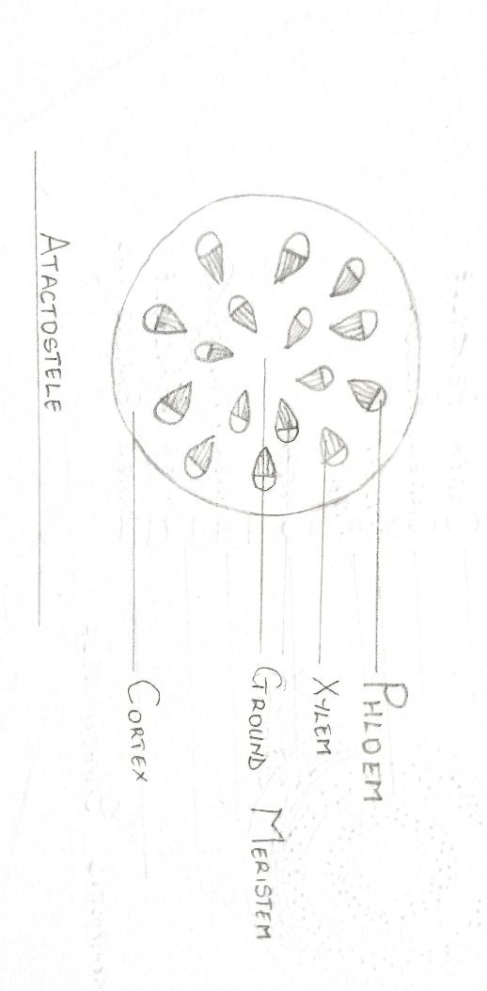

- Siphonostele:
In more advanced vascular systems e.g. stems of ferns and higher plants, the stele is a cylinder enclosing a parenchymatous pith. This kind of vascular organization is known as siphonostele. There are two kinds of siphonostele:

- Amphiphloic Siphonostele:
In this type of siphonostele the pith is surrounded by the vascular tissue. The concentric inner phloem cylinder surrounds the central pith. Next to the inner phloem is the concentric xylem cylinder, which is immediately surrounded by outer phloem cylinder.

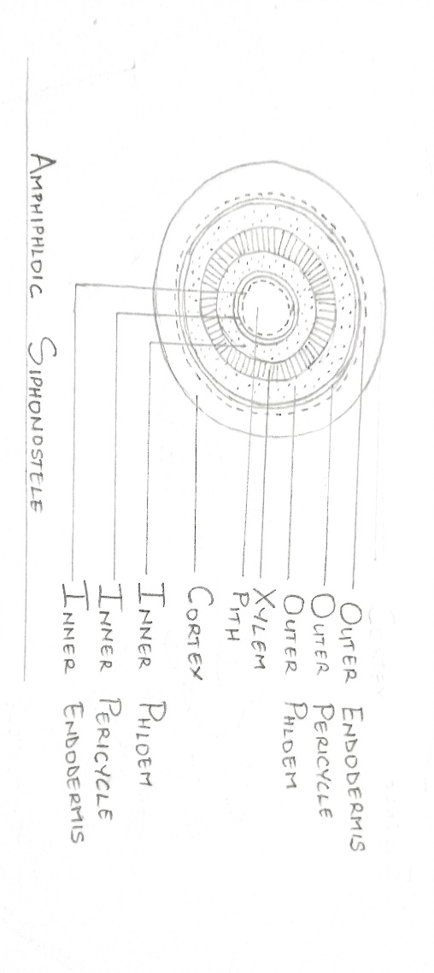

- Ectophloic Siphonostele:
In this type of siphonostele, the pith is surrounded by concentric xylem cylinder and next to xylem the concentric phloem cylinder.

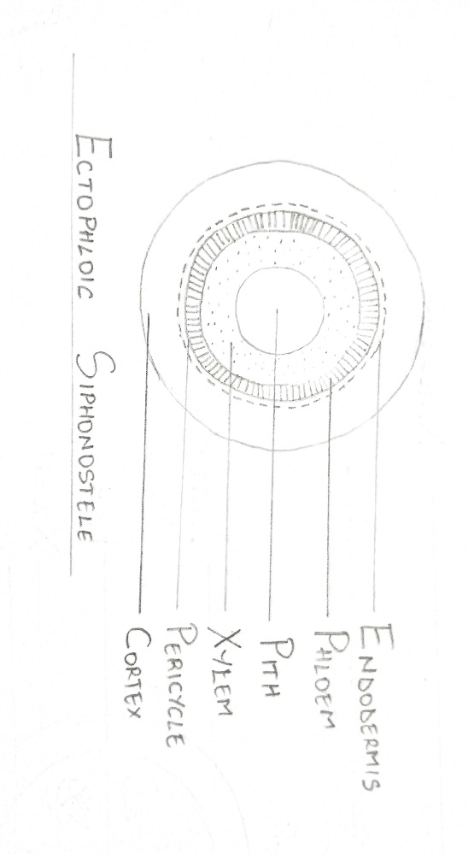

- Dictyostele:
This is a type of siphonostele in which the vascular supply to leaves is associated with leaf gaps and the conducting cylinder is a dissected one.
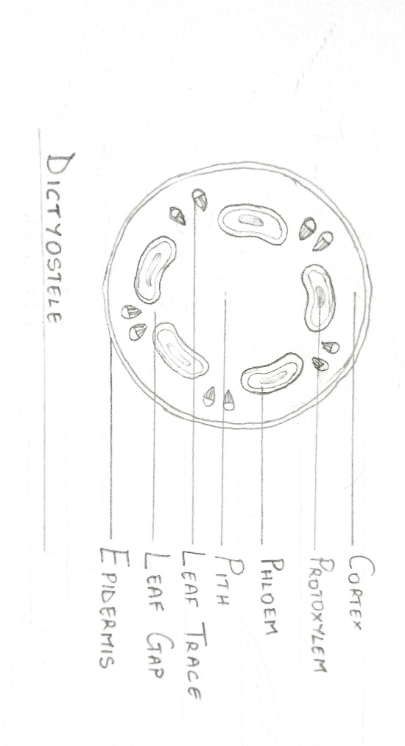

- The life cycle of a primitive vascular plant (Psilotum):