NAME: YAKUBU ZAINAB IZEE COURSE: BIO 102
DEPARTMENT: PHARMACY MATRIC NO: 19/MHS11/149.

- Importance of fungi to man;
- Fungi e.g. yeast are important in food industry.
- Fungi specie e.g. Penicillium notatum produce importance antibiotics.
- Many fungi specie mediate the spoilage of wood, food and paper.
- Some fungi serve as parasites to some certain obnoxious pests e.g. grasshopper and there for constitute importance biological control agents in regard to such pests.
- Mushroom serves as food for man.

- Unicellular form of fungi:
YEAST: Brewer’s yeast is one of the best known unicellular form of fungi. The cell structure is very simple though the organism is one of the more advanced fungal forms from the point of view of its spore-producing structures. Yeast has eukaryotic organelles such as; Golgi apparatus, mitochondria, endoplasmic reticulum, vacuole and cytoskeleton. The primary method of reproduction is by budding.
Each yeast cell has a distinct cell wall enclosing granular cytoplasm, within which can be seen a large vacuole and a nucleus. The wall of the yeast is thin, delicate and composed of chitin in combination with other compounds. Reserve materials are present in the cytoplasm in the form of oil globules, glycogen and volutin. Glycogen accumulation increases with the decrease in fermentation. The volutin content is also very much linked with the metabolic aspect of the yeast.
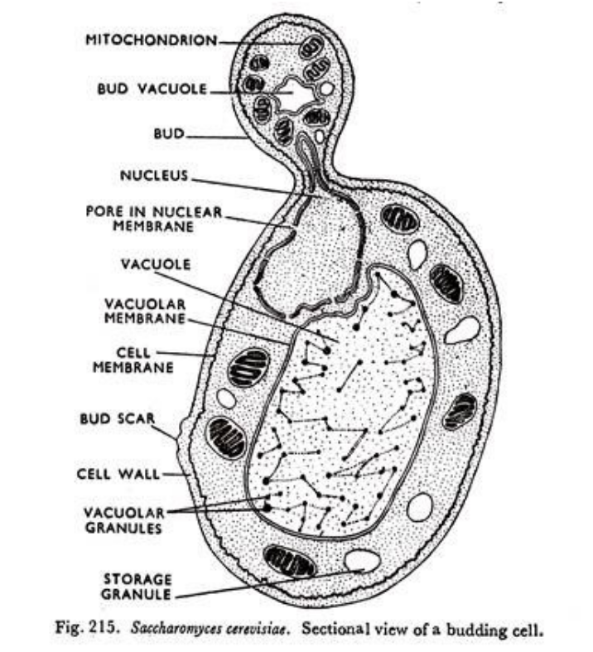
- Reproduction in a filamentous fungi(Rhizopus )

- Most Rhizopus are heterothallic
- When two mycelium of opposite strain come close to each other, each mycelium produce small out growth, called progametangia.
- The apical region of the two progametangia come in close contact and cytoplasm of each progametangium push closer towards the apical region which swell up with dense protoplasm.
- The apical region is also known as gametangia and basal region is known as suspensor.
- The protoplasm in gametangia fuses to form zygospore.
- The zygospore is a resting spore.
- During favorable condition, spore wall rupture and form germ tube which elongates to form promycellium.
- Promycellium have to region; germsporangiophore and germsporangium.
- Nucleus in germsporanium divides by meiosis forming haploid nuclei, which gather cytoplasm and behaves as spore.
- The haploid spores are released and germinates to give mycelium.

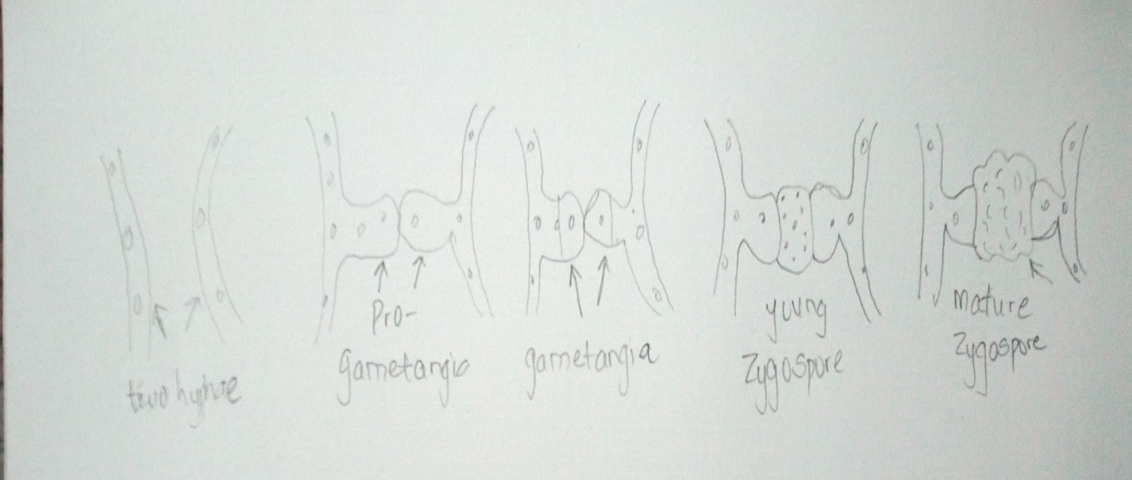

- Adaptations of bryophytes to their environment:
Two adaptations made the move of bryophytes from water to land; a waxy cuticle and gametangia. The waxy cuticle helps to protect the plant tissue from drying out and the gametangia provided further protection against drying out specifically for the plants gametes.
- Bryophytes show embryonic development.
- They have definite structures for water and nutrient absorption from the soil; therefore the plant body is divided into two (an aerial portion and a subterranean portion). The subterranean portion is the rhizoid and is not a true root as the case of land plants that are advanced.
- The aerial portion being exposed to the atmosphere demands some modifications that prevents excessive loss of water through the body surface (i.e. desiccation).

- I. Eusteles: a stele typical of dicotyledonous plants that consist of vascular bundles of xylem and phloem strands with parenchymal cells between the bundles.
- Atactostele: is a type of eustele found in monocots, in which the vascular tissue in the stem exists as scattered bundles.
- Siphonstele: a stele consisting of a core of pith surrounded by concentric layers of xylem and phloem.
- Dicotyostele: a stele in which the vascular cylinder is broken up into a longitudinal series or network of vascular strands around a central pith (as in many ferns).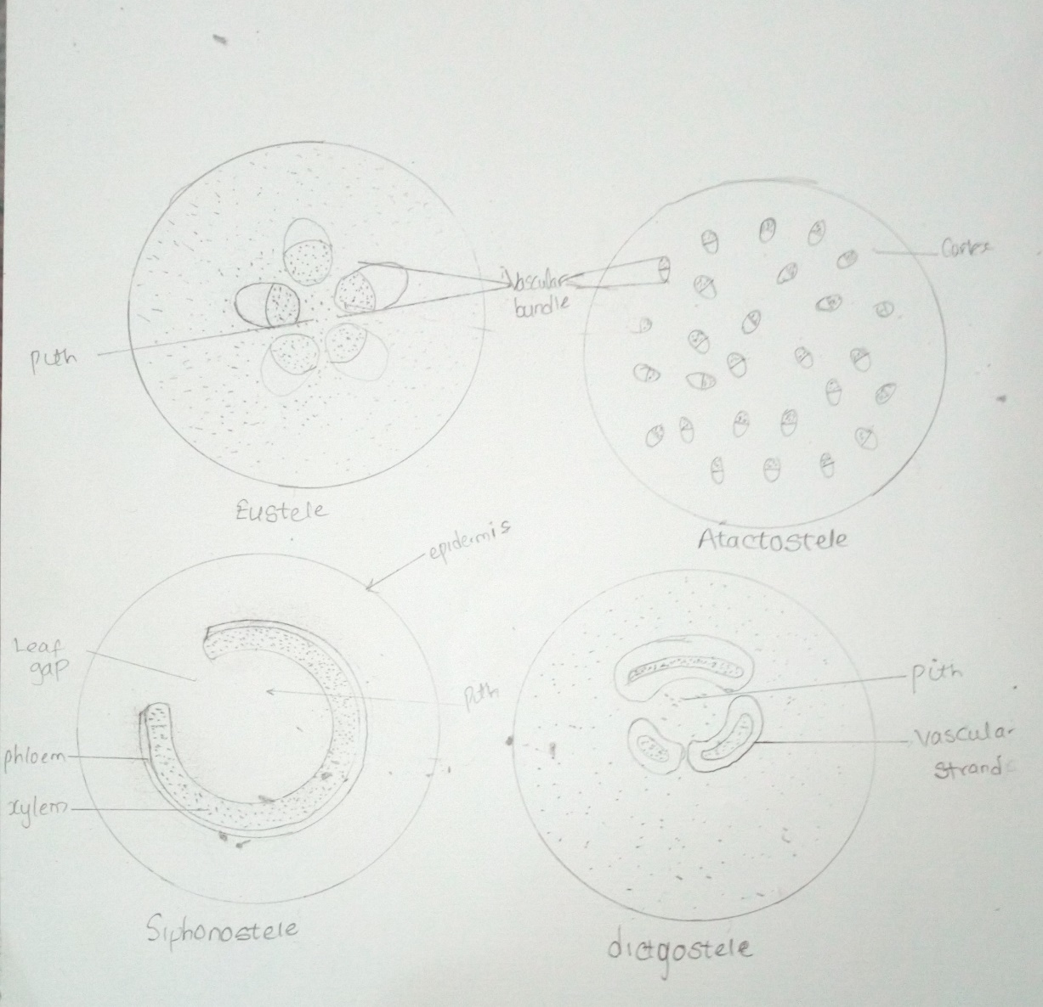
- Life cycle of a primitive vascular plant;
There are two forms of the vascular plant, the sporophyte, a diploid organism, goes through meiosis to produce haploid spore. The spore grows into an organism, the gametophyte. The gametophyte is responsible for producing gametes, capable of fusing together during sexual reproduction. These gametes, the sperm and egg, fuse together to form a zygote, which is the new diploid sporophyte generation. In some plants, this zygote will develop directly into a new organism. In others, the zygote develops into a seed, which is dispersed and must have a period of dormancy or some activation signal to begin growing. A vascular plant which is closer in relation to the mosses and non- vascular plants is more likely to have independent alternating generations. Seeding plants tend to have a highly reduced gametophyte, which is typically entirely dependent on and lives with the sporophyte. The distinction is hardly noticeable between the two organisms, besides the amount of DNA they carry within their cells (haploid vs. diploid) and the cellular division processes they use.
