BIO 102 (ASSIGNMENT)
Name: Tobby, Glory Inyang

Department: Medicine and Surgery (MBBS)

Matric Number: 19/MHS01/406
1) Importance of fungi to mankind:
(i) Fungi are responsible for the mediation of decay process.
(ii) Fungi e.g yeast (saccharomyces species) is useful in the food industry.
(iii) Penicillium which is a fungus is used to produce important antibiotics.
(iv) Mushrooms are eaten as food by human species.
(v) They serve as important biological control agents to certain horrible obnoxious pests.
2) Cell structure of a unicellular fungi e.g Yeast
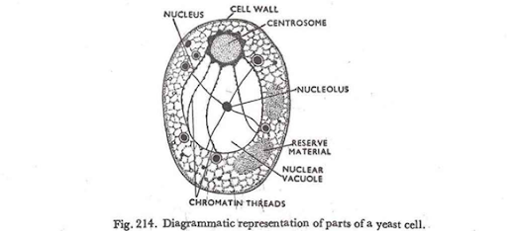

3) Sexual Reproduction in a typical filamentous form of fungi:
It occurs when two mating types of hyphae grow in the same medium. Chemical interaction in the two mating types of hyphae induces growth perpendicular to the hyphae in opposite directions. These growths are delimited by a wall such that many nuclei are isolated in what is called gametangium. The two gametangia fuse (plasmogamy) and a zygote is formed which may undergo prolonged dormancy or resting stage. The nuclei in the zygote fuse in twos and undergo meiosis independently. The zygote germinates under favourable conditions to produce a fruiting which at maturity liberates the haploid spores.

4) Adaptation of Bryophytes to their environment.
Bryophytes adapt to their land environment in two ways:
i) They have definite structure for water and nutrient absorption from the soil; therefore the plant body is divided into two (an aerial portion and a subterranean portion). The subterranean portion is the rhizoid and is not a true root as the case of land plants that are advanced.
ii) The aerial portion being exposed to the atmosphere demands some modifications that prevents excess loss of water from the plant body and not only exchange of gases between the internal parts of the plants and the atmosphere therefore openings are available on the aerial parts of the plant.
5) a) Eusteles: In Eusteles, the vascular bundles are discrete, concentric collateral bundles of xylem and phloem.
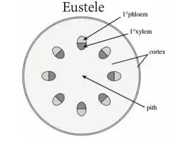
b) Atactostele: Here, the vascular bundles are scattered. The nature of the vascular supply to leaves is also noteworthy elements of the vascular system.
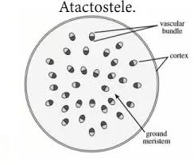
c) Siphonostele: This is found in more advanced vascular systems examples stems of ferns and higher vascular plants, the stele is a cylinder enclosing parenchymatous pith.
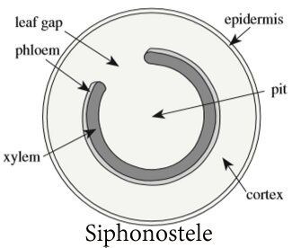
d) Dictyostele: Here, vascular supply to leaves is associated with leave gaps and the conducting cylinder is a dissected one.
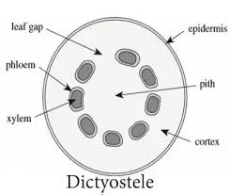

6) Life cycle of a primitive vascular plant e.g Psilotum

