NAME: Aibangbee Efeosa Anthonia
DEPARTMENT: Pharmacy
MATRIC NO.: 19/MHS11/021
COURSE: BIOLOGY( BIO102)
Assignment
- How are fungi important to mankind?
- Fungus is used to produce antibiotics to prevent bacterial growth in the body on wounds. Example of antibiotics is penicillin natatum.
- Some fungi act as a biological control agent to control pests cause some fungi are parasitic in nature.
- Fungi are responsible for breaking down organic matter and releasing carbon, oxygen, nitrogen, and phosphorus into the soil and the atmosphere.
- Fungi are essential to many household and industrial processes, notably the making of bread, wine, beer, and certain cheeses through a process called fermentation.

2. Illustrate the cell structure of a unicellular fungus with a well labeled diagram.
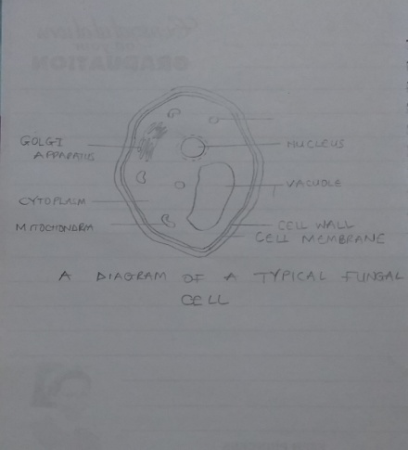.
3. Outline the sexual reproduction in a typical filamentous form of fungi.
- This involves mating between two haploid hyphae.
- During mating, two haploid parent cells fuse, forming a diploid spore called a zygospore
- The zygospore is genetically different from the parents. the zygospore then germinates.
- it can undergo meiosis forming haploid cells that develop into new hyphae which may then form asexual sporangiospores.
- These sporangiospores allow the fungus to rapidly disperse and germinate into new genetically identical haploid fungal mycelia.
4. How do Bryophytes adapt to their environment?
They have waxy cuticle helped to protect their tissue from drying out and the gametangia provided further protection against drying out specifically for the plants gametes. They are also dispersed by the wind.

5. Describe with illustration the following terminologies: (a) eusteles (b) atactostele (c) siphonostele (d) dictyostele.
Eusteles – a type of siphonostele, in which the vascular tissue in the stem forms a central ring of bundles around a pith.
Atactostele – a type of monocotyledonous siphonostyle in which the vascular bundles are dispersed irregularly throughout the centre of the stem
Siphonostele- a stele in which the vascular tissue is in form of a cylinder surrounding the pith, as in the stems of most ferns and other seedless primitive plants.
Dictyostele – a stele in which the vascular cylinder is broken up into a longitudinal network of vascular strands around a central pith.
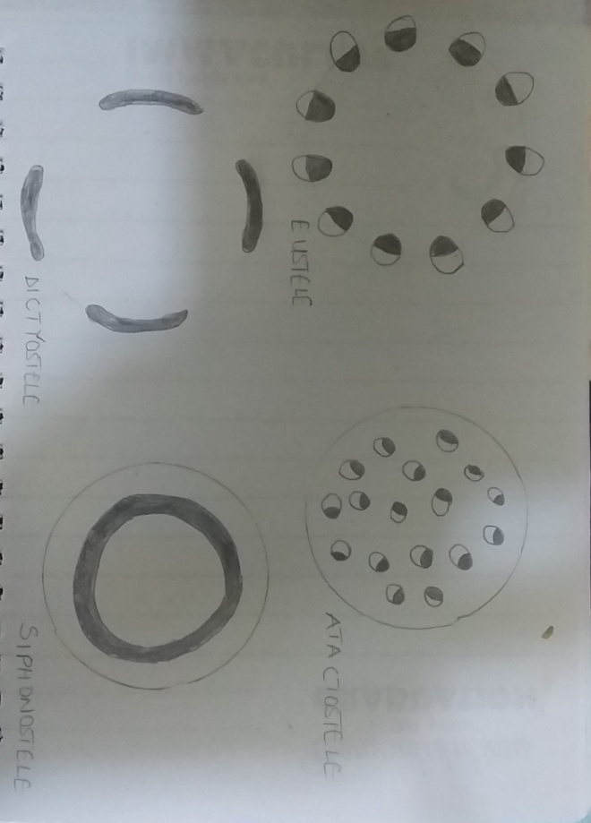

6. Illustrate the life cycle of a primitive vascular plant.
The life cycle of a fern undergoes two stages;
- The released spores grow into a small, heart shaped plant called a gametophte.
- The gametophyte has both male and female sex organs. They mature at different times to aid in cross fertilization.
- Ferns need water for fertilization. The sperm swims to the eggs and a zygote is formed.
- The zygote grows using mitosis. This plant is the sporophyte. This is the plant most of us recognize as ferns.
- On the underside of fern leaves, sori are formed. They are clumps of sporangia holding reproductive spores.
- Spores are formed using meiosis. They are released from the sporangium.

