NAME – YOUGHA PRAISE
MATRIC NO- 19/MHS01/441
DEPT- MBBS
COURSE- BIO102

(1) Importance of fungi to mankind
- Recycling
Fungi, together with bacteria, are responsible for most of the recycling which returns dead material to the soil in a form in which it can be reused. Without fungi, these recycling activities would be seriously reduced. We would effectively be lost under piles many metres thick, of dead plant and animal remains.
- Food
Fungi are also important directly as food for humans. Many mushrooms are edible and different species are cultivated for sale worldwide. While this is a very small proportion of the actual food that we eat, fungi are also widely used in the production of many foods and drinks. These include cheeses, beer and wine, bread, some cakes, and some soya bean products.
- Medicines
Penicillin, perhaps the most famous of all antibiotic drugs, is derived from a common fungus called Penicillium. Many other fungi also produce antibiotic substances, which are now widely used to control diseases in human and animal populations. The discovery of antibiotics revolutionized health care worldwide.
- Animal Disease
Fungi can also parasitise domestic animals causing diseases, but this is not usually a major economic problem. A wide range of fungi also live on and in humans, but most coexist harmlessly. Athletes foot and Candida infections are examples of human fungal infections.
- Food Spoilage
It has already been noted that fungi play a major role in recycling organic material. The fungi which make our bread and jam go mouldy are only recycling organic matter, even though in this case, we would prefer that it didn't happen! Fungal damage can be responsible for large losses of stored food, particularly food which contains any moisture.
(2) The cell structure of unicellular fungus with a well labelled diagram

Fungi are eukaryotes and have a complex cellular organization. As eukaryotes, fungal cells contain a membrane-bound nucleus where the DNA is wrapped around histone proteins. A few types of fungi have structures comparable to bacterial plasmids (loops of DNA).

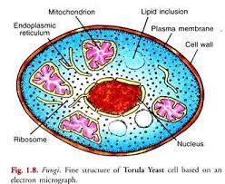

(3) The sexual reproduction in a typical filamentous form of fungi

Sexual reproduction is characterized by the process of meiosis, in which progeny cells receive half of their genetic information from each parent cell. Sexual reproduction is usually regulated by environmental events. In many species, when temperature, salinity, inorganic nutrients (e.g., phosphorus, nitrogen, and magnesium), or day length become unfavourable, sexual reproduction is induced. A sexually reproducing organism typically has two phases in its life cycle. In the first stage, each cell has a single set of chromosomes and is called haploid, whereas in the second stage each cell has two sets of chromosomes and is called diploid. When one haploid gamete fuses with another haploid gamete during fertilization, the resulting combination, with two sets of chromosomes, is called a zygote. Either immediately or at some later time, a diploid cell directly or indirectly undergoes a special reductive cell-division process (meiosis). Diploid cells in this stage are called sporophytes because they produce spores. During meiosis the chromosome number of a diploid sporophyte is halved, and the resulting daughter cells are haploid. At some time, immediately or later, haploid cells act directly as gametes. In algae, as in plants, haploid cells in this stage are called gametophytes because they produce gametes.

(4) How do Bryophytes adapt to their environment?

Two adaptations made the move from water to land possible for Bryophytes: a waxy cuticle and gametangia. The waxy cuticle helped to protect the plants tissue from drying out and the gametangia provided further protection against drying out specifically for the plants gametes.

(5) Describe with illustration the following terminologies:

(A) Eustele:
a stele typical of dicotyledonous plants that consists of vascular bundles of xylem and phloem strands with parenchymal cells between the bundles

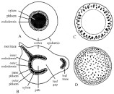

(B) Atactostele:
A type of eustele, found in monocots, in which the vascular tissue in the stem exists as scattered bundles.

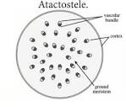

(C) Siphonostele:
noun. A stele in which the vascular tissue is in the form of a cylinder surrounding the pith, as in the stems of most ferns and other seedless vascular plants.

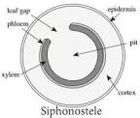

(D) Dictyostele:
a stele in which the vascular cylinder is broken up into a longitudinal series or network of vascular strands around a central pith (as in many ferns).

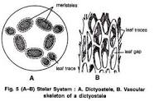

(6) The life cycle of a primitive vascular plant
Pteridophytes are primitive vascular plants, commonly known as ferns. Unlike other vascular plants, the life cycle of ferns is split between free-living gametophytes and sporophytes phases. The gametophyte is generally simple in structure, containing egg-producing archegonium and sperm-producing antheridium.

