NAME : IMOYIN-OMENE EMUOBONUVIE
MAATRIC NUMBER : 17/MHS01/159
DEPARTMENT: ANATOMY
LEVEL: 300
COLLEGE : MEDICINE AND HEALTH SCIENCES
COURSE CODE : BCH 308
COURSE TITLE : CELLULAR BIOCHEMISTRY
QUESTIONS
- What do you understand by primary obesity
- How does drug therapy and congenital syndrome affect secondary obesity
- Discuss the aetiology of cancer and its molecular basis
ANSWERS
- Obesity is a medical condition in which represents the state of excess storage of body fat,the excessive body fat has accumulated to an extent that it may have adverse effect on the risk of diseases and health problems, such as heart disease,diabetes,high blood pressure and certain cancers.People are generally considered obese when their body mass index (BMI), a measurement obtained by dividing a person's weight by the square of the person's height, is over 30 kg/m2; the range 25–30 kg/m2 is defined as overweight.It is not associated with clinical condition .It is characterised by a normal or increased growth rate with an acceleration of bone age maturation. It is characterised by a reduced growth hormone secretion evaluated by standard provocative tests, the administration of growth hormone releasing hormone or spontaneous 24 hour secretion. It is also associated with high insulin and insulin like growth factor I levels which may interfere in the complex endocrine interactions. It is a complex disease that is evaluated in terms of fat distribution via the waist-hip ratio and total cardiovascular risk factors.
In classification of obesity;there are 2 major types-primary and secondary obesity.
Primary /constitutional obesity:It's major etiology is increased food incoming band decreased energy asage and congenital susceptibility.No secondary >95%cases.In it's pathology diagnostics:excess of carbohydrates -hyperinsulinism-increase of TG synthesis-increase of fatty cells synthesis -increase of ACTH secretion + hypercorticism - violation s of sensitiveness of thalamus nucleus to the sense of hunger and saturation - development of the secondary diencephalic syndrome.It develops on the background of related (80%) or absolute (20%) leptine insufficiency.Interaction between genetic predisposition (50-90%) and environment affecting food intake and energy expenditure.Twin stideies offer some insight into the genetics of common obesity.Data from >25,000 twin pairs and 50,000 biological and adaptive family members.Estimates for mean correlations for BMI are:0.74 for monozygotic twins,0.32 for dizygotic twins,0.25 for siblings,0.19 for parent - offspring,0.06 for adoptive relatives and 0.12 for spouses.

2.) Secondary obesity:It means that one has a medical condition that has caused one to gain(disease of endocrine glands i.e hypothyroidism and hyperinsulinism. endocrine disorders,hypothalamic disorders(violations of the functions of thalamus nucleus) and some congenital conditions.It is also known as exogenous obesity. Its etiology are; Genetic syndromes like prader-willi, down's bradet-biedi,Cohen,carpenter syndrome;Hypothalamic: Infections (TBM, post meningitis,sequelae),ICSOL, radiation,surgery,head trauma,Hypothalamic harmartoma.
Drug therapy: It is also called pharmacotherapy,is a general term for using medication to treat diseases.Drugs react with receptors or enzymes in cells to promote healthy functioning and reduce or cute illnesses.They aim to treat psychological disorders with medications.The main categories are: antianxiety drugs, antidepressants and antipsychotics.Others include: chemotherapy,antimetabollites,antimitotics,antitum or antibiotics,biosimilars,etc. Congenital syndromes: Congenital disorders/disease or birth defects is a condition present at birth regardless of it cause.Birth defects may result in disabilities that may be physical, intellectual,or developmental.It can be acquired be acquired during fetal stage of development or from the genetic makeup of the parents: Examples are heart conditions,cleft lip and cleft palate, cerebral palsy,fragile X syndrome,down syndrome ,Spina bifida,cystic fibrosis,heart conditions,etc.
i.)HOW CONGENITAL SYNDROME AFFECTS SECONDARY OBESITY: Hyperthyroidism which is when the thyroid makes less of its hormone the body metabolism slows down. The more severe the syndrome the more weight gained. Some of the weight gained is fat, which may lead to obesity along the line but most of it is fluid.Polycystic ovarian syndrome can cause missed or irregular menstrual periods, excess hair growth and weight gain. Syndromic obesity corresponds to severe obesity associated with additional phenotypes (mental retardation, dysmorphic features, and organspeciﬁc developmental abnormalities). Prader-Willi (PWS) and BardetBiedl (BBS) syndromes are the 2 syndromes most frequently linked to obesity, but more than 100 syndromes are now associated with obesity.
- Prader-Willi: some clinical features associated to obesity; neonatal hypotonia, mental retardation, hyperphagia, facial dysmorphy, hypogonadism, shoet stature.
- Bardet- Biedl: some clinical features associated with obesity; mental retardation, renal dystrophy or pigmentary retinathy, dysmorphic extremeities, hypogonadism, kidney anomalies.
ii.) HOW DRUG THERAPY AFFECTS SECONDARY OBESITY:
Some drugs like certain steroids and antidepressants can stimulate the human appetite which causes you to eat more and gain extra weight. Some also affect the body metabolism and slows it down making the body burn calories at a much slower rate. Drugs like the diabetes drug, Pioglitazone, make the body hold onto more salt, which in turn leads to water build up.
Drug therapy plays an important complementary role in an integrated strategy for managing obesity.
Various pharmacologic agents, referred to as anorectic drugs, are used as adjuncts to behavioral therapy in weight reduction programs. The two classes of anorectic drugs currently available are the noradrenergic and the serotonergic agents.
a.)Noradrenergic drugs affect weight loss through action in the appetite center.Phenylpropanolamine (Dexatrim), a sympathomimetic drug and a synthetic derivative of ephedrine, is available as an over-the-counter appetite suppressant and decongestant. In studies lasting 14 weeks, the subjects who took phenylpropanolamine had a greater weight loss than those who took placebo, although the difference was minimal.

b.)The serotonergic drugs partially inhibit the reuptake of serotonin and release serotonin into the synaptic cleft, thus acting on the hypothalamus to decrease satiety.
Fluoxetine (Prozac) is a highly selective serotonin reuptake inhibitor (SSRI) that has been studied in the treatment of obesity. Fluoxetine may increase energy expenditure by raising basal body temperature; however, weight loss has not been consistent among subjects in clinical trials. In a three-month study, fluoxetine did not significantly reduce weight when compared with placebo. In a longer clinical trial, significantly greater weight loss was achieved in the subjects taking fluoxetine at 20 weeks, compared with the subjects taking placebo. However, after one year, weight loss was not different in the two groups.Adrenergic/Serotonergic Agents. Sibutramine (Meridia) is an adrenergic/serotonergic agent recently labeled by the FDA for use in the management of obesity.Sibutramine and its metabolite inhibit monoamine uptake, suppressing appetite in a fashion similar to SSRIs. Sibutramine may also stimulate thermogenesis by activating the beta3-system in brown adipose tissue. Initially tested for its antidepressant activity, sibutramine was found to cause weight loss 1 to 2 kg (2.2 to 4.4 lb) in healthy and depressed patients. In six-month studies, weight loss in subjects taking sibutramine, although modest, was found to be significantly greater than the loss in subjects taking placebo, and weight loss increased with increasing dosages. In a continued, open-label, 96-week extension study, weight was regained even in subjects taking high-dose sibutramine.
Sibutramine is indicated for the management of obesity, including weight loss and maintenance of weight loss, and should be used in conjunction with a reduced calorie diet. It is recommended for obese patients with an initial BMI of greater than 30 kg per m2, or greater than 27 kg per m2 in the presence of other risk factors (e.g., hypertension, diabetes, hyperlipidemia).

3.)Cancer is caused by accumulated damage to genes. It is the uncontrolled growth of abnormal cells in the body. Such changes may be due to chance or to exposure to a cancer causing substance.These cells may form a mass called a tumor,they have the potential to invade or spread to other parts of the body Cancer is also called "malignancy".The most common bare: carcinoma, sarcoma, melanoma, lymphoma and leukemia;others include breast, prostate, testicular, cervical, thyroid,colon cancer,etc.
The substances that cause cancer are called carcinogens. A carcinogen may be a chemical substance, such as certain molecules in tobacco smoke. The cause of cancer may be environmental agents, viral or genetic factors.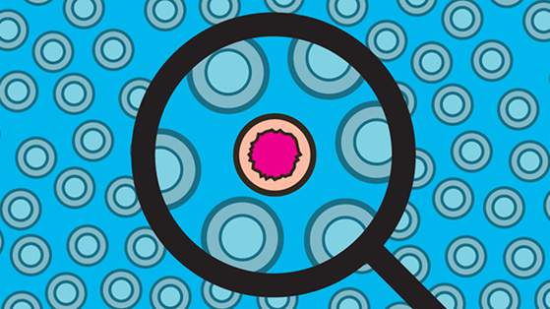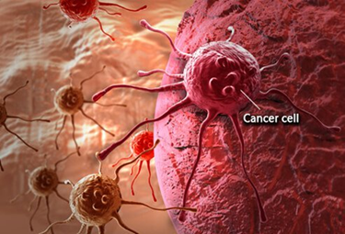
We should bear in mind, though, that in the majority of cancer cases we cannot attribute the disease to a single cause.

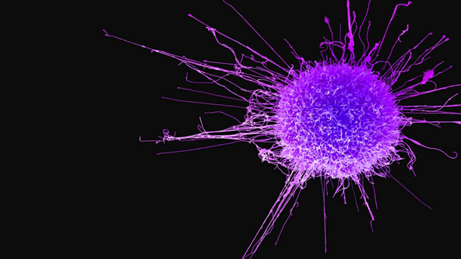
Aetiology of cancer:There are many causes of cancer, anything that may cause abnormal body cell to develop abnormally potentially can cause cancer .The main causes of cancer are smoking and tobacco,diet and physical activity,sun or other types of radiation,viruses and other infections.The basic cause of sporadic (non-familial cancers is DNA damage and genomic instability. 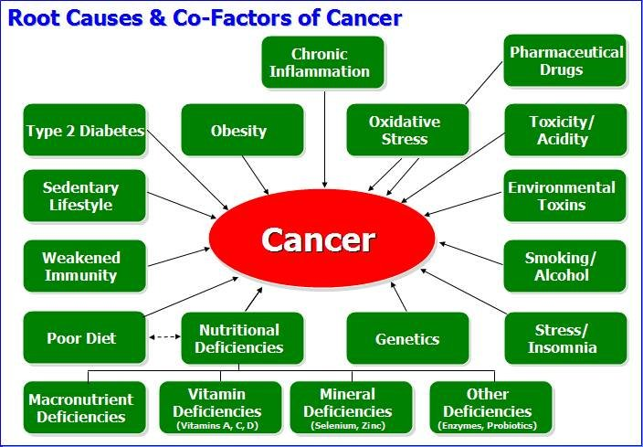Even biological or internal factors such as age, gender,inherited genetic defects and skin type.Environmental exposure,for instance the radon and UV radiation,and fine particulate matter. 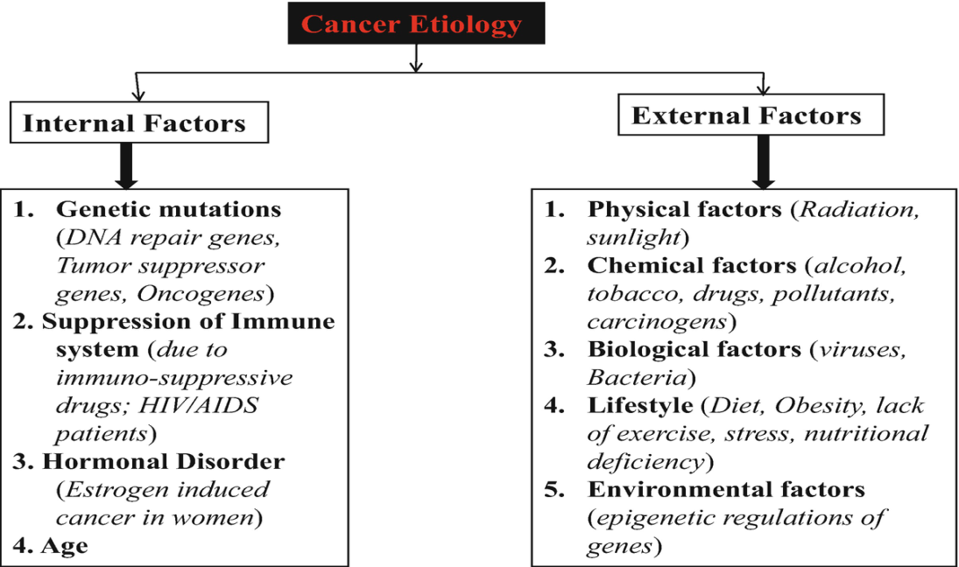Occupational risk factors, including carcinogens such as many chemicals, radioactive materials and abestos.The causes of cancer can be categorized into the following:
i.)Biological factors
a. Inherited genetic defects
b. Viruses
c. Bacteria
ii.) Chemical factors
a. Aflatoxin B
b. Nickel
c. Tobacco smoke
d. Industrial pollutants
iii.)Physical factors
a. UV Ray's
b. X-rays
c. Beta and gamma rays.
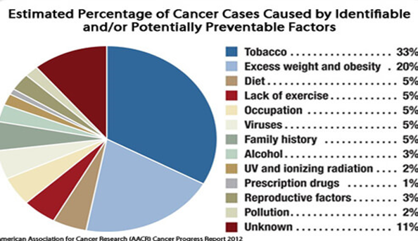
Molecular basis of cancer:
Molecular basis of cancer:
It is a multi-step process that requires the accumulation of many genetic changes over time. These genetic alterations involve activation of proto-oncogenes to oncogenes, deregulation of tumour suppressor genes and DNA repair genes and ‘immortalisation’.The process of protein production involves a cascade of several different steps, each with its attendant enzymes, which are also encoded by DNA and regulated by other proteins. Most steps in the process can be affected, eventually leading to an alteration in the amount or structure of proteins, which in turn affects cellular function. However, whereas cellular function may be altered by disturbance of one gene, malignant transformation is thought to require two or more abnormalities occurring in the same cell. Although there are mechanisms responsible for DNA maintenance and repair, the basic structure of DNA and the order of the nucleotide bases can be mutated. These mutations can be inherited or can occur sporadically, and can be present in all cells or only in the tumor cells. At the nucleotide level, these mutations can be substitutions, additions or deletions. 