NAME: EGBOCHUKWU
OTHER NAMES: ESTHER CHINALU
MATRIC NUMBER: 19/MHS11/049
DEPARTMENT: PHARMACY
COURSE CODE: BIO 102
ANSWERS
- Importance of fungi to mankind are;
- They are responsible for the mediation of the decay of dead organic matter.
- Yeast is important in food industries like bakeries and yogurt making factories.
- Mushrooms are eaten by man.
- Many fungi plants pathogens causing blights and smuts in cereals
- Some fungi are parasites to obnoxious pests of man.

- CELL STRUCTURE OF A UNICELLULAR FUNGUS E.g Yeast
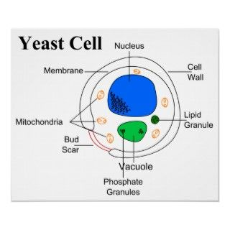
- Sexual reproduction in a filamentous fungi e.g Rhizopus stolonifer undergoes the following steps;
- Firstly, two mating types of hyphae grow in the same medium.
- A chemical interaction between these hyphae induces growths perpendicular to the hyphae in opposite directions, so they can mate with one another.
- These growths are the delimited by a wall just so that many nuclei are isolated in differentiated sex organs called gametangia (plural).
- The two gametangia fuse in a process called plasmogamy and together they form a zygote which may undergo prolonged dormancy or resting stage.
- The nuclei in the zygote fuse in twos and undergo meiosis independently
- The zygote germinates under favourable conditions to produce a fruiting which at maturity liberates the haploid spores.
- In summary, sexual reproduction in fungi consists of three stages; plasmogamy, karogamy and meiosis.
- Bryophytes adapt in their habitat via the following;
- They possess definite structures for water and nutrient absorption from the soil.
- Their aerial portion when being exposed to the atmosphere demands some modifications that prevents excessive loss of water through the body surface this process is called dessication.
- They possess gametangia that keep the plants gametes from drying out.
5. A. Eusteles: this is a type of stele found in herbaceous dicotyledonous plants in which the vascular tissue in the stem forms a central ring of bundles around a pith. The vascular bundles are discrete, concentric collateral bundles of xylem and phloem.
B. Atactostele: this is a type of stele found in grasses and many monocotyledons plants, in which their vascular tissue in the stem exists as scattered bundles.
C. Dictyostele; this is a type of stele found in stems of ferns and higher vascular plants, in which the vascular cylinder is broken up into a longitudinal series or network of vascular strands around a pith.
Diagrammatic illustrations of the different steles.
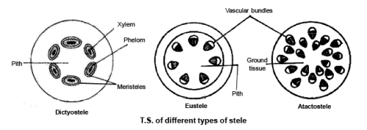
- Life cycle of a primitive vascular plant
An example is psilotum

