Name: JUMBO RICHMOND TAMUNONENGINYEOFORI
Matric number: 19/MHS02/068
Department : NURSING
COURSE: BIO102
ASSIGNMENT
- How are the fungi important to mankind?
Answer: They important to man for the following reason:
- Fungi, as food play a role in human nutrition in the form of mushroom (mushroom are eaten by many human consumption.
- Species e.g Penicillium notanum produces important antibiotic for man use
2)
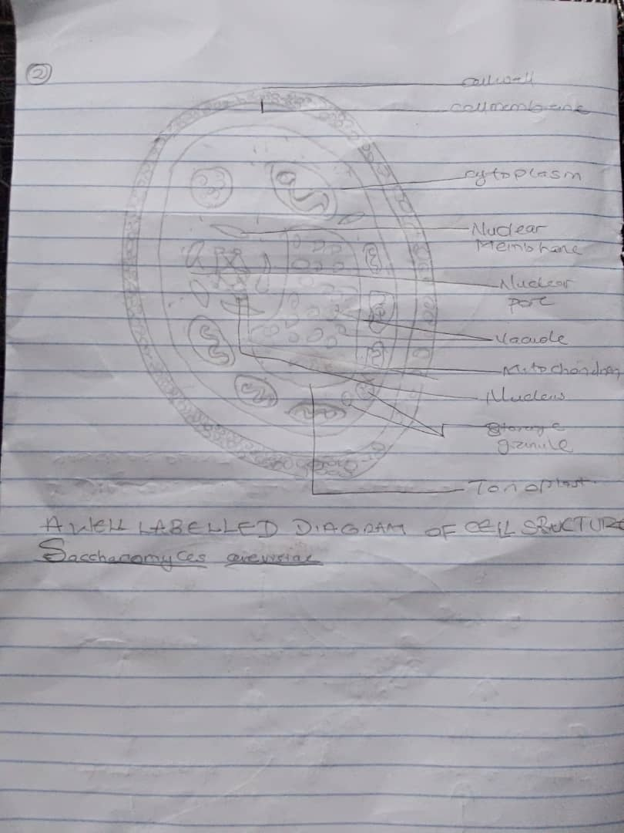

- Outline the sexual reproduction in a typical filamentous form of fungi?
Answer: sexual reproduction in a filamentous fungi like Penicillium, a filamentous, conidia-producing form.
The hyphae are septate and the conidia are produced on vertical conidiophores with characteristic branching patterns. Apart from the species that produces antibiotics, other species of penicillium cause considerable damage to ripening fruits while other species are used in food processing. Sexual reproduction is rare in Aspergillus and penicillium, though it occurs. Plasmogamy and karyogamy are involved.
These processes lead to meiosis and production of spores (ascospores), special structures (asci; sing:ascus) which are in turn contained in a fruiting body which may be completely closed (cleistothecium) as in the red bread-mould (Neurospora crassa) or disc-shaped (apothecium) as in peziza sp. The haploid phase (mycelia phase) is the dominant generation in both Aspergillius and Penicillium.
- How do Bryophythes adapt to their environment (Land)
- They have definite structures for water and nutrition absorption from the soil; therefore the plant body is divided into two (an aerial portion and a subterranean portion). The subterranean portion is the rhizoid and is not a true root as the case of land plants that are advanced
- The aerial portion being exposed to the atmosphere demands some modifications that prevents excessive loss of water through the body surface
- Describe with illustration the following terminologies
- Eusteles: (singular eustele) it is a type of siphonostele, in which the vascular tissue in the stem forms a central ring of bundles around a pitch. There are other kinds of vascular organization encountered in the flowering plants. In herbaceous dicotyledonous plants -EUSTELES in which the vascular bundles are discrete, concentric collateral bundles of xylem and phloem.
- Atactostele: it is a type of eustele, found in grasses and many monocotyledonous plants i.e the vascular bundles are scattered.
- Siphonostele: it is a type of vascular system consisting of a ring of vascular bundles surrounding a central pitch.
- Dictyostele: (plural dictyosteles) it is a type of spihonostele,in which the vascular tissue in the stem forms a central cylinder around a pitch, but with closely leaf gaps. Vascular supply to leaves is associated with leaf gaps and the conducting cylinder is a dissected one- dictyostele

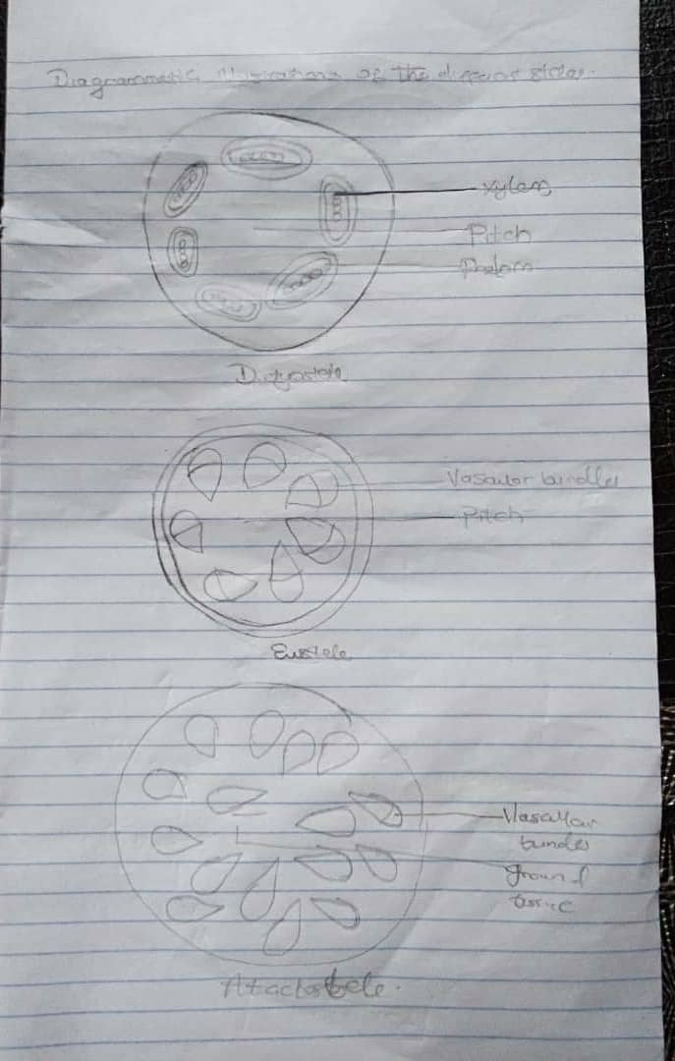

Question 6
