NZEGWU RALUCHUKWU CHINWE FREDA
MHS
DENTISTRY
19/MHS09/016
BIO 102

QUESTION 1: How are fungi important to mankind?
ANS:
- Fungi can be used as a biological insecticide.
- Fungi can serve as food, e.g shiitake mushroom, chanterelles, morels, etc.
- Fungi can be used in the field of medicine as they naturally produce antibiotics to kill or inhibit growth of bacteria.
QUESTION 2 : Illustrate the cell structure of a unicellular fungus with a well labeled diagram.
ANS:

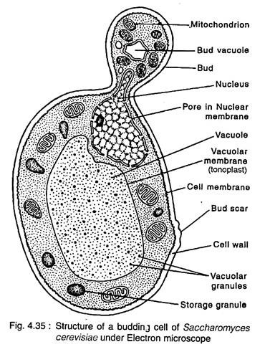
Cell structure of a yeast.

QUESTION 3 : Outline the sexual reproduction in a typical filamentous form of fungi.
ANS:
- Plasmogamy
- Karyogamy
- Meiosis

QUESTION 4: How do Bryophytes adapt to their environment?
ANS: The bryophytes possess a waxy cuticle which protects the plant tissues from drying out and the gametangia provided for protection against drying ou especially for the plant gametes.

QUESTION 5: Describe with illustration the following terminologies: a) eusteles b) atactostele c) siphonostele d) dictyostele.
ANS:
- Eustele: a stele typical of dicotyledonous plants that consists of vascular bundles of xylem and phloem strands with parenchymal cells between the bundles.
- Atactostele: a type of eustele found in monocots, in which the vascular bundles in the stem exists as scattered bundles.
- Siphonostele: It’s a stele in which the vascular tissue is in the form of a cylinder surrounding the pith, as in the stems of most ferns and other seedless vascular plsants.
- Dictyostele: a type of siphonostele, in which the vascular tissue in the system forms a central cylinder around pith, but with closely spaced leaf gaps.

QUESTION 6: illustrate the life cycle of a primitive vascular plant.
ANS:
PSILOTUM

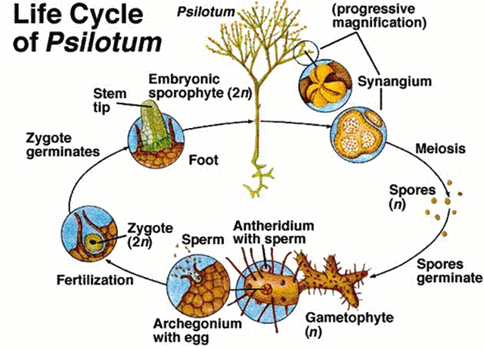

The life cycle is dominated by the sporophyte stage of alternation of generations. The spores of the plant are catapulted into the air, the spores develop into heart shaped haploid gametophytes that contain both male and female sex organs. As the young mature, the sex organs become more active. The male reproductive organ is the antheridium, which produces and releases the sperm. The female reproductive organ, which is archegonium, at the base of which lies the egg. The reproduction requires water for the sperms to swim to the archegonium and fertilize the egg. The zygote grows through a process of mitosis, producing roots and stems, and a new sporophyte. Embryonic sporophtes are initially tightly curled structures called fiddleheads that unfurl as they grow into fronds. The mature fronds is the sporophyte, which contains multiple sporangia. Spores form by meiosis and are released inti the air and the life cycle continues.

