EKERUCHE CHINWE BRIDGET
15/ENG02/020
COMPUTER ENGINEERING
DIGITAL DESIGN USING VHDL
COE 506

PROGRAMMABLE LOGIC DEVICE ARCHITECTURES
programmable logic device (PLD) is an electronic component used to build reconfigurable digital circuits. Unlike integrated circuits (IC) which consist of logic gates and have a fixed function, a PLD has an undefined function at the time of manufacture.^{[1]} Before the PLD can be used in a circuit it must be programmed (reconfigured) by using a specialized program

DIGITAL SYSTEM DEVICES

DIGITAL SYSTEM FAMILY TREE:

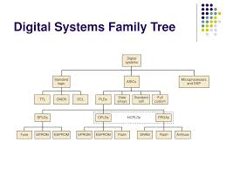

The major digital systems include standard logic , application-specific integrated circuits (ASICs) and microprocessor/digital signal processing (DSP) devices .
first category of standard logic devices refers to the basic functional digital components (gates. Flip flops , decoders, mutltiplexers , registers , counters ,etc) that are available as SSI amd MSI chips .
second category the microprocessor/digital signal processing ( DSP) is a much different approach to digital systems design . these devices actually contain the various types of functional blocks. A great deal of flexibility can be achieved with this particular type of system because all you have to do is change the program.
The third major digital systems category is called application –specific integrated circuits (ASICs). It represents the modern hardware design solution for digital systems .

FUNDAMENTALS OF PLD CIRCUITRY
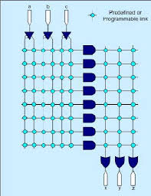
A simple PLD device

Each of the OR gates can produce an output that is a function of the input variables . Each output function is programmed with the fuses located between the AND or OR gates. Each of the inputs feed a noninverting buffer and inverting buffer to produce the true and inverted forms of each variable . these are the input linrs to AND gatr array . Each AND gate is connected to two different input lines to generate a unique product of the input variables . the AND outputs are called the product lines .

PROGRAMMABLE ARRAY LOGIC
Programmable Array Logic (PAL) is a family of programmable logic device semiconductors used to implement logic functions in digital circuits
PAL devices consisted of a small PROM (programmable read-only memory) core and additional output logic used to implement particular desired logic functions with few components. Using specialized machines, PAL devices were "field-programmable". PALs were available in several variants :"One-time programmable" (OTP) devices could not be updated and reused after initial programming (MMI also offered a similar family called HAL, or "hard array logic", which were like PAL devices except that they were mask-programmed at the factory.)
