IVWIGHREN OGHENEOGA
15/ENG02/031
COE 506

DIGITALS SYSTEMS
A digital system is a system that stores data in a discrete way. Usually they store this information in binary form (i.e.) every bit of information cant not have a value other than zero(off) or one (on). A digital system can either be simple or complex. The different categories of a digital system can be described using the digital system tree which is shown in figure 1.
The major categories include; Standard logic, Microprocessor/Digital signal processing, Application-specific integrated circuits.
- Standard logic: the first category of standard logic devices refers to the basic functional and digital components ie gates decoders, registers etc. thes devices have been used over time to design complex digital systems. They are three major families of standard logic devices; TTL, CMOS and ECL.
- Microprocessor/digital signal processing (DSP): This category has a more different approach as the devices actually contain various types of functional blocks. Using DSP devices can be controlled electronically and data can be manipulated by executing a program of instructions that has been written by the application
- Application-Specific Integrated Circuits(ASICs) : This category represents the modern hardware design solution for digital systems. In this category, an integrated circuit They’re four subcategories in this category and they include; Programmable logic device, Gate arrays, Standard cells and full-custom.
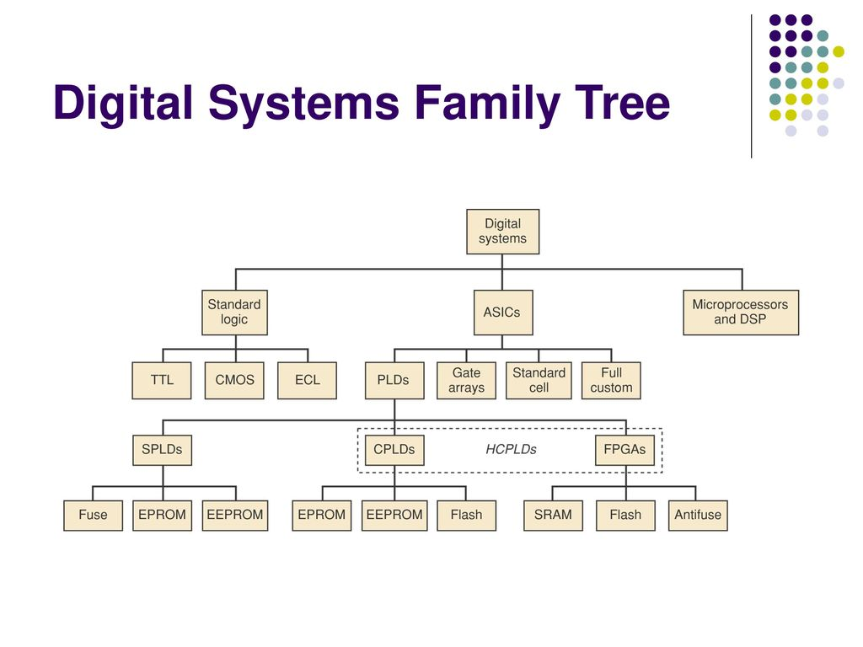FIGURE 1
PROGRAMMABLE LOGIC DEVICE
A programmable logic device is an electronic component used to build reconfigurable digital circuits. Unlike integrated circuits which consists of logic gates, and have a fixed function, a PLD has an undefined function at the time of manufacture. PLDs have been in use for more than thirty years but they have advanced over the years. PLDs can be described as being one of three types; Simple programmable logic devices (SPLDs), Complex programmable logic device (CPLDs), Field programmable gate arrays (FPGAs)
SPLDs AND CPLDs: The SPLDs is simply a programmable logic device with complexity below that of a complex programmable logic device CPLDs. SPLDs are available only in small sizes, equivalent to a few hundred logic gates. For bigger logic circuits, CPLDs can be used. one integrated circuit. CPLDs can replace thousands, or even hundreds of thousands, of logic gates. CPLDs are programmed using a PAL programmer, but this method becomes inconvenient for devices with hundreds of pins
Field Programmable Gate Array (FPGAs): FPGAs use a grid of logic gates, and once stored, the data doesn't change, similar to that of an ordinary gate array. The term "field-programmable" means the device is programmed by the customer, not the manufacturer. FPGAs are usually programmed after being soldered down to the circuit board, in a manner similar to that of larger CPLDs. In most larger FPGAs, the configuration is volatile and must be re-loaded into the device whenever power is applied or different functionality is required.
Main Difference Between CPLDs And FPGAs: The difference between FPGAs and CPLDs is that FPGAs are internally based on look-up tables (LUTs) whereas CPLDs form the logic functions with sea-of-gates (e.g. sum of products). CPLDs are meant for simpler designs while FPGAs are meant for more complex designs. In general, CPLDs are a good choice for wide combinational logic applications, whereas FPGAs are more suitable for large state machines such as microprocessors.
PLD Circuitry and Architecture
The architecture of the PLDs varies a lot due to several manufacturers having different families of PLD devices. The differentiation of these different types is always a little fuzzy but together they are often referred to as High-capacity programmable logic devices (HCPLDs). The HCPLDs is usually preferable to use as it has more gates available. Figure 2 shows the PLD circuitry.
The PROM (Programmable Read Only Memory): This has a fixed AND array (constructed as a decoder) and programmable connections for the output OR gates array. The PROM implements Boolean functions in sum-of-midterms form.
The PLA (Programmable Logic Array): This has programmable connections for both AND and OR arrays. So it is the most flexible type of PLD. The PLA (Programmable Logic Array): In PLAs, instead of using a decoder as in PROMs, a number (k) of AND gates is used where k < 2n (n is the number of inputs).
Generic Array Logic (GAL) and PAL: This device was an innovation of the PAL and was invented by Lattice Semiconductor. The GAL was an improvement on the PAL because one device type was able to take the place of many PAL device types or could even have functionality not covered by the original range of PAL devices. Its primary benefit, however, was that it was eraseable and re-programmable, making prototyping and design changes easier for engineers. A similar device called a PEEL (programmable electrically erasable logic) was introduced by the International CMOS Technology (ICT) Corporation.
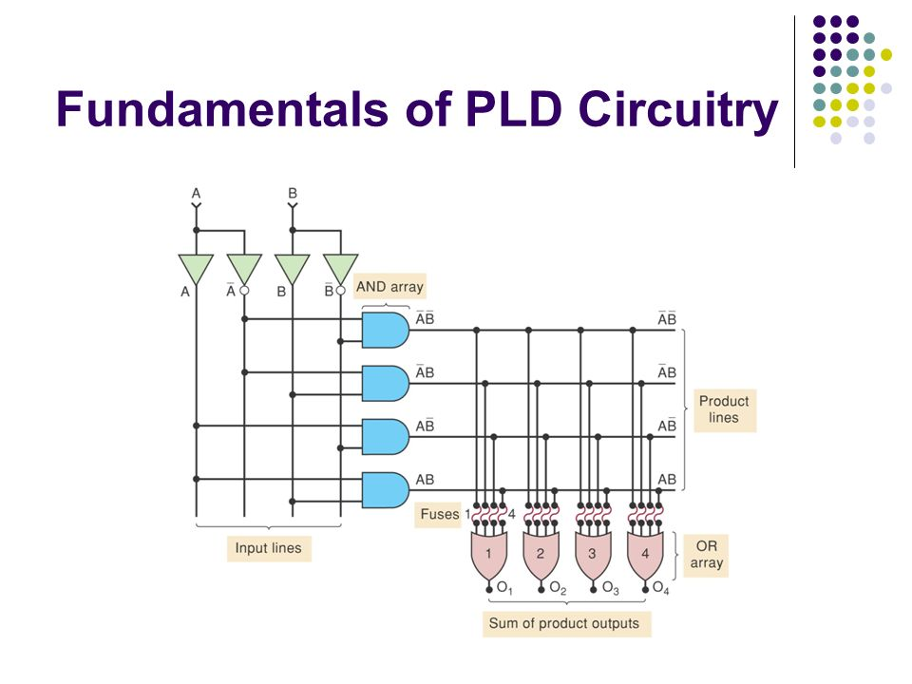
Figure 2.

