NAME: OTIOTIO EDWIN DUABONOA
COURSE CODE: BIO 101
COLLEGE: MEDICAL AND HEALTH SCIENCES
DEPARTMENT: DENTISTRY
MATRIC NO: 19/MHS 09/ 021

GENERAL BIOLOGY II)

- HOW ARE FUNGI IMPORTANT TO MANKIND?
Fungi are very important to the entire terrestrial ecosystem and to man
- They are responsible for the mediation of decay of organic matter. Without fungi and other microbes, the surface of the earth would have been clogged up with dead matters with all the various elements locked up in them instead of returning to various cycles.

ii) Fungi are important to the food industry for example yeast (saccharomyces cerevisae) is used in the preparation of bread.
iii) Fungi is used in medicine as a source of anti-biotic drugs e.g penicillium notatum.

2. illustrate the cell structure of a unicellular fungus with a well labelled diagram 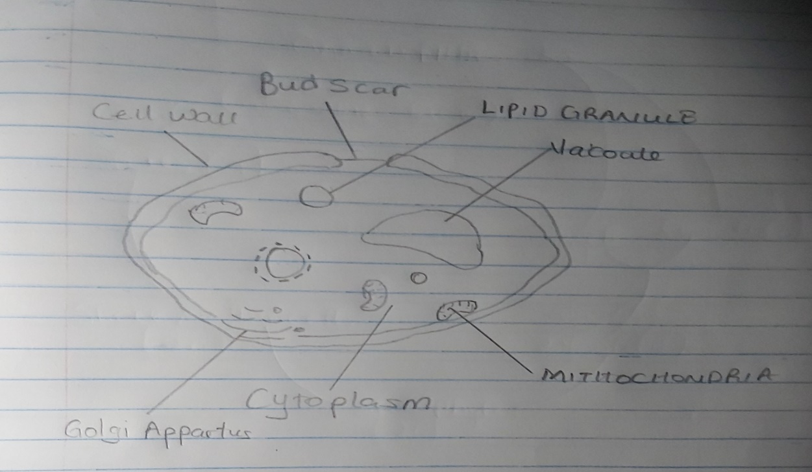

DIAGRAM OF YEAST CELL ( A UNICELLULAR FUNGUS)SS

3). OUTLINE THE SEXUAL REPRODUCTION IN A TYPICAL FILAMENTOUS FORM OF FUNGI
RHIZOPUS STOLONIFER
VEGETATIVE REPRODUCTION: This is achieved by the liberation of spores from the sporangium. The spores are numerous and light thus are easily dispersed by air. The spores readily germinates to produce a new mycelium on landing on a moist and favorable substrate.
SEXUAL REPRODUCTION: this occurs when two mating types of hyphae grow in one medium. Chemical interaction in the two mating types of hypae induces growth perpendicular in the hyphae in opposite directions. These growths are delimited by a wall such that many nuclei are isolated in what is called a gametangium.
The two gametangia fuse and a zygote is formed which may undergo prolonged dormancy or resting stage. The nuclei in the zygotes fuse in twos and undergoes meiosis independently.

4.) HOW DO BRYOPHYTES ADAPT TO THEIR ENVIRONMENT
I). They have definitive structure for water and nutrient absorption from the soil. The plant body is divided into two aerial and subterranean portions
ii) The aerial portion being exposed to the atmosphere demands some modification that prevents excess loss of water.
III. Some other modifications that permit elimination of excess water from the plant body and not only exchange of gasses between the integral parts of the plants and the atmosphere therefore openings are available on the aerial part of the plant
5) I.Eusteles: This are vascular bundles that are discrete concentric bundles of xylem and phloem.
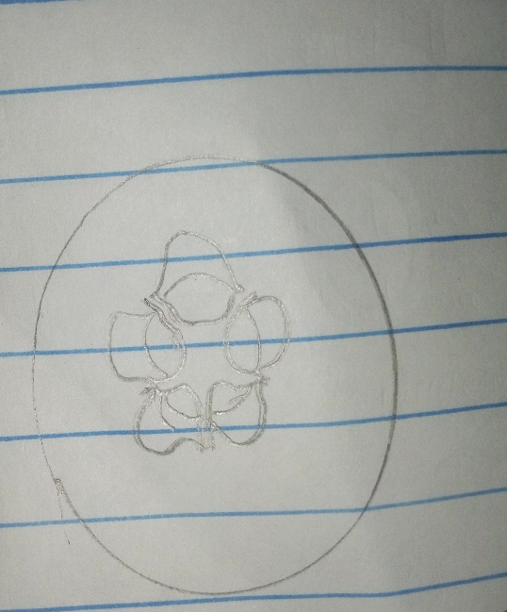
DIAGRAM OF A EUSTICLE

- Atactostele: This is a variant of a eustele found in monocots in which the vascular bundles are scattered

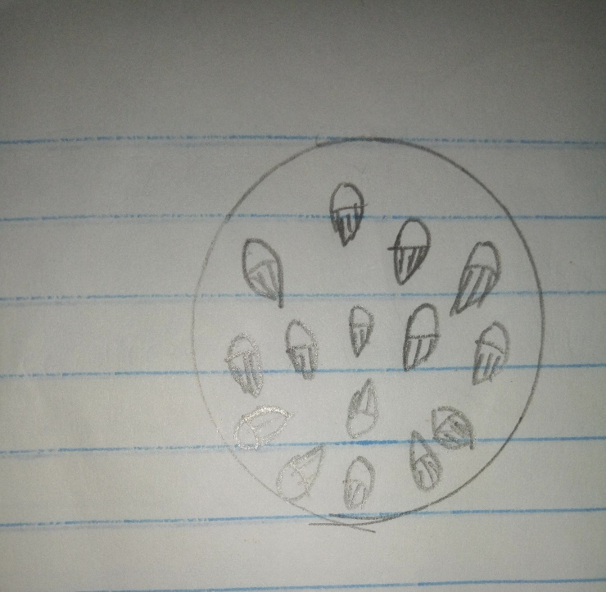

- Siphonostele: This a type of stele in which the vascular tissue in the stem forms a cylinder surrounding a central pith and possessing leaf gaps.
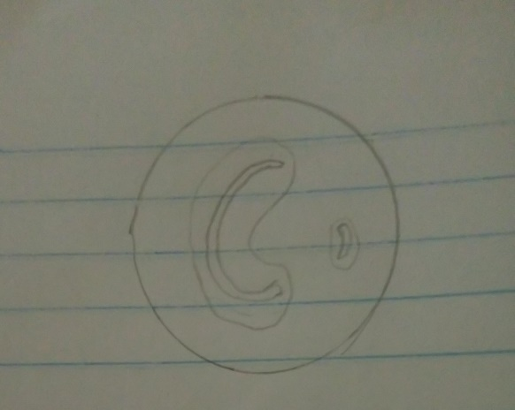
- Dictyostele: This is a type of siphonostele, in which the vascular tissue in the stem forms a cylinder around a pith, but with closely spaced leafs.

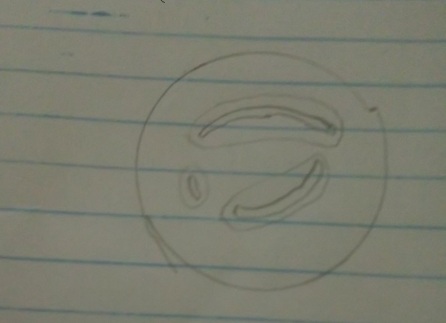
DIAGRAM OF A DICTYOSTELE

6) ILLUSTRATE THE LIFE CYCLE OF A PRIMITIVE VASCULAR
PLANT
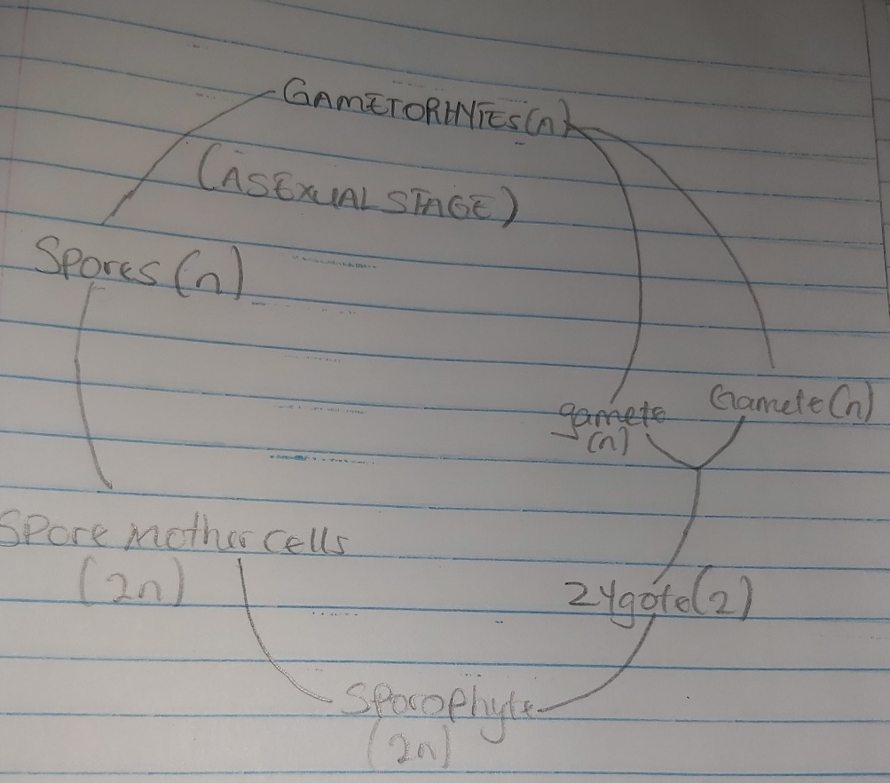

DIAGRAM OF THE LIFECYCLE OF FERN ( A PRIMITIVE VASCULAR PLANT)

