Name: Adeleye Adebisi Moyinoluwa
Matric number: 19/MHS01/031
Department: Medicine and Surgery
College: Medicine and Health Sciences
Bio 102 assignment
1i) Fungi could serve as food for man e.g mushroom
ii) A type of fungi, yeast is used to bake
iii) Some fungi are parasites to some pests e.g houseflies, grasshoppers, therefore they serve as control agents in regard to such pests
iv) Some fungi species such as penicilium notanum produce important antibiotics
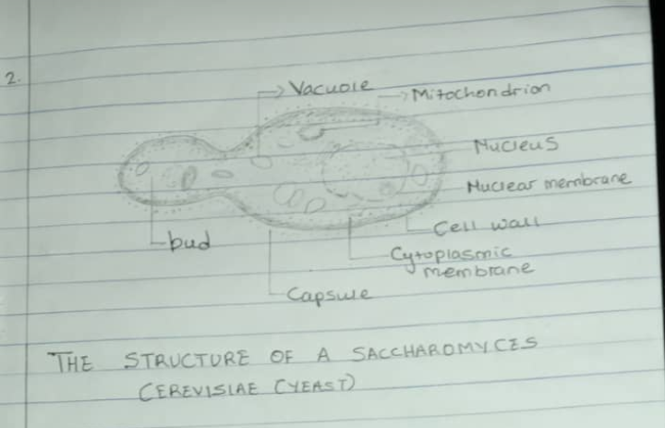
v) Fungi keeps in fermentation of some grains to produce veer and some fruits to produce wine
2)

3. Sexual reproduction hyphae stolonifer:- This occurs when two mating types of hyphae grow in the same medium. Chemical reproduction in the two mating types of hyphae induces perpendicular to the hyphae in opposite directions. These growths are delimited by a wall such that many nuclei are isolated in a gametangium. The two gametangia fuse by plasmogany and a zygote is formed which may undergo prolonged dormancy or resting stage. The nuclei in the zygote fuse in twos and undergo meiosis independently. The zygote germinated under favorable conditions to produce a fruit which at maturity liberates the haploid spores.
4. Bryophytes have definite structures for water and nutrients absorption from the soil therefore the plant body is divided into two Aeriel portion and a subterranean portion . The subterranean portion is the rhizoid and is not a true root as the case of land plants that are advanced. The Aeriel portion been exposed to the atmosphere demands some modification that prevent excessive ions of water through the body surface. Another modification that permits elimination of excess water from the plant body and not only exchange of gases between the internal parts of the plant and the atmosphere therefore openings are available on the serial parts of the plant.
5.a) Eusteles: in herbaceous dicotyledonous plants, eusteles in which the vascular bundles are discrete, concentric, collateral bundles of xylem and phloem.
b) Atactostele: in grasses and many monocotyledonous plants, atactostele, the vascular bundles are scattered.
c) Siphonostele: in more advanced vascular systems e.g stems of ferns and higher vascular plants the stele is a cylinder enclosing a parenchymtous pith
d) Dictyostele: in siphonostele, vascular supply to leaves is associated with leaf gaps and the conducting cylinder is a dissected one which makes it a dictyostele.
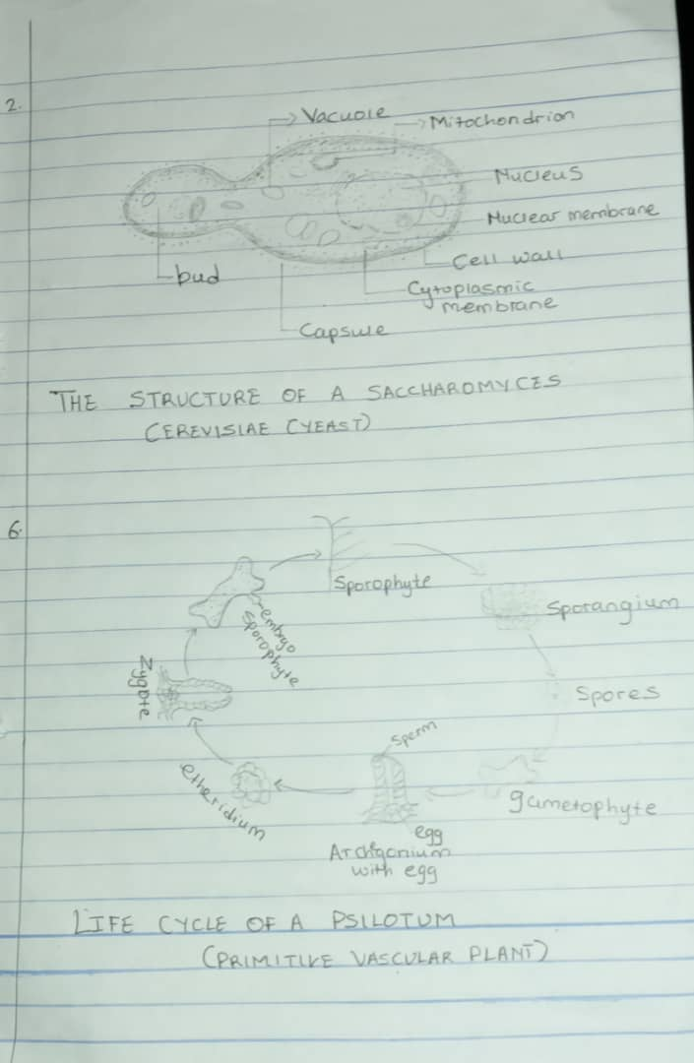
6.

