Name: Olatunji Imoleayo Oluwaseyifunmi
Matric Number:: 19/MHS01/333
Department: Medicine and Surgery
College: Medicine and Health Sciences
- (I) Fungi are responsible for the mediation of decay of organic matter.
(II) They serve as agents of fermentation in the production of beverages
(III) They serve as a form of nutrition through mushrooms
(IV) Yeast can be used to bake
(V) Some species serve as a form of antibiotics e.g penicillium notatum
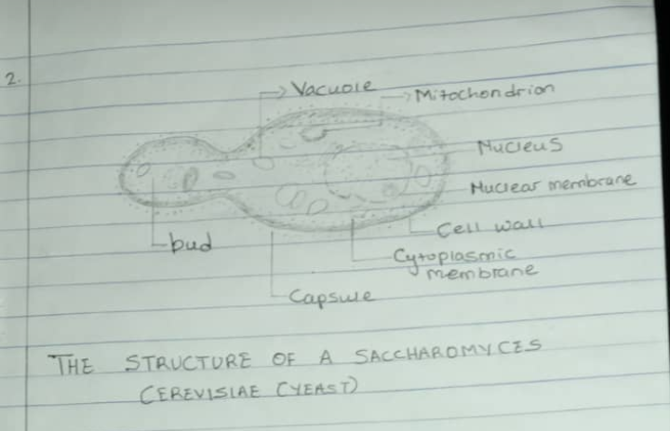
2.

3. Sexual reproduction in a filamentous form of algae- Hyphae stolonifer: This occurs when two mating types of hyphae grows in the same medium. Chemical interactions in the two mating types of hyphae induces perpendicular to the hyphae in opposite directions. These growths are delimited by a wall such that, many nuclei are isolated in a gametangium. The two gametangia fuse by and a zygote is formed which may undergo prolonged dormancy or resting stage. The nuclei in the zygote fuse in twos and undergo meiosis independently. The zygote germinates under favourable conditions a fruit which at maturity liberates the haploid spores.
4. Bryophytes have definite structures for water and nutrients absorption from the soil therefore the plant body is divided into two, the aeriel portion and a subterranean portion.
The subterranean portion is the rhizoid and is not a true root as the case of land plants that are advanced. The aeriel portion being exposed to the atmosphere demands some modifications that prevents excessive ions of water through the body surface.
5. (a) Eusteles: In herbaceous dicotyledonous plants, eusteles which the vascular bundles are discrete, concentric, collateral bundles of xylem and phloem.
(b) Atactostele: In grasses an many monocotyledonous plants, atactostele- the vascular bundles are scattered
(c) Siphonostele: In more advanced vascular systems the stele is a cylinder enclosing a parenchymtous pith.
(d) Dictyostele: In siphonostele, vascular supply to leaves is associated with leaf gaps and the conduction cylinder is a dissected one which makes it a dictyostele.

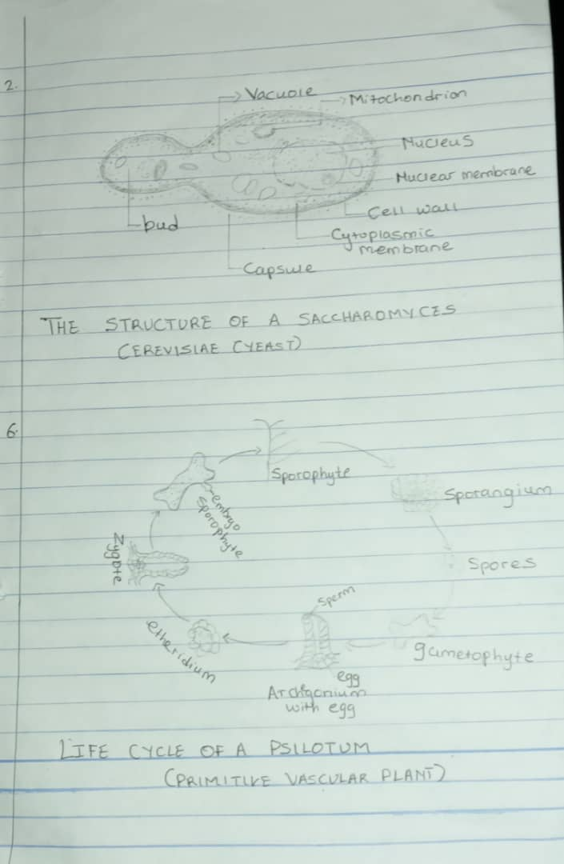
6.

