NAMES: IWUOHA AKWAUGO FAVOUR
MATRIC NUMBER: 19/MHS11/075
COURSE CODE:. BIO 102
DEPARTMENT: PHARMACY
ASSIGNMENT
- Importance of Fungi to mankind are;
i. Fungi are responsible for the mediation of decay of organic matter.
ii. Important in food industry e.g yeast is used in bakeries for bread and other pastries.
iii. Mediates the spoilage of wood, food, clothes and paper.
iv. Used to produce important antibiotics.
2. CELL STRUCTURE OF A UNICELLULAR FUNGUS
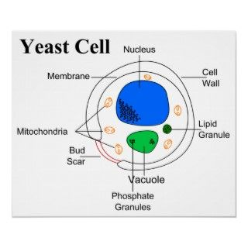
- Sexual reproduction in a typical filamentous fungi; Rhizopus stolonifer undergoes the following steps;
- First, two mating types of hyphae grow in the same medium.
- A chemical interaction between them causes growth perpendicular to the hyphae in opposite directions, so they can meet with one another.
- These growths are the delimited by a wall such that many nuclei are isolated in sex organs called gametangium.
- The two gametangia fuse in a process called plasmogamy and together they form a zygote which may undergo prolonged dormancy.
- The nuclei in the zygote fuse in twos and undergo meiosis independently, the zygote germinates under favourable conditions to produce a fruiting which at maturity liberates haploid spores.
In summary, sexual reproduction in fungi consists of three stages; plasmogamy, karogamy and meiosis.
- How bryophytes adapt to their environment;
- They have definite structures for water and nutrient absorption from soil.
- They possess an aerial portion that prevents excessive loss of water through the body surface.
- They have openings on the aerial parts of the plants that permit elimination of excess water from the plant body.
- They possess gametangia that keep the plants gametes from drying.
Description;
- 1. Eusteles: A type of stele in which the vascular tissue in the stem forms a central ring of bundles around a pith. The vascular bundles are discrete, found in herbaceous dicotyledonous plants.
2. Atactostele: A type of stele found in monocots, in which the vascular tissue in the stem exists as scattered bundles.
3. Siphonostele: This stele is a cylinder enclosing a parenchymatous pith.
4. Dictyostele: A type of stele in which the vascular supply to leaves is associated with leaf gaps and the conducting cylinder is dissected.
Diagrammatic illustrations of the different steles.
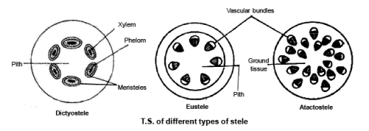

6. Life cycle of a primitive vascular plant (psilotum)

