Eberechukwu chima-dim. 19/mhs01/127. Mbbs
1a. Fungi are responsible for the mediation of decay of organic matter
1b. Fungi cause the spoilage of wood ,food, clothes and paper
1c.some fungi species are used as important biological control agent to pests like houseflies, grasshoppers e.t.c
1d. Fungi are plant pathogens causing blights and smuts in cereals.
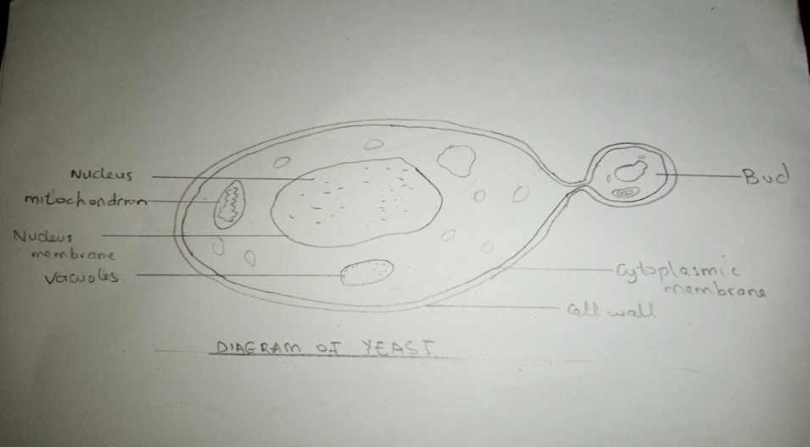
1e. Fungi are important in food industry and some can be eaten
.2.

3a. Sexual reproduction occurs when the two mating types of hyphae grow in the same medium. Then, chemical interaction in the two mating types of hyphae induces growths perpendicular to the hyphae in opposite directions. These growth are delimited by a wall such that many nuclei are isolated in what is called a gametangium. The two gametangia fuse and a zygote is formed which may undergo prolonged resting stage. The nuclei in the zygotes fuse in twos and undergo meiosis independently. The zygote germinates under favorable conditions.
4a.They have definite structure for water and nutrients absorption from the soil
b. The aerial portion has a modification that prevents excessive water loss through the body surface
c. They are are openings on the aerial parts of the plant that allows the exchange of gasses between the internal parts of the plant and the atmosphere.
d. There are also modification that permit elimination of excess water from of plant body
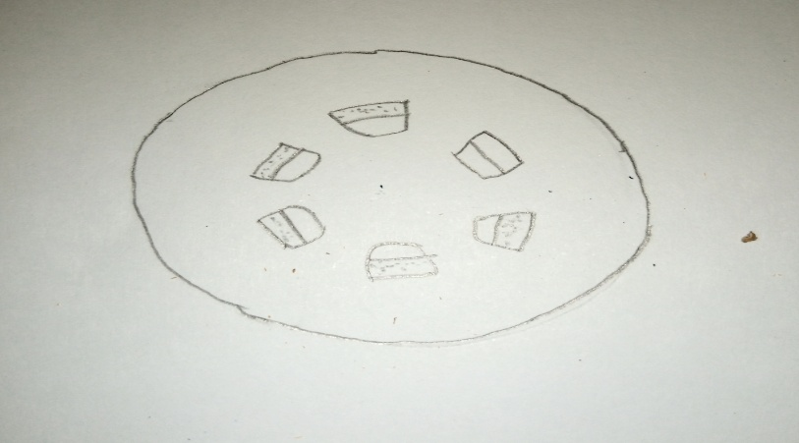
5a. Eusteles: They are found in herbaceous dicotyledonous plants in which the vascular bundles are discrete, concentric, collateral bundles of xylem and phloem.
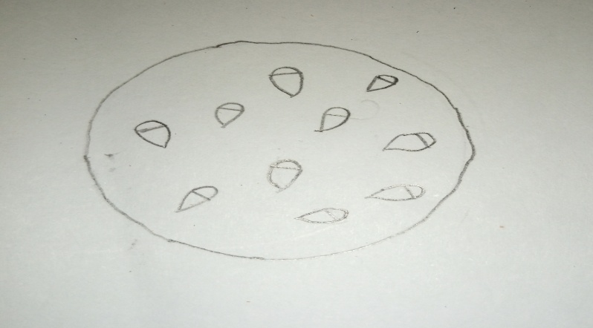
b. Atactostele: They are found in grasses and many monocotyledon plants in which the vascular bundles are scattered.
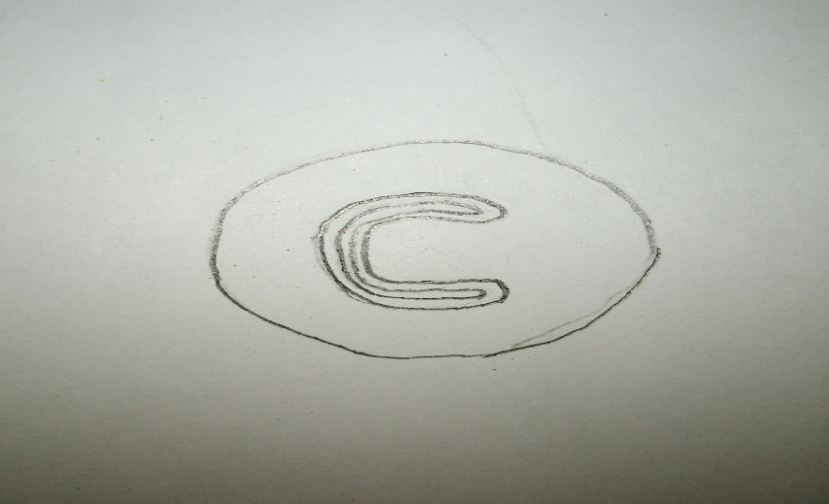
c. Siphonostele: They are found in more advanced vascular system e.g stems of ferns and higher vascular plants in which stele is a cylinder enclosing a parenchymatous pith.
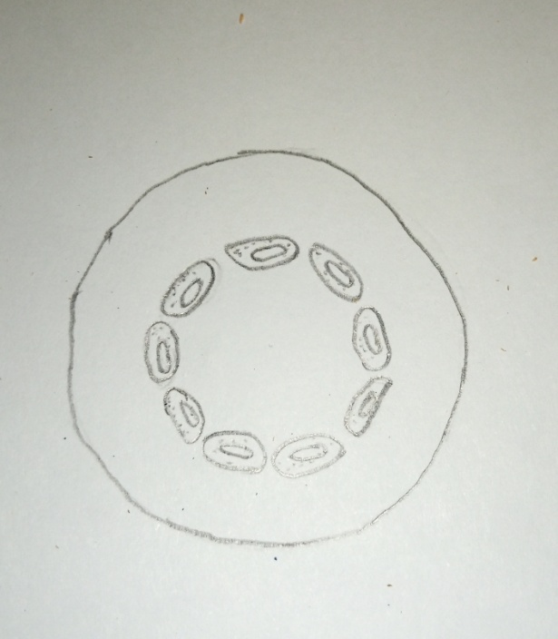
d. Dictyostele: The vascular supply to leaves associated with leaf gaps and conducting cylinder is a dissected
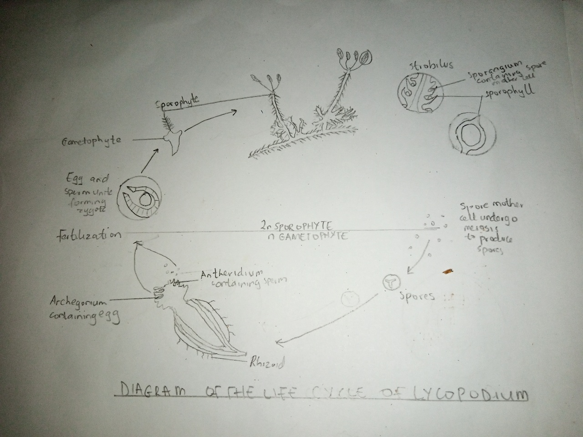
6.

