AJISE TENIOLA PRECIOUS
19/MHS01/069
MBBS
BIO 102 ASSIGNMENT
- IMPORTANCE OF FUNGI TO MANKIND
i. fungi is responsible for the mediation of the decay of dead organic matter.
ii.fungi is used as agents of fermentation in the production of bread, cheeses, alcoholic beverage and numerous other food preparation.
iii. mushrooms are eaten by human societies.
iv. fungi species pencillium notatum produce important antibiotics.
v. some fungi are parasites to obnoxious pests.
2. CELL STRUCURE OF A UNICELLULAR FUNGUS
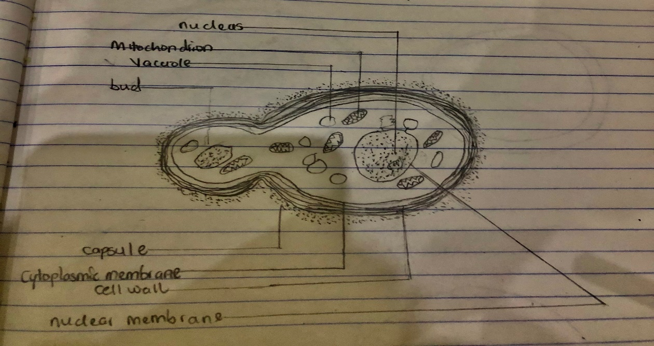
3. SEXUAL REPRODUCTION IN A TYPICAL FILAMENTOUS FORM OF FUNGI
Two mating type of hyphae grow in the same medium. A chemical interaction between them causes growth perpendicular to the hyphae in opposite directions, so they can meet with one another. The growths are the delimited by a wall just so that the nuclei are isolated in differentiated sex organs called a gametangium. The two gametangia fuse in a process called plasmogamy and together they form a zygote which may undergo dormancy for a period. The nuclei in the zygote fuse in twos and undergo meiosis independently, it then moves on to germinating under favorable conditions so as to liberate haploid spores at maturity through the production of a fruiting.
4.HOW BRYOPHYTES ADAPT TO THEIR ENVIRONMENT
i. they possess definite structure for water and nutrient absorption from the soil.
ii. they also possess a waxy cuticle that keeps them from drying out through the process of desiccation.
iii. they possess gametangia that keeps the plants gametes from drying out.
5. DESCRIBE WITH FOLLOWING ILLUSTRATION THE FOLLOWING TERMINOLOGIES
a. Eusteles: a stele in which the vascular tissue in the stem forms a central ring of bundles around a pith. The vascular bundles are discrete, concentric collateral bundles of xylem and phloem.
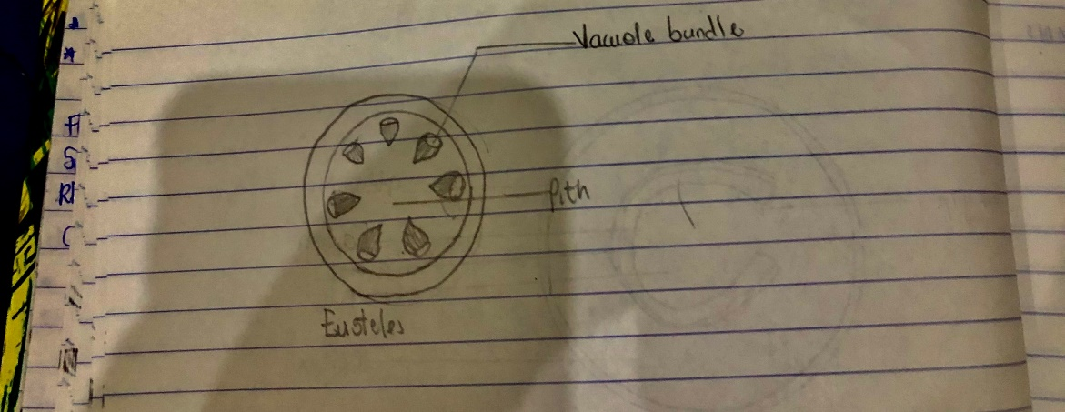
B. Atactostele: a type of stele found in monocots, in which the vascular tissue in the stem exists as scattered bundles. 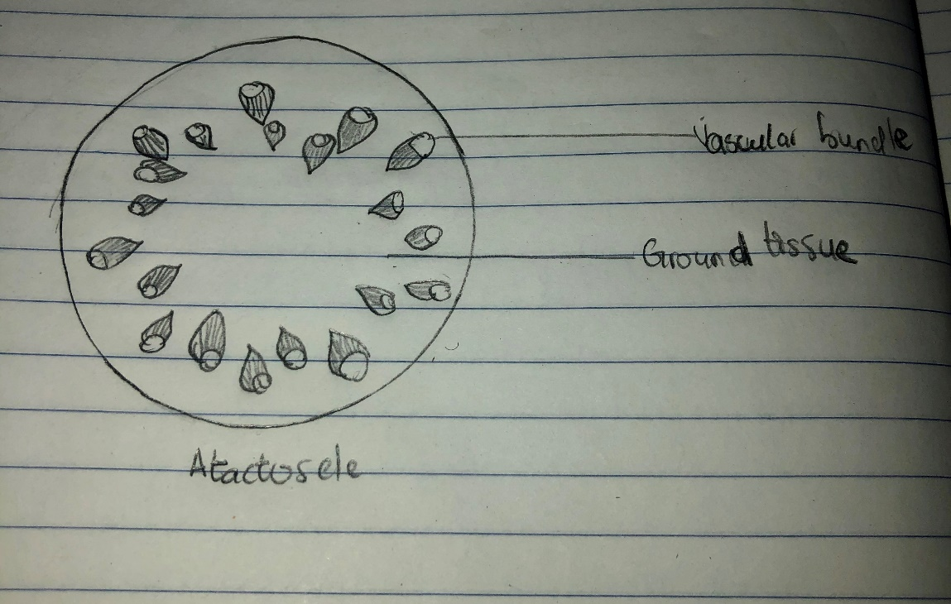
C. Siphonostele: a stele consisting of a core of pith surrounded by concentric layers of xylem and phloem.
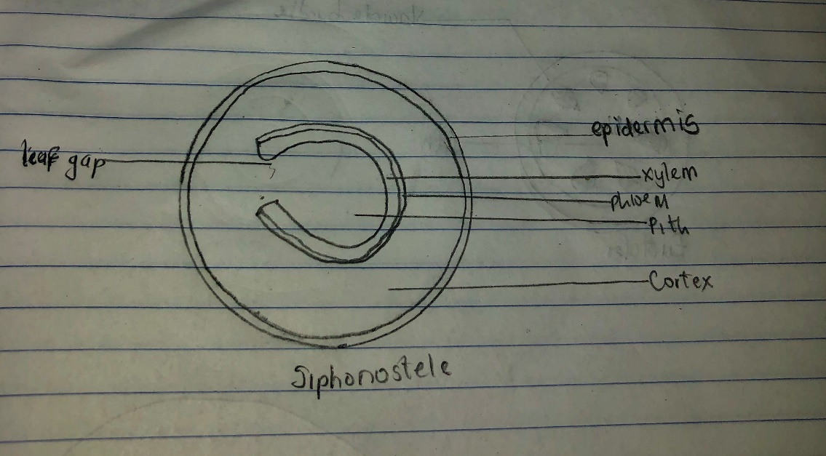

D. Dictyostele: a type of stele in which the vascular cylinder is broken up into a longitudinal series or network of vascular strands around a pith.
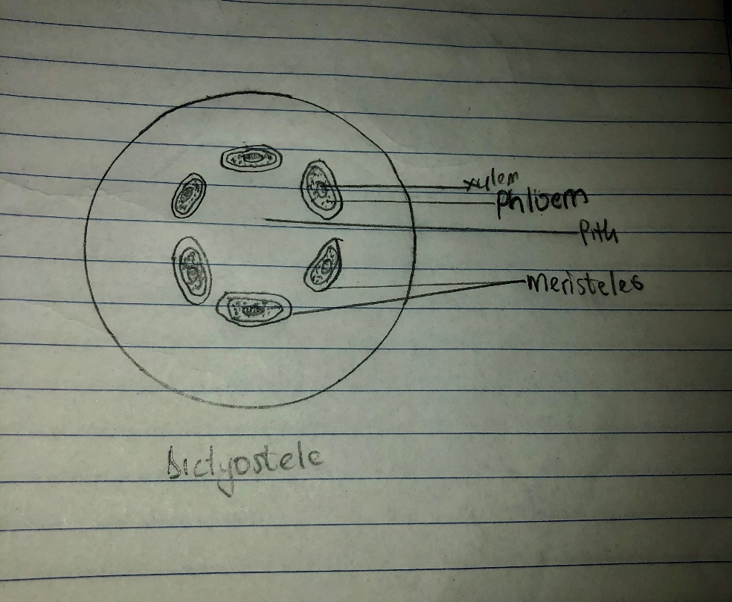
6. LIFE CYCLE OF A PRIMITIVE VASCULAR PLANT(PSILOTUM) 