- Importance of fungi to mankind includes
The majority of grasses and trees require a mycorrhizal relationship with fungi to survive.
Yeasts have been used for thousands of years in the production of beer, wine, and bread.
Fungi not only directly produce substances that humans use as medicine, but they are also versatile tools in the vast field of medical research.
Some fungi attack insects and, therefore, can be used as natural pesticides.

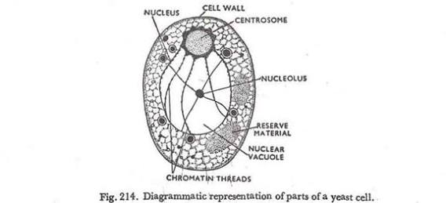
2

- Sexual reproduction in the fungi consists of three sequential stages: plasmogamy, karyogamy, and meiosis. The diploid chromosomes are pulled apart into two daughter cells, each containing a single set of chromosomes (a haploid state).Plasmogamy, the fusion of two protoplasts (the contents of the two cells), brings together two compatible haploid nuclei. At this point, two nuclear types are present in the same cell, but the nuclei have not yet fused. Karyogamy results in the fusion of these haploid nuclei and the formation of a diploid nucleus (i.e., a nucleus containing two sets of chromosomes, one from each parent). The cell formed by karyogamy is called the zygote. In most fungi the zygote is the only cell in the entire life cycle that is diploid.

- Two adaptations made the move from water to land possible forBryophytes: a waxy cuticle and gametangia. The waxy cuticle helped to protect the plants tissue from drying out and thegametangia provided further protection against drying out specifically for the plants gametes.

- I) Eusteles; A type of siphonostele, in which the vascular tissue in the stem forms a central ring of bundles around a pith.

ii) Atactostele; A type of eustele, found in monocots, in which the vascular tissue in the stem exists as scattered bundles.

iii) Siphonostele; a stele consisting of a core of pith surrounded by concentric layers of xylem and phloem.

iv) Dictyostele; a stele in which the vascular cylinder is broken up into a longitudinal series or network of vascular strands around a central pith (as in many ferns)

- The life cycle of seedless vascular plants is an alternation of generations, where the diploid sporophyte alternates with the haploid gametophyte phase. The diploid sporophyte is the dominant phase of the life cycle, while the gametophyte is an inconspicuous, but still-independent, organism.

