OLAWUYI AANUOLUWAPO CHRISTIANAH
19/MHS01/334 BIO 102 ASSIGNMENT (FUNGI)

- Importance Of Fungi To Man

- Harmless fungi can be used to control pathogenic bacteria and insect pests on crops. Fungi compete with bacteria for nutrients and space, and they parasitize insects that eat plants. Fungi reduce the need for pesticides and other toxic chemicals.
- They are a major source of citric acid (vitamin C).
- They produce antibiotics such as penicillin, which has saved countless lives.
- They can be genetically engineered to produce insulin and other human hormones.
- They are model research organisms.
- They are responsible for the mediation of the decay of dead organic matter.
- Fungi especially mushrooms are eaten by many human societies.
- Fungi (yeast) is a major product used in breweries and baking industries.
- Skin diseases e.g. ringworm and dermatitis are caused by fungal agents.

- Cell Structure Of A Unicellular Fungus

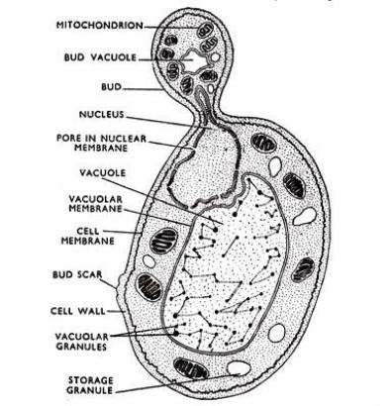
A labelled diagram of saccharomyces cerevisiae (yeast) a
Unicellular Fungi undergoing Budding

- Sexual reproduction in Aspergillus nidulans a filamentous Fungi.

- Aspergillus nidulans (also called Emericella nidulans when referring to its sexual form, or teleomorph) is one of many species of filamentous fungi in the phylum Ascomycota.
Sexual reproduction occurs in two fundamentally different ways. This is by outcrossing (heterothallic sex), in which two distinct individuals contribute nuclei, or by homothallic sex or self-fertilization (selfing) in which both nuclei are derived from the same individual.
- Self fertilization in A. nidulans involves activation of the same mating pathways characteristic of sex in outcrossing species, i.e. self-fertilization does not bypass required pathways for outcrossing sex but instead requires activation of these pathways within a single individual.
- Fusion of haploid nuclei occurs within reproductive structures termed “cleistothecia,” in which the diploid zygote undergoes meiotic divisions to yield haploid ascospores.

- How Bryophytes adapt to their environment.
- They possess definite structures for water and nutrient absorption from the soil.
- They reproduce using spores rather than seeds and don’t produce wood, fruit or flowers. Their life-cycle is dominated by a gametophyte generation which provides support and nutrients for the spore producing growth form known as the sporophyte.
- The aerial portion being exposed to the atmosphere demands some modifications that prevents excessive loss of water through the body surface.
- They also possess a waxy cuticle that keeps them from drying out through the process of desiccation
- Some Bryophyte species have evolved special tissue which allows them to transport water and other substances through their tissue. However, the tissue doesn’t contain lignin, an essential protein found in true vascular tissue. This specialized tissue is therefore not considered to be vascular tissue although it does a respectable job of performing a similar function.
- Bryophytes can grow where vascularized plants cannot because they do not depend on roots for an uptake of nutrients from soil. Bryophytes can survive on rocks and bare soil.
- They possess gametangia that keep the plants gametes from drying out.

5. Describe with illustrations The different kinds of Steles
A. Eusteles; a type of stele in which the vascular tissue in the stem forms a central ring of bundles around a pith. The vascular bundles are discrete, concentric collateral bundles of xylem and phloem.
B. Atactostele; a type of stele found in monocots, in which the vascular tissue in the stem exists as scattered bundles.
C. Dictyostele; a type of stele in which the vascular cylinder is broken up into a longitudinal series or network of vascular strands around a pith.
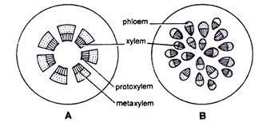
Diagrammatic illustrations of the different steles.
A.
(A—B) Stelar system: A. Eustele, B. Atactostel
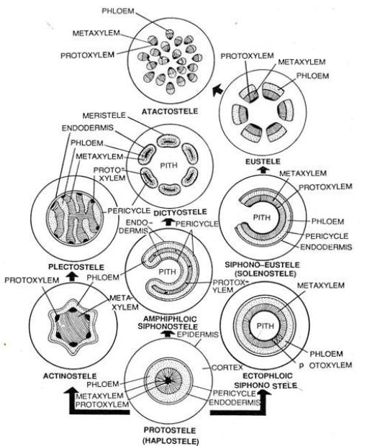
THE Stelar System. Different Types of Steles Arranged in Evolutionary Sequence.
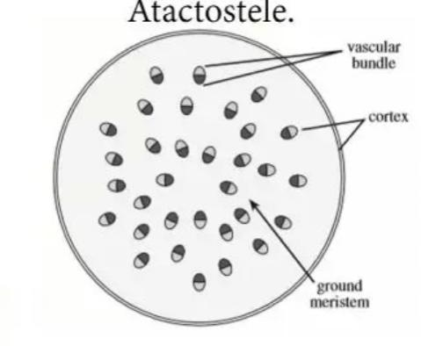
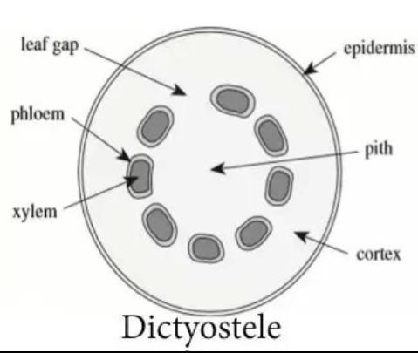
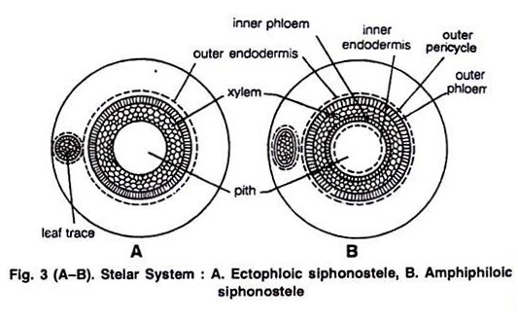

- The Life cycle of Psilotum a primitive vascular plant

