NAME: Taiwo Esther Toluwalase.
MATRIC NO: 19/MHSO9/024.
DEPARTMENT: Dentistry.
COURSE CODE: BIO102.

1a) Fungi are responsible for the meditation of decay of organic matter.
b) Fungi(yeast) are important in food industries
c) Many fungi species meditate the spoilage of wood, food, clothes and paper
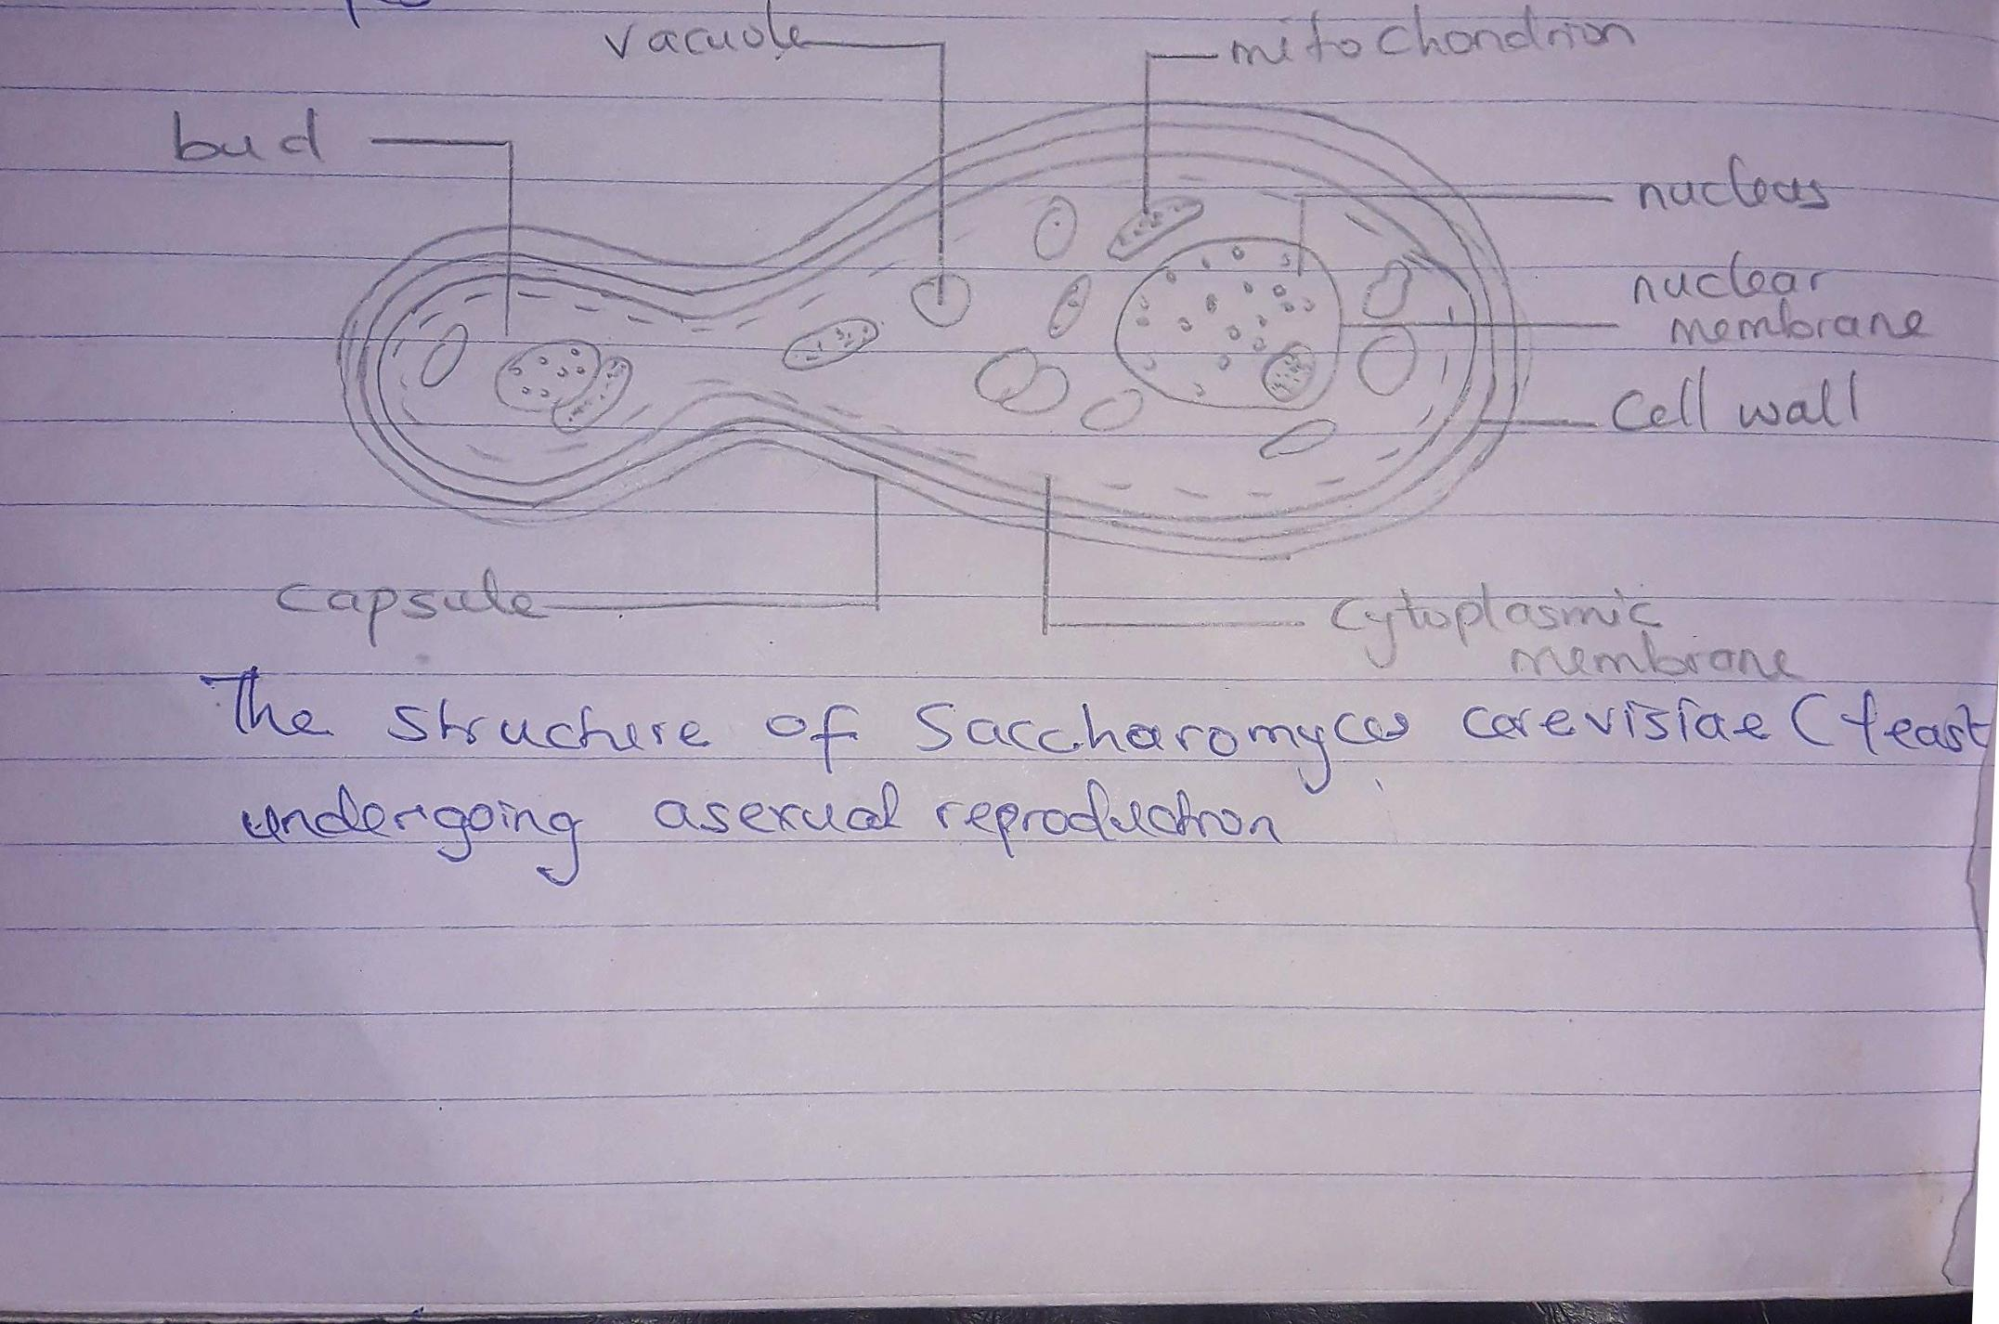
d) Some fungi are parasite to some certain horrible obnoxious coffensive unbearable pests. E.g. houseflies, grasshopper, and therefore serve as a biological control agent in regard to such pest.2
3. Sexual Reproduction in Rhizopus stolonifer
It occurs when two mating types of hyphae grow in the same medium. Chemical interaction in the two mating types of hyphae induces growths perpendicular to the hyphae in opposite directions. These growths are delimited by a wall such that many nuclei are isolated in what is called a gametangium.
The two gametangia fuse and a zygote is formed which may undergo prolonged resting stage. The nuclei in the zygote fuse in two and undergo meiosis independently. The zygote germinates under favorable conditions to produce a fruiting which at maturity liberates the haploid spores.
4. Adaptation of Bryophytes to their environment
They possess definite structures for water and nutrient absorption from the soil. Their plants body is divided into aerial portion and a subterranean portion.
4a) The subterranean portion is the rhizoid and is not a true root as the case of land plants that are advanced.
4b) The aerial portion being exposed to the atmosphere demands some modifications that prevents excessive loss of water through the body surface.
4c) Other modifications that permits elimination of excess water from the plant body and not only exchanged of gases between the internal parts of the plants and the atmosphere therefore openings are available on the aerial parts of the plants.
5a. Eusteles: A type of stele in which the vascular tissue in the stem forms a central ring of bundles around a pity. The vascular bundles are discrete, concentric collateral bundles of xylem and phloem.
5b Dictyostele ; A type of stele in which the vascular cylinder is broken up into a longitudinal series or network of vascular strands around a pith.
5c. Atactostele; A type of stele found in monocots, in which the vascular tissue in the stem exists as scattered bundles.
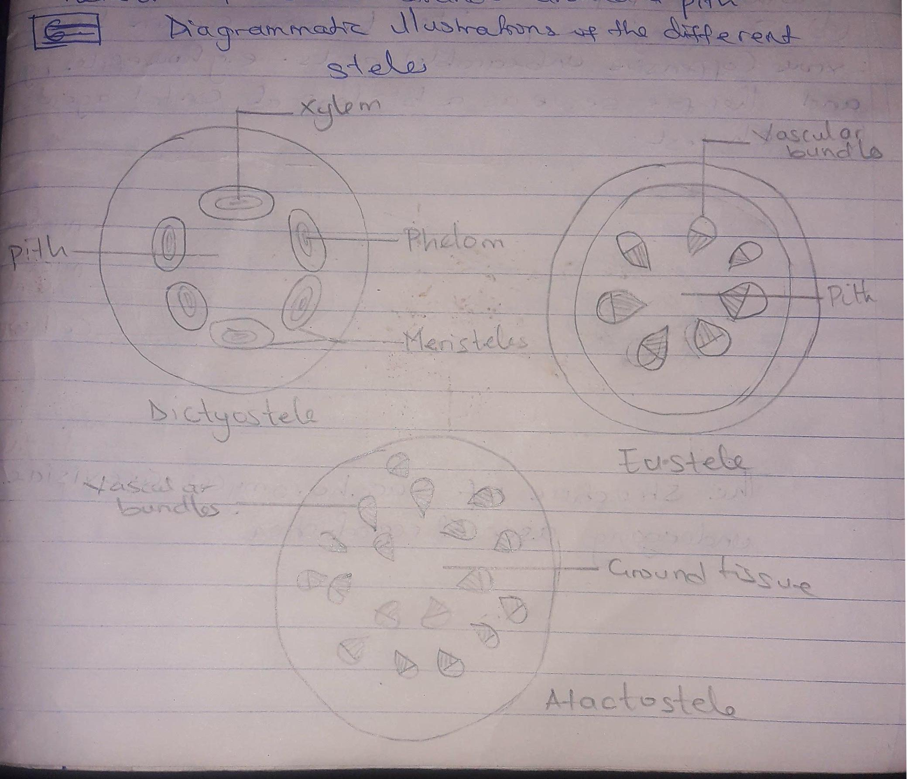
5d. Siphonostele; In more advanced vascular systems e.g stems of ferns and higher vascular plants, the stele is a cylinder enclosing a parenchymatous pith. The type of siphonostele are; solenostele, dictyostele, eustele.

