Name:Najeebat Ahmed opeyemi
Matric no:16/sci03/001
Csc104
Test
Advantages of using the internet
1) Information on almost every subject imaginable.
2) Powerful search engines
3) Ability to do research from your home versus research libraries.
4) Information at various levels of study. Everything from scholarly articles to ones directed at children.
5) Message boards where people can discuss ideas on any topic. Ability to get wide range of opinions. People can find others that have a similar interest in whatever they are interested in.

Disadvantage
1) There is a lot of wrong information on the internet. Anyone can post anything, and much of it is garbage.
2) There are predators that hang out on the internet waiting to get unsuspecting people in dangerous situations.
3) Some people are getting addicted to the internet and thus causing problems with their interactions of friends and loved ones.
4) Pornography that can get in the hands of young children too easily.
5) Easy to waste a lot of time on the internet. You can start surfing, and then realize far more time has passed than you realized. Internet and television together of added to the more sedentary lifestyles of people which further exacerbates the obesity problem.

2. Usability. One of the most important aspects of web design is actually making the site usable for the average user. ...
Speed. Website speed can make or break your entire company. ...
Aesthetics. The look and feel of your page is just as important as the functionality. ...
Content. ...
Contact Info. ...
Website Maintenance. ...
Mobile-Friendly.

3. The function of HTML is to provide a set of general rules that suggest how content should look when rendered. A markup language doesn't dictate the methods used to display the content, nor does it have foreknowledge of the target context, so this control is imprecise.

CSS stands for Cascading Style Sheets and is used by web pages to help keep information in the proper display format. CSS files can help define font, size, color, spacing, border and location of Html information on a web page, and can also be used to create a continuous look throughout multiple pages of a website.

Functions are one of the fundamental building blocks in JavaScript. A function is a JavaScript procedure—a set of statements that performs a task or calculates a value. To use a function, you must define it somewhere in the scope from which you wish to call it.

4. A static site is one that is usually written in plain HTML and what is in the code of the page is what is displayed to the user. A dynamic site is one that is written using a server-side scripting language such as PHP, ASP, JSP, or cold fusion.

Static in general means stationary or fixed, something that lacks movement, action or change. Same goes for a web page or a website. Static websites are the most basic type of sites usually the ones that don’t require much of a coding or design and easiest to create. As the name suggests, it’s a stationary website with a limited or a fixed number of pages that are delivered exactly as they are stored. Dynamic website, on the other hand, refers to something that is characterized by constant change or progress, something that’s more functional and interactive, something users can use not just read.

The static web pages display the same content each time when someone visits it, whereas in dynamic web pages the page content changes according to the user. ... A database is used in at the server end in a dynamic web page. In contrast, there is no database used in a static web page

Dynamic websites can be easily upgraded by end users. Static websites is difficult to upgrade
The theme of website and content of website are fixed. Website designs and content can be changed on runtime
With the help of markup language static websites loads quickly whereas dynamic websites delays to load because of more processing time.
Static website provides information to their clients like an organization website. Dynamic website is where content changes frequently. Like a Electronic-commerce site etc.
Static website directly run on browser and does not require other internet application language. This website can be created from HTML and CSS .Dynamic website run the application on server and the result will be display on webpage. So this requires server application language like PHP, JSP etc.
Static websites are easy to develop and a experienced person can develop it. But in case of Dynamic websites it cannot be developed easily because it require qualify developers to create it, manage it, test it and maintain security of application and database.
In Static website if you want to change the page content then you has to upload that page on server many times. Dynamic sites provide some facilities that it possible to change the page content using server application. There is no need to upload the page on server

5. Inline
Internal
External

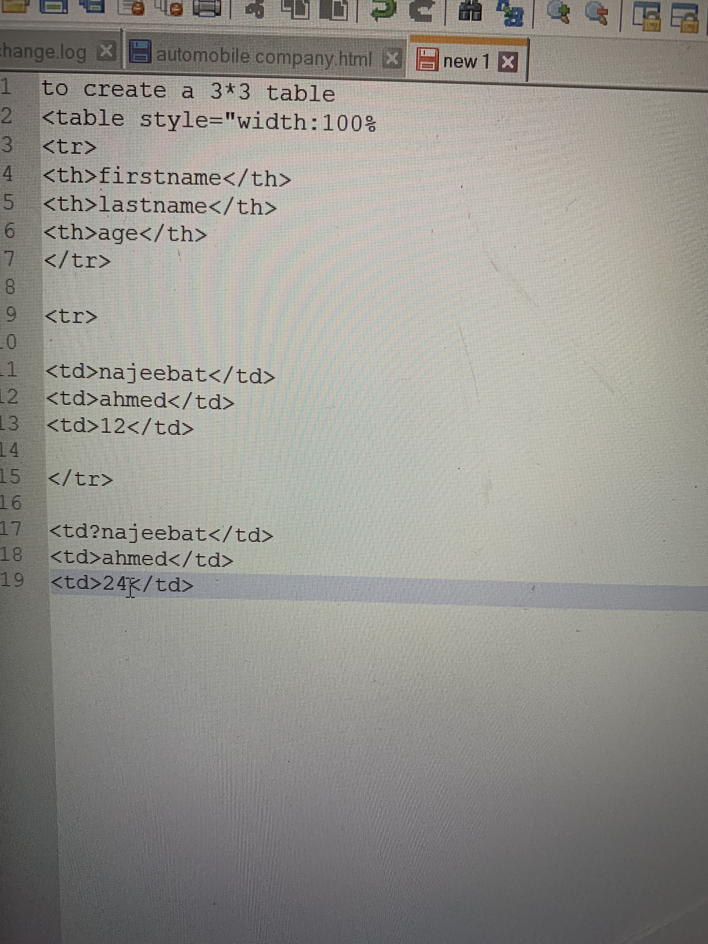
6.

