NAME: ALONGE KEHINDE WURAOLA
MATRIC NO: 19/MHS02/020
COLLEGE: MHS
DEPARTMENT: NURSING SCIENCE
COURSE CODE: CHM 102

- Alcohols are very important organic compound discuss briefly their classification and give one example each
ANSWER
Alcohols are classified based on two categories:
- Based on the number of hydrogen atoms attached to the carbon atom containing the hydroxyl group, If the number of hydrogen atoms attached to the carbon atom bearing the hydroxyl group are three or two, it is called a primary alcohol (1$°)$. If it is one hydrogen atom, it is called secondary alcohol (2$°)$and if no hydrogen is attached to the carbon atom bearing the hydroxyl group, it is called tertiary alcohol (3$°)$. Example;
$$and CH_{3}CH\left(OH\right)CH_{3} Propan-2-ol\left(2°\right)$$

- Based on the number of hydroxyl groups they possess. Monohydric alcohols have one hydroxyl group present in the alcohol structure. Dihydric group are also called glycols and they have two hydroxyl groups present in the alcohol structure while trihydric alcohols or triols have three hydroxyl groups present in the structure of the alcohol. Polyhydric alcohols or polyols have more than three hydroxyl groups. Example;
$$CH_{3}CH\left(OH\right)CH\left(OH\right)CH\left(OH\right)CH\left(OH\right)CH\left(OH\right)CH\left(OH\right)CH_{3}$$
$$Heptane-2,3,4,5,6-Pentaol (Polyhydric alcohol)$$

- Discuss the solubility of alcohols in water, organic solvents
ANSWER
SOLUBILITY IN WATER
Solubility of alcohols is due to the hydroxyl group in the alcohol which is able to form hydrogen bonds with water molecules. Alcohols with a smaller hydrocarbon chain are very soluble. As the length of the hydrocarbon chain increases, the solubility in water decreases.
SOLUBILITY IN ORGANIC SOLVENTS
All monohydric alcohol are soluble in organic solvents their solubility in organic solvent is largely due to their ability to form hydrogen bonds.

- Show the three steps in the industrial manufacture of ethanol. Equations of reaction are mandatory.
ANSWERS
IST STEP: On warming the starch containing material (e.g. rice) with malt at 60$℃$ for a specific period of time it gets converted into maltose by the enzyme diastase contained in malt.
$$2\left(C_{6}H_{10}O_{5}\right)n+nH_{2}O\overset{→}{60℃/diastase} nC_{12}H_{22}O_{11}$$
Carbohydrate Maltose
2ND STEP: The maltose become broken down into glucose on addition of yeast which contains the enzyme maltase and at temperature 15$℃$
$$C_{12}H_{22}O_{11}+H_{2}O\overset{→}{15℃/Zymase} 2C_{6}H_{12}O_{11}$$
Maltose Glucose
3RD STEP: The glucose at constant temperature 15$℃$ is then converted into alcohol by the enzyme Zymase contained also in yeast
$$C_{6}H_{12}O_{11}+H_{2}O\overset{→}{15℃/Zymase} 2CH_{3}CH_{2}OH+CO_{2}$$
Glucose Ethanol

- Show the reaction between 2-methylpropanal and butyl magnesium chloride
ANSWER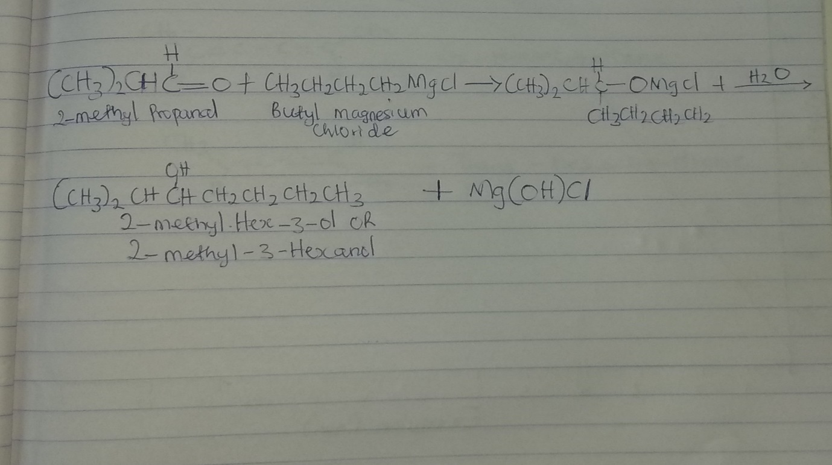

- Show the reduction reaction of 2-methylpropanal
ANSWER
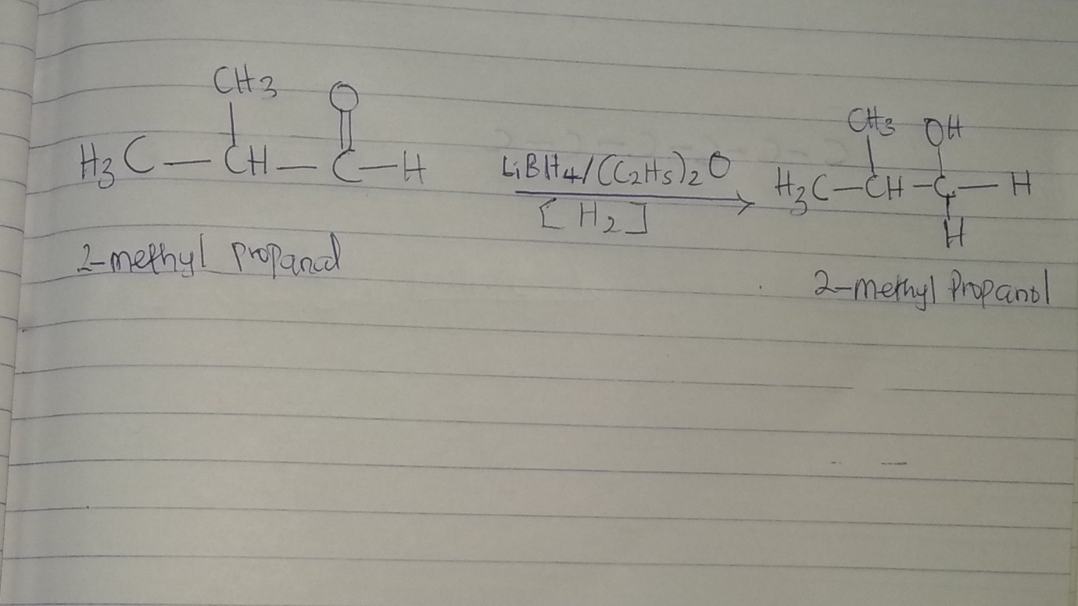

- Propose a scheme for the conversion of Propan-1-ol to Propan-2-ol
ANSWER
$$CH_{3}CH_{2}CH_{2}OH+H_{2}SO_{4}\underset{→}{}CH_{3}CH_{2}CH_{2}OH_{2}OSO_{3}H\underset{→}{-H_{2}O}$$
Propan-1-ol
$$CH_{3}CH_{2}CH_{2}OSO_{3}H\underset{→}{-H_{2}SO_{4}}CH_{3}CH=CH_{2}\underset{→}{+H_{2}O}CH_{3}CHOHCH_{3}$$
Propene Propan-2-ol

