Samuel Ibitogbe
15/eng02/029
VHDL

PROGRAMMABLE LOGIC DEVICE ARCHITECTURE

- Digital System Family Tree
- A digital system family tree showing most of the hardware choices currently available can be useful in sorting out the many categories of digital devices
- 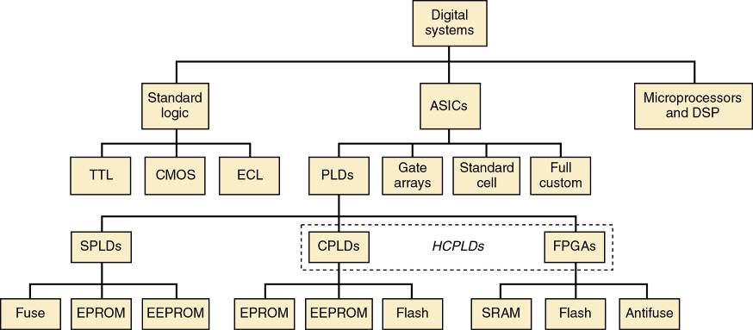

Fundamentals of PLD Circuitry
- A device that be programmed by blowing the appropriate fuses at the input to the OR ar
- Manufacturers have adopted the simplified diagram symbols shown
- Gate arrays are ULSI circuits.
  - Logic functions are created by interconnections of hundreds of thousands of prefabricated gates.
    - A custom-designed mask is used—much like
the stored data in a mask-programmed ROM.
  - Individually less expensive than PLDs of comparable gate count.
    - Custom programming process is very expensive
and requires a great deal of lead time.
- Standard-cell ASICs use predefined logic function building blocks called cells to create
the desired digital system.
  - A library of available cells is stored in a database.
    - Design costs for standard-cell ASICs are higher
than for MPGAs—with greater lead time.
- Cell-based functions are designed to be much smaller than equivalent functions in gate arrays.
  - Allows for generally higher-speed operation and cheaper manufacturing costs.
- Full-custom ASICs are the ultimate ASIC choice.
  - All components and the interconnections between them are custom-designed by the IC designer.
  - Requires a significant amount of time and expense, but it can result in ICs that can operate at the highest possible speed and require the smallest die area.
    - Which significantly lowers manufacturing cost.

PLD Architectures
- PROMs.
  - Fuses are blown to implement a SOP expression.
    - Bit map generation is made easier with general purpose logic compilers.
    - 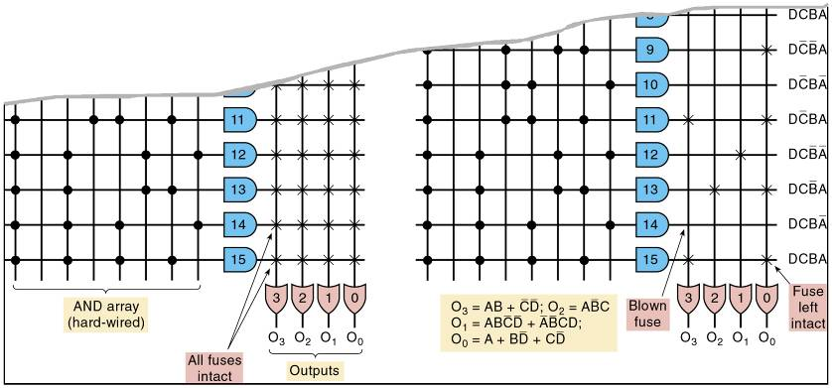
- Programmable array logic (PAL).
  - Every AND gate can be programmed to generate any desired product of four input variables.
- The PAL family also contains devices with variations of the basic SOP circuitry.
  - Channel SOP logic circuit to a D FF input and use one of the pins as a clock input, to clock all of the output flip-flops synchronously.
  - Field programmable logic array (FPLA)
  - Programmable AND as well as OR arrays.
  - Used in state machine applications where a large number of product terms are needed in each SOP expression.
  - Not as widely accepted by engineers
  - Generic array logic architecture (GAL).
  - Uses an EEPROM array in the programmable matrix that determines the connections.
  - The EEPROM switches can be erased and
reprogrammed at least 100 times.
  - GAL chips use a programmable output logic macrocell (OLMC).
  - Can be used as a generic, pin-compatible replacement for most PAL devices

  - The Altera
- I/O control blocks configure each I/O pin for input, output, or bi-directional operation.
- All I/O pins have a tristate output buffer that is:
  - Permanently enabled or disabled.
  - Controlled by one of two global output enable pins.
  - Controlled by other inputs or functions generated
by other macrocells.
- During in-system programming I/O pins will be tristated and internally pulled up to avoid board conflicts.

The Altera Cyclone Series
- Different architecture—based on the look up
table (LUT).
  - The LUT functions like a truth table for the logic function.
- SRAM devices that use LUT are generally classified as field programmable gate arrays (FPGAs).
- The LUT:
  - Is a portion of the programmable logic block that produces a combinational function.
    - The function can be output or registered.
  - Consists of FFs that store the truth table.
  - Is usually small, typically with 4 input variables.
  - Is basically, a 16 X 1 SRAM memory block.
- Has SRAM that must be loaded at PLD power up

