AGBEJA AYOOLUWA OREOLUWA
15/MHS01/012
COE 506
ASSIGNMENT
Digital Systems Family Tree
This digital system family tree as shown in the figure below indicating most of the hardware choices currently available and is found useful in sorting out digital devices categories.

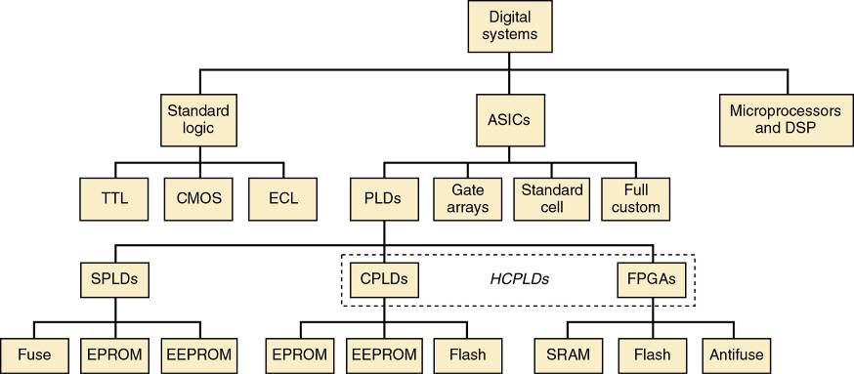

- First Category
This category of standard logic devices refers to the basic functional digital components. Gates, flip- flops, decoders, multiplexers, registers, counters, etc. Available as SSI and MSI chips.

- Second Category
With the second category, microcomputer/DSP systems, devices can be controlled electronically & data manipulated by executing a program of instructions.

- Third Category
The third category are application specific integrated circuits (ASIC). ICs designed for a specific application.

Programmable logic devices (PLDs) - Field-programmable logic devices (FPLDs). . Generally, the lowest cost of the subcategories. The PLD architecture selected depends on the application—PLDs are very diverse and dynamic. (SPLD)simple programmable logic devices, (CPLD)complex programmable logic devices. (FPGA)field programmable gate arrays. CPLDs and FPGAs are often referred to as high-capacity programmable logic devices (HCPLDs).
They can be custom-configured to create any desired digital circuit for simple or complex systems

Gate arrays are ULSI circuits.
Logic functions are created by interconnections of hundreds of thousands of prefabricated gates. A custom-designed mask is used—much like the stored data in a mask-programmed ROM. Individually less expensive than PLDs of comparable gate count. Custom programming process is very expensive
and requires a great deal of lead time.
Standard-cell ASICs
Use predefined logic function building blocks called cells to create the desired digital system. A library of available cells is stored in a database. Design costs for standard-cell ASICs are higherthan for MPGAs—with greater lead time. Cell-based functions are designed to be much smaller than equivalent functions in gate arrays. Allows for generally higher-speed operation and cheaper manufacturing costs.
Full-custom ASICs
are the ultimate ASIC choice. All components and the interconnections between them are custom-designed by the IC designer. Requires a significant amount of time and expense, but it can result in ICs that can operate at the highest possible speed and require the smallest die area. Which significantly lowers manufacturing cost.
Fundamentals of PLD Circuitry
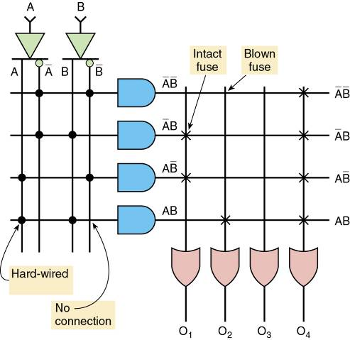
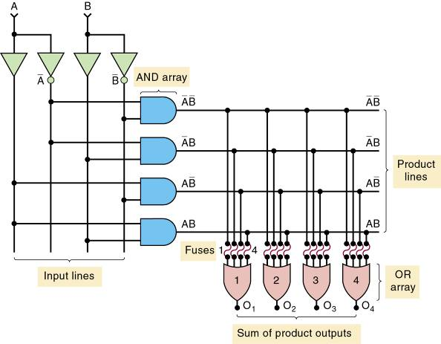
A device that be programmed by blowing the appropriate fuses at the input to the OR array

Manufacturers have adopted the simplified diagram symbols shown.

PLD Architectures
- PROMs: Fuses are blown to implement a SOP expression. Bit map generation is made easier with general purpose logic compilers.
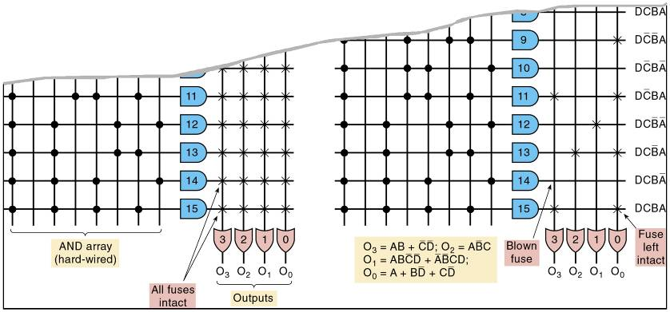
Programmable array logic (PAL): Every AND gate can be programmed to generate any desired product of four input variables. The PAL family also contains devices with variations of the basic SOP circuitry. Channel SOP logic circuit to a D FF input and use one of the pins as a clock input, to clock all of the output flip-flops synchronously. These devices are referred to as registered PLDs because the outputs pass through a register.
Field programmable logic array (FPLA): Programmable AND as well as OR arrays. Used in state machine applications where a large number of product terms are needed in each SOP expression. Not as widely accepted by engineers.
Generic array logic architecture (GAL): Uses an EEPROM array in the programmable matrix that determines the connections. The EEPROM switches can be erased and
reprogrammed at least 100 times. GAL chips use a programmable output logic macrocell (OLMC). Can be used as a generic, pin-compatible replacement for most PAL devices.

The Altera MAX7000S Family
EEPROM based device in Altera MAX7000S CPLD family.
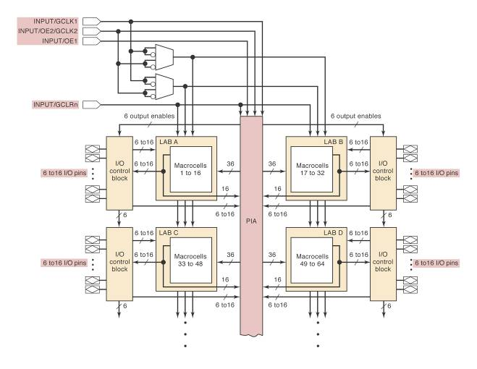
The major structures in the MAX7000S are the logic array blocks (LABs) and programmable interconnect array (PIA). A LAB contains a set of 16 macrocells and looks very similar to a single SPLD device. Each macrocell consists of a programmable AND/OR circuit and a programmable register (flip-flop).
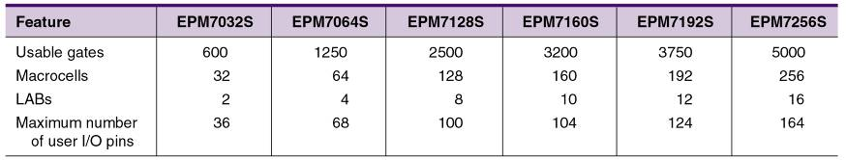

The Altera MAX II Family
Major structures:
  - Logic array blocks (LABs). 16 macrocells—number of determined from the
part number (EPM7128S has 128).
  - Programmable interconnect array (PIA). A global bus that connects signal sources/destinations. Up to 36 signals can feed each LAB from the PIA
  - I/O pins are connected to specific macrocells. Number of available I/O pins depends on package.
  - ISP features uses a JTAG interface which requiresfour pins dedicated to the programming interface. TDI (test data in), TDO (test data out), TMS (test mode select), TCK (test clock).
- In-system programming can be done via JTAG pins and a PC parallel port.
- Macrocells not connected to I/O pins can be used by the compiler for internal logic.
- The four input-only pins can be configured as high speed control signals or general user inputs. GCLK1—primary global clock input for all macrocells, GCLK2—secondary global clock, OE1—the tristate enable, GCLRn—controls the asynchronous clear on any macrocell.

In-system programming can be done via JTAG pins and a PC parallel port.
- Macrocells not connected to I/O pins can be used by the compiler for internal logic.
- The four input-only pins can be configured as high speed control signals or general user inputs. GCLK1—primary global clock input for all macrocells, GCLK2—secondary global clock, OE1—the tristate enable, GCLRn—controls the asynchronous clear on any macrocell.
- I/O control blocks configure each I/O pin for input, output, or bi-directional operation.
- All I/O pins have a tristate output buffer that is: Permanently enabled or disabled, Controlled by one of two global output enable pins. Controlled by other inputs or functions generated by other macrocells.
- During in-system programming I/O pins will be tristated and internally pulled up to avoid board conflicts.
- Macrocells can produce either combinational
or registered output.
- Combinational outputs are created by bypassing the register in a macrocell.
- Each macrocell can produce five product terms. Additional product terms can be borrowed from adjacent macrocells in the same LAB.
- Macrocell FFs can implement D, T, JK, or SC(SR) operations.
- Three different clocking modes.
With global clock signal.
With global clock when FF is enabled.
With array clock signal produced by a buried macrocell or a non-global input pin.
- Each register can be cleared with GCLRn pin.
- All registers will reset at power-up.
The Altera Cyclone Series
- Different architecture—based on the look up
table (LUT). The LUT functions like a truth table for the logic function.
- SRAM devices that use LUT are generally classified as field programmable gate arrays (FPGAs).
- The LUT: Is a portion of the programmable logic block that produces a combinational function, The function can be output or registered, Consists of FFs that store the truth table, Is usually small, typically with 4 input variables, Is basically, a 16 X 1 SRAM memory block, Has SRAM that must be loaded at PLD power up.

