Name: AJAKAYE JADESOLA STELLA
Matric Number: 18/SCI01/010
Course Code: CSC 206

- A C program that count from 100 to 1 varying the control variables in the steps of 3 and printing its square for each count .Using for statement and while statement .
#include<stdio.h>
int main()
{
void countFrom1to100();
{
int count,sqr;
for(count = 100;count>0; count--)
{
sqr=count*count;
printf("%d\n",sqr);
} }
return 0 ;
}

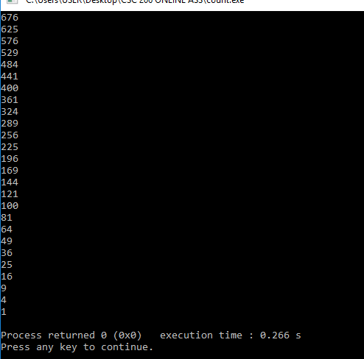

- A C program to display 80 bottles, But if the input exceeds 59, exit the loop and end the program.<hint: using break statement >

- A C program that reads an integer and displays a message to indicate whether it’s a prime number or not. It is reminded that a prime number is any integer greater than 1 with no divisor other than 1 itself
#include <stdio.h>
int main() {
int i , num , p = 0;
printf("Please enter a number;\n");
scanf("%d", & num);
for(i = 1; i<=num;i++){
if(num % i==0){
p++;
}
}
if (p==2){
printf("Entered number is %d "\
"and it is a prime number,",num);

} else{
printf("Entered number is %d "\
"and it is not a prime number,",num);
}
}

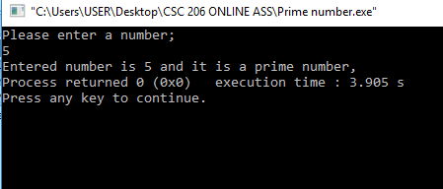

- A C program to find factorial of a natural number
#include <stdio.h>
int main()
{
int n,i,fac=1;
printf("Enter the number:\n");
scanf("%d", &n);
i=1;
while(i<=n)
{
fac=fac*1;
i++;
}
printf("The factorial is %d is %d",n,fac);
}

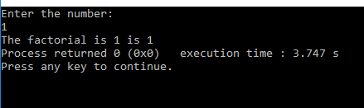

- A C program that count from 50 to 1000 varying the control variable in steps of 7 using do while statement.
#include<stdio.h>
int main ()
{
int n = 50;
do{
printf("n is equal to: %d\n",n);
n+=7;
}
while (n <= 1000);
return 0;
}

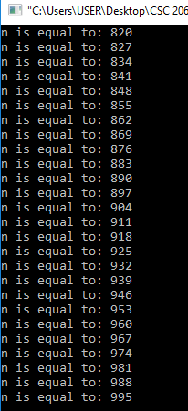
- Using conditional operator write a c program to find if a given character is a consonant or a vowel.
#include <stdio.h>
int main()
{
char ch;
printf("Please enter an alphabet: \n");
scanf(" %c", &ch);

if (ch == 'a' || ch == 'e' || ch == 'i' || ch == 'o' || ch == 'u' ||
ch == 'A' || ch == 'E' || ch == 'I' || ch == 'O' || ch == 'U' ){
printf("\n %c is a VOWEL.",ch);
}
else{
printf("\n %c is a CONSONANT.",ch);
}
return 0;
}
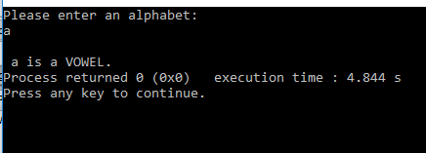

- A program (using for statement) that reads an integer and displays its multiplication table. The program should force the user to enter an integer within {1,10}
#include <stdio.h>
int main ()
{
int num;
int i;
printf("Enter an integer number:");
scanf("%d", &num);
i=1;

while(i<=10){
}
printf("%d\n",(num*i));
i++;
}

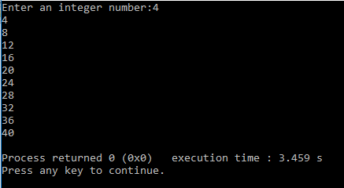

- A test consists of 10 multiple choice questions each of which has three possible answers. The first answer gets three points, the second gets one points, and the third gets two points. Write a c program that uses the switch statement to read the test takers 10 answers and displays the final score.

- A C program to find the product of 8 integers entered by a user. If user enters 0 skip it {hint: using continue statement}
#include <stdio.h>
int main()
{
int i, num ,product;
for (i=1, product=1;i<=8;++i)
{
printf("Enter number %d:",i);
scanf("%d",&num);
if (num ==0)
continue;
product*=num;
}
printf("product=%d",product);
return 0 ;
}

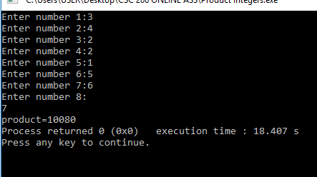

- A c program that reads the initial population growth <as a percentage > then, the program should read the number of years and display the new population for each year.
#include<stdio.h>
int main()
{
int years;
double population, growth;

printf("Enter the population in a year :");
scanf("%lf", &population);

printf("Enter the annual percentage population growth rate :");
scanf("%lf", &growth);

printf("Enter number of years:");
scanf("%d", &years);
int i = 1;
for(i = 1; i <= years ; i++)
{
population +=(population/100) * growth;
printf("\nYear %d: %2.lf\n",i,population);
}
return 0 ;

}

