NAME: AKINDERU SULTANBASIT
MATRIC NO: 15/ENG06/006
DEPARTMENT: MECHANICAL ENGINEERING
TOPIC: FEASIBILITY REPORT ON FASCIAL MASK

INTRODUCTION
Surgical face masks are worn by health care professionals during surgery or while tending to patients in order to avoid contact with bacteria shed in the form of liquid droplets and aerosols from the mouth and nose or infectious blood and body fluids. Surgical face masks are used as a protective barrier to prevent cross-contamination among patients and surgeons. They are made mostly from non-woven fabric and are available in the two-layer and three- layer form. The layers are ultrasonically welded for efficient bacterial filtration. Bacterial filtration efficiency (BFE) is the
effectiveness of the surgical mask material to filter bacteria of a specified particle size. Particle filtration efficiency (PFE) is the effectiveness of a material to filter aerosol particles. Both BFE and PFE are expressed as a percentage of a quantity that does not pass through the material of the surgical mask Surgical face masks are used in operation theatres and every area of health care that requires patient inspection. Rise in awareness regarding airborne infections has led to an increase in usage of surgical face masks in not only large health care facilities but also smaller ones across the world. The usage of surgical face masks has increased among the general public owing to the rise in outbreaks of airborne diseases in recent times. The inevitable use of surgical face masks and lower threat of their substitutes are expected to propel the global surgical face masks market during the forecast period. A surgical mask, also known as a procedure mask, is intended to be worn by health professionals during surgery and during nursing to catch the bacteria shed in liquid droplets and aerosols from the wearer's mouth and nose. They are not designed to protect the wearer from inhaling airborne bacteria or virus particles and are less effective than respirators, such as N95 or NIOSH masks which provide better protection due to their material, shape and tight seal. Surgical masks are popularly worn by the general public in East Asian countries to reduce the chance of spreading airborne diseases.
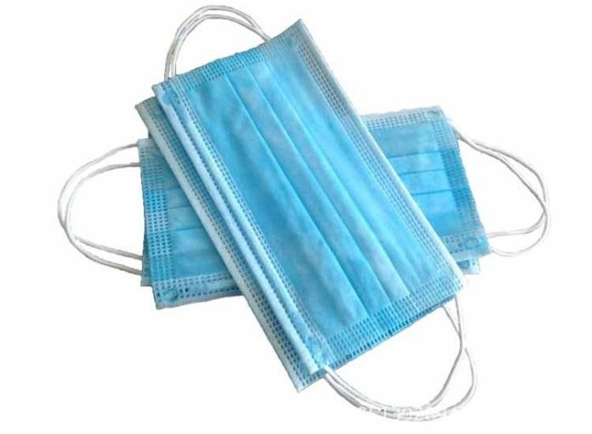
Healthcare workers involved in treating and caring for individuals injured or sick as well as the patient can be exposed to biological aerosols capable of transmitting diseases. These diseases, which may be caused by a variety of microorganisms, can pose significant risks to life and health. Surgical face masks are used to cover the mouth and nose by doctors and other healthcare workers. It reduces the risk of contaminations from secretion of the mouth and nose in operation room or clinics. It is purposely to be worn by health care professionals during surgery and at same time to catch the bacteria shed in liquid droplets.

Surgical face masks (SFMs) provide a physical barrier between bacteria of oropharyngeal and nasopharyngeal origin and an open patient wound. Wearing a SFM in the OR is one of many long standing preventative practices, yet controversy exists as to the clinical effectiveness of SFMs in reducing the frequency of SSIs. Additionally, SFMs potentially protect OR staff by providing a physical barrier to infectious bodily fluid splashes from the patient. General purpose disposable SFMs however, are not specifically designed to protect the wearer from airborne infectious particulates. A review of clinical effectiveness and evidence-based guidelines for mask use in the OR can inform practice decisions to minimize the occurrence of SSIs and OR staph infections.
Increase in aging population, prevalence of hospital acquired infections (HAIs), and rise in demand of improved healthcare facilities in the developing economies drive the market. However, high cost associated with the preparation of different types of media culture restraint the market growth.

MARKET SURVEY
The global disposable medical masks market is segmented based on type, end user, and region. On the basis of type, the market is bifurcated into facemasks and respirators. Based on application, it is categorized into hospitals & clinics, industrial, individual and others. By region, the market is analyzed across North America, Europe, Asia-Pacific, and LAMEA. The global surgical face mask market can be segmented based on distribution channel, end- user, and region. Healthcare professionals or the general public are the end users of surgical face masks. Surgical face masks are widely available through all distribution channels, and owing to the rise in number of outbreaks, the usage of surgical masks is expected to increase considerably in the near future. In terms of distribution channel, the global surgical face mask market can be segregated into independent pharmacies, online sales, hospital pharmacies, retail stores, and others.

Based on region, the global surgical face mask market can be segmented into North America, Europe, Asia Pacific, Latin America, and Middle East & Africa. North America, Europe, and Asia Pacific accounted for more than half the share of the global surgical face mask market in 2016. Asia Pacific is expected to account for a prominent share of the market in terms of volume during the forecast period, due to higher population, large number of airborne diseases, and awareness regarding postoperative surgical site infections in the region.
The surgical face mask market in Latin America and Middle East & Africa is anticipated to expand at a significant pace during the forecast period. Due to rise in requirement for cutting down health care costs, several health care
professionals have begun to evaluate traditional methods of infection control, the prominent one of them being the usage of surgical facemask
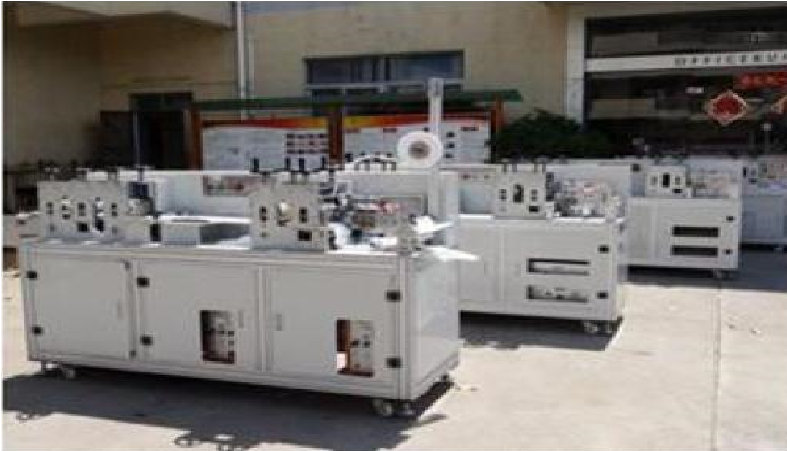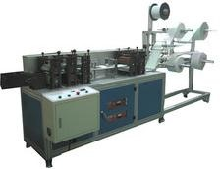
Face Mask Machine
Mask Inner Ear Loop Welding Machine

PROJECT AT A GLANCE
COST OF PROJECT
Particulars | Existing | Proposed | Total
Land & Site Development Exp. | 0.00 | 102.00 | 105.00
Buildings | 0.00 | 20.60 | 20.60
Plant & machineries | 0.00 | 39.02 | 39.02
Motor vehicles | 00.00 | 4.00 | 4.00
Technical& exp | 0.00 | 13.00 | 13.00
Automation equipment’s | 0.00 | 3.00 | 3.00
Other deposit | 0.00 | 0.00 | 0.00
Pre-operative expenses | 0.00 | 1.00 | 1.00
Provision of contingencies | 0.00 | 3.00 | 3.00
Margin money-working | 0.00 | 5.62 | 5.62
TOTAL | 0.00 | 194.24 | 194.24

MEANS OF FINANCE
Particulars | Existing | Proposed | Total
Capital | 0.00 | 48.5 | 48.5
Share premium | 0.00 | 0.00 | 0.00
Share capital | 0.00 | 0.00 | 0.00
Reserves | 0.00 | 0.00 | 0.00
Cash subsidy | 0.00 | 0.00 | 0.00
Internal cash | 0.00 | 0.00 | 0.00
Long/medium term borrowings | 0.00 | 145.68 | 145.68
Debentures/bonds | 0.00 | 0.00 | 0.00
Unsecured  Loans/deposits | 0.00 | 0.00 | 0.00
Total | 0.00 | 194.24 | 194.24

Year | d.s.c.r | debt | Equity as- equity | Total net worth | Return on networth |  |  |  | Profitable ratio |  |  | Asset turnover ratio | Current ratio
 |  |  |  |  |  |  |  |  | GPM | PBT | PAT | NET CONTRIBUTION | P/V RATIO
 | Numbers of times |  |  |  | % | % | % | % | % | % | % | % | %
Initial |  | 3.00 | 3.00
1-2 | 1.02 |  | 1.71 | 1.71 | 1.85 |  | 42.61 % | 22.50 % | 15.65 % | 125.2 1 | 100.82 % | 0.66 | 0.42
2-3 | 1.13 |  | 0.89 | 0.89 | 1.00 |  | 47.39 % | 31.94 % | 20.93 % | 141.7 9 | 97.86 % | 0.75 | 0.70
3-4 | 1.25 |  | 0.42 | 0.42 | 0.51 |  | 50.53 % | 38.55 % | 24.73 % | 161.5 % | 97.79 % | 0.80 | 1.20
4-5 | 1.84 |  | 0.15 | 0.15 | 0.22 |  | 52.57 % | 43.25 % | 27.48 % | 182.1 % | 97.75 % | 0.81 | 1.88
5-6 | 2.22 |  | 0.00 | 0.00 | 0.06 |  | 53.82 % | 46.58 % | 29.47 % | 202.2g | 97.71 % | 0.78 | 8.04

BEP
BEP – Maximum Utilization year | 5
Cash BEP(%of installed capacity | 48.88 %
Total BEP(% of installed capacity) | 51.98 %
Internal rate of return .. (in %age) | 14.60 %
Payback period of the project is (In years) | 3 years 2 months
Fixed asswsts coverage ratio ( no. of times) | 1.407

