NAME: UKEKO EWOMAZINO JESSE.
DEPT: MBBS
COURSE: BIO 102.
MATRIC NO: 19/MHS01/416.
ASSIGNMENT.
- Fungi are important to mankind in the following ways:
- They are essential to farming because of their relationship with plants.
- They are prominently used in the human diet.
- Fungi naturally produce antibiotics to kill bacteria.

- CELL STRUNCTURE OF UNICELLUAR FUNGUS.

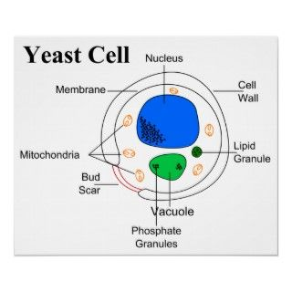

- Sexual reproduction in a filamentous fungi like Rhizopus stolonifer undergoes the following steps;
- First, two mating types of hyphae grow in the same medium.
- A chemical interaction between them causes growth perpendicular to the hyphae in opposite directions, so they can meet with one another.
- The growths are the delimited by a wall just so the nuclei are isolated in differentiated sex organs called gametangia (plural).
- The gametangia fuse in a process called plasmogamy and together they form a zygote which may undergo dormancy for a period.
- The nuclei in the zygote fuse in twos and undergo meiosis independently, it then moves on to germinating under favorable conditions so as to liberate haploid spores at maturity through the production of a fruiting.
- Here are the following adaptations in bryophytes to adapt land habitat:
Multicellular plant body and conservation of water:
A compact multicellular plant body was formed which helped in the conservation of water by reducing cell surface are exposed to dry land conditions.
Absorption of CO2:
Modification of photosynthetic tissues for the absorption of carbon dioxide without losing much water and exposure to light.
Absorption of water:
Special structures like rhizoids were developed for absorption of water and anchorage.
Heterogamy:
Heterogamy was evolved, forming non-motile egg containing stored food and motile sperms.
Protection of gametes:
Gametes were produced and protected by the special multicellular organs.
Embryo formation:
Multicellular embryo was formed which was retained inside the female reproductive body during its development

- A. Eusteles; a type of stele in which the vascular tissue in the stem forms a central ring of bundles around a pith. The vascular bundles are discrete, concentric collateral bundles of xylem and phloem.
B. Atactostele; a type of stele found in monocots, in which the vascular tissue in the stem exists as scattered bundles.
C. Dictyostele; a type of stele in which the vascular cylinder is broken up into a longitudinal series or network of vascular strands around a pith.

- LIFE CYCLE OF A PRIMITIVE VASCULAR PALNT. ( PISTLUM).

