NAME:ONALAJA HALEEMAH MODUPEOLUWA
DEPARTMENT:MBBS
MATRIC NO:19/MHS01/346

1)Fungi is used in breweries and baking industry
_Mushroom is edible to human being
_Penicilium is used to cure bacteria infections
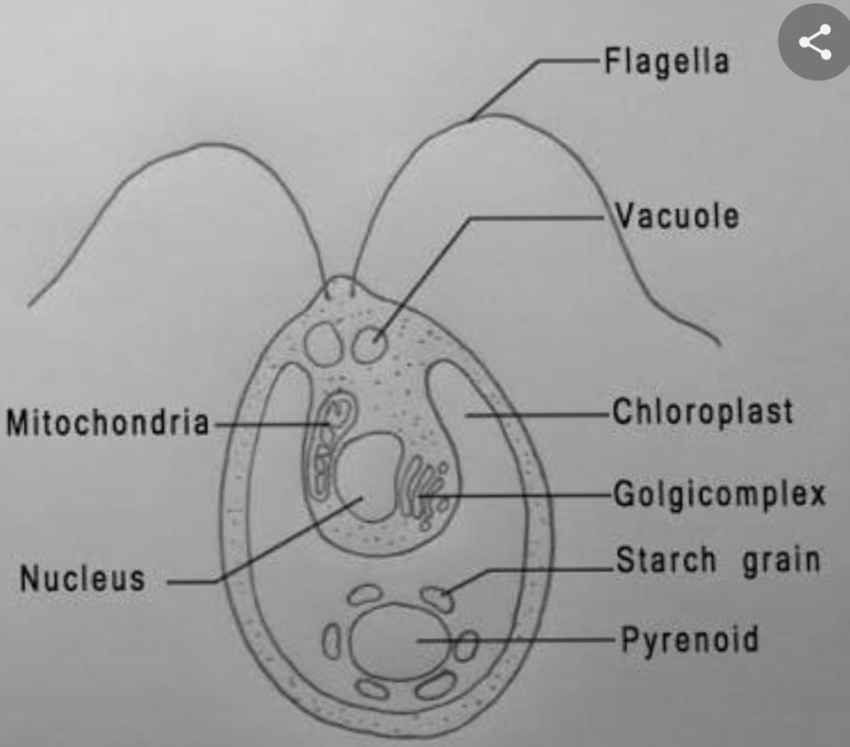
_Yeast is useful in food industries
STRUCTURE OF A CHLAMYDOMONAS
2)The labelling of a unicellular fungus (Chalmydomonas) is on page 1
_Flagella: Structure for mobility
_Pyrenoid: Manufactured sugar is processed into starch here
_Nucleus: Here is the genetic programme of the cell
_Mitochondria Mediate the elaboration of energy molecule

3 Sexual Reproduction in a typical filamentous form of fungi:
_It occurs when two mating types of hyphae grow in the same medium
_Two gametangia fuses together through plasmogamy to form zygote.

_The nuclei in the zygote fuses in twos and undergo meiosis independently.
_The zygote germinates in favourable condition producing fruitings, when the fruitings matures, it produces haploid spores.

4) They have definite structures for water and nutrient absorption from the soil; therefore the plant body is divided into two: Aerial portion and subterranean pportion.
_Aerial portion :Prevents loss of water through the body surface
:_It has some other modifications that permit elimination of excess water from the plant body and not only exchange of gases between the internal parts of the plant and the atmosphere through openings which are available in the Aerial part off the plant.
_Subterranean portion: This is the rhizoid, this portion performs the role of a rhizoid

5)Eustele: A kind of vascular organization in herbaceous dicotyledonous plants in which the vascular bundles are discrete, concentric collateral bundles if xylem and phloem.
_Atactostele: A kind of vascular organization in grasses and monocotyledonous plants.
_Dictyostele: A type of stele in which the vascular cylinder is broken up into a longitudinal series or network of vascular strands around a pith.
_Siphonstele: Vascular supply to leaves is associated with leaf gaps and the conducting cylinder is a dissected one
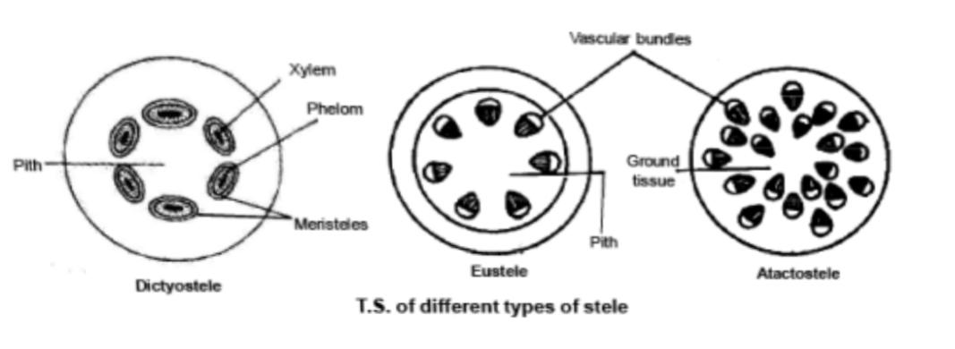

6) Life cycle of a primitive vascular plant
