NAME: NAFARNDA FALNYI SARAH

DEPARTMENT: PHARMACY

MATRIC NO: 19/MHS11/083

BIOLOGY ASSIGNMENT

1. How are fungi important to mankind?

Fungi are important to everyday human life.

1. Fungi serve as important decomposers in most ecosystems.
2. Mycorrhizal fungi are essential for the growth of most plants.
3. Fungi serve as food, they play a role in human nutrition in the form of mushrooms, and also as agents of fermentation in the production of bread, cheeses, alcoholic beverages, and numerous other food preparations.
4. Secondary metabolites of fungi are used as medicines, such as antibiotics and anticoagulants.
5. Fungi are model organisms for the study of eukaryotic genetics and metabolism.
6. Illustrate the cell structure of a unicellular fungus with a well labeled diagram

The yeasts are unicellular fungi. Cells may remain attached in short chains forming a pseudo mycelium, but they do not produce true mycelium. The cells are extremely variable in shape being globose, oval, elongated, or rectangular. The yeast cells are very polymorphic and are capable of assuming different forms depending upon the medium in which they grow and their age. Individually yeast cells are hyaline but in colonies they appear white, cream-colored or slightly brownish. The structure of yeast cell has been very thoroughly worked out by a large number of investigators who differ in their interpretations. Each yeast cell has a disti­nct cell wall enclosing granular cytoplasm, within which can be seen a large vacuole and a nucleus. The vacuole varies much in size according to the state of activity of the cell. It may at times become much contracted, but it does not disap­pear completely except during spore formation. The wall is thin delicate and is com­posed of chitin in combination with other compounds. Reserve materials are present in the cytoplasm in the form of oil globules, glycogen, and volutin. Glycogen accumula­tion increases with the decrease in fermentation. The volutin content is also very much linked with the metabolic conditions of the yeast cells. Difference of opinion exists whether the vacuole is a part of the nucleus or the vacuole and the nucleus are separate entities.



DIAGRAM OF THE REPRESENTATION OF PARTS OF A YEAST CELL

1. Outline the sexual reproduction in a typical filamentous form of fungi

a. Fungal life cycles are unique and complex

b. Fungi reproduce sexually ether through cross- or self-fertilization. Haploid fungi form hyphae that have gametes at the tips.

c. Two different mating types (represented as “+ type” and “-type”) are involved

d. The cytoplasm’s of the + and – type gametes fuse (in an event called plasmogamy), producing a cell with two distinct nuclei (a dikaryotic cell).

e. Later, the nuclei fuse (in an event called Karyogamy) to create a diploid zygote.

f. The zygote undergoes meiosis to form spores that germinate to start the hapoid stage, which eventually creates more haploid mycelia

g. Depending on the taxonomic group, these sexually produced spores are known as zygospores (in zygomycota), ascospores (in Ascomycota), or basidiospores ( in basidio mycota).

1. Adaptations of Brophytes

Two adaptations made the move from water to land possible for Bryophytes: a waxy cuticle and gametangia. The waxy cuticle helped to protect the plants tissue from drying out and the gametangia provided further protection against drying out specifically for the plants gametes. They have a waxy cuticle that prevents the body, the zygote, and the embryo from drying out. Spores are dispersed by the wind. They have no vascular (transport) system

1. Describe with illustration the folowing
2. Eusteles: A eustele is a stele type characteristic of most seed-bearing plants and a few ferns and fern allies.  Although other stele types can function to make wood, the eustele is the most common one.  Vascular bundles characteristically are arranged in a circle around a region of pith.  The cortical parenchyma is continuous with the pith through rays which separate the vascular bundles.  Xylem is on the inside and phloem is on the outside of each bundle.

DIAGRAM OF AN EUSTELE

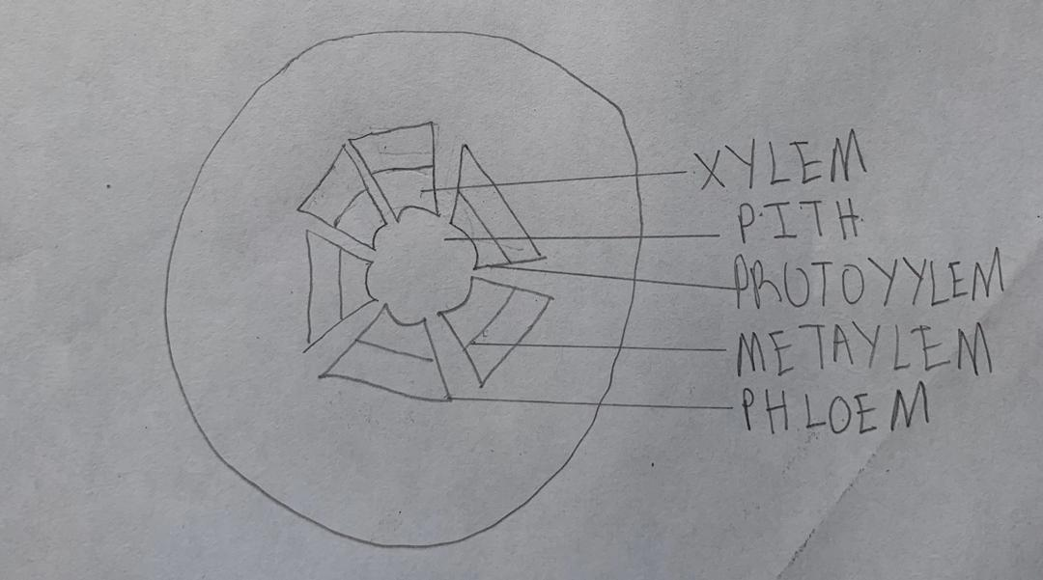

1. Atactosteles: A type of eustele, found in monocots, in which the vascular tissue in the stem exists as scattered bundles.

DIAGRAM OF AN ATACTOSTELE

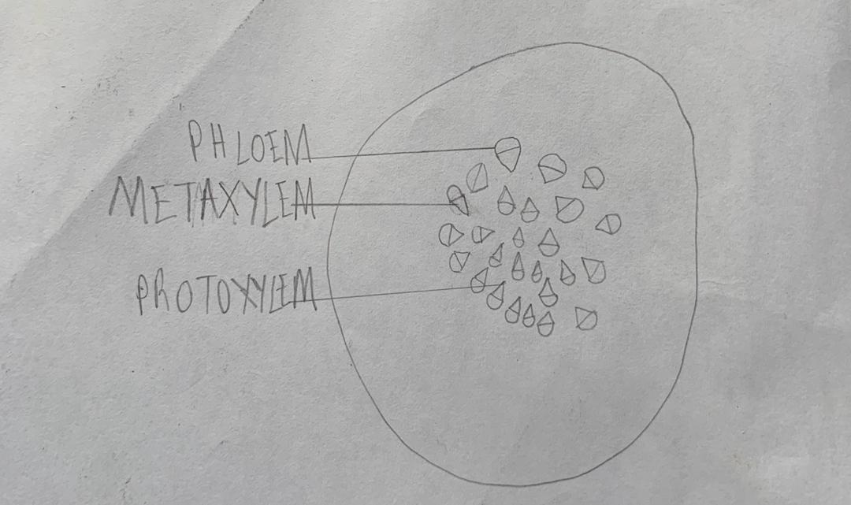

1. Siphonostele: A stele in which the vascular tissue is in the form of a cylinder surrounding the pith, as in the stems of most ferns and other seedless vascular plants. Siphonosteles have a region of ground tissue called the [pith](https://en.wikipedia.org/wiki/Pith) internal to xylem. The vascular strand comprises a cylinder surrounding the [pith](https://en.wikipedia.org/wiki/Pith). Siphonosteles often have interruptions in the vascular strand where leaves (typically megaphylls) originate (called leaf gaps).

DIAGRAM OF A SIPHONOSTELE

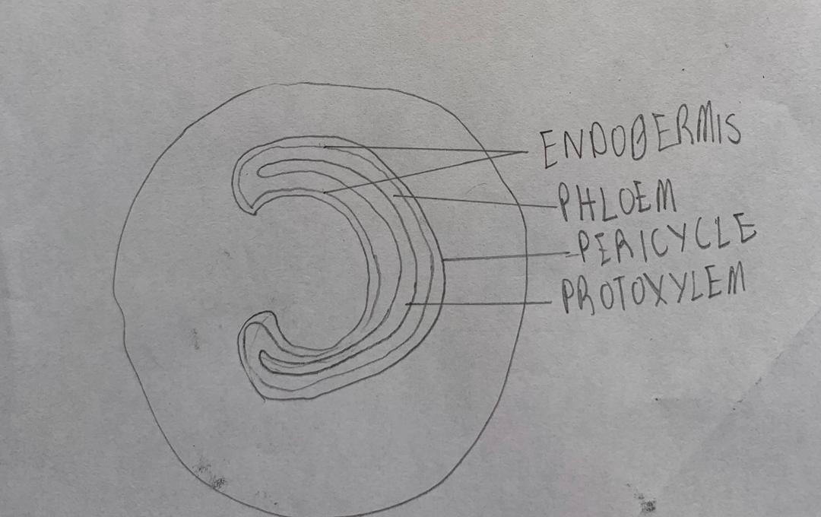

1. dictyostele – a stele in which the vascular cylinder is broken up into a longitudinal series or network of vascular strands around a central pith (as in many ferns). if multiple gaps in the vascular cylinder exist in any one transverse section. The numerous leaf gaps and leaf traces give a dictyostele the appearance of many isolated islands of xylem surrounded by phloem. Each of the apparently isolated units of a dictyostele can be called a meristele. Among living plants, this type of stele is found only in the stems of ferns.

DIAGRAM OF A DICTYOSTELE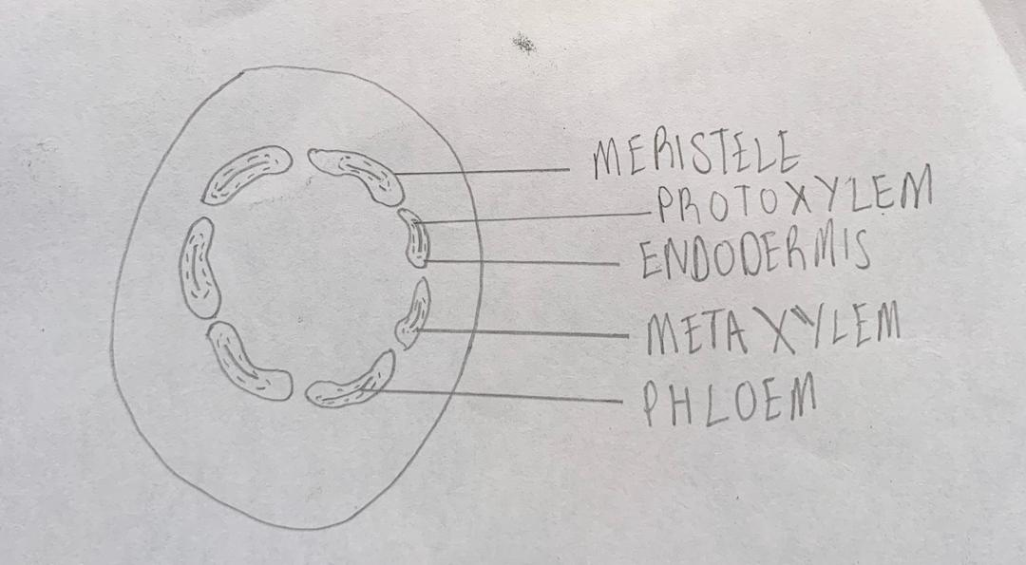

1. Illustrate the life cycle of a primitive vascular plant

Pteridophyta is a primitive vascular plat commonly known as fern. Therfore we shall discuss the life cycle of a fern.

The life cycle of the fern. (1) Clusters (sori) of sporangia (spore cases) grow on the undersurface of mature fern leaves. (2) Released from its spore case, the haploid spore is carried to the ground, where it germinates into a tiny, usually heart-shaped, gametophyte (gamete-producing structure), anchored to the ground by rhizoids (rootlike projections). (3) Under moist conditions, mature sperm are released from the antheridia and swim to the egg-producing archegonia that have formed on the gametophyte's lower surface. (4) When fertilization occurs, a zygote forms and develops into an embryo within the archegonium. (5) The embryo eventually grows larger than the gametophyte and becomes a sporophyte.

DIAGRAM OF THE LIFE CYLCE OF A PRIMITIVE VASCULAR PLANT