Name: Alkali Alheri
Matric no: 19/MHS01/086
Department : MBBS
College: medicine and health sciences.

- Importance of fungi to mankind.
- It serve as food as mushrooms and truffles are eaten by man.
- Fungi like cordyceps, Melonthae are used as insecticides to control insects.
- It can be used for soil fertility.
- It can be used for plant nutrition
- It can be used for medicine
- It can be used in bread and cake production.

- Cell structure of a unicellular fungus.

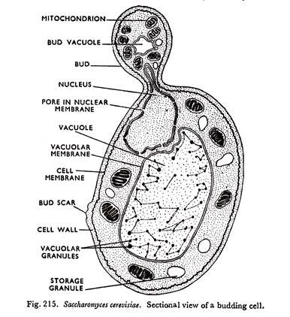

  - Sexual reproduction in a filamentous fungi like Rhizopus stolonifer undergoes the following steps;
First, two mating types of hyphae grow in the same medium.
A chemical interaction between them causes growth perpendicular to the hyphae in opposite directions, so they can meet with one another.
The growths are the delimited by a wall just so the nuclei are isolated in differentiated sex organs called gametangia (plural).
The gametangia fuse in a process called plasmogamy and together they form a zygote which may undergo dormancy for a period.
The nuclei in the zygote fuse in twos and undergo meiosis independently, it then moves on to germinating under favorable conditions so as to liberate haploid spores at maturity through the production of a fruiting.
In summary, sexual reproduction in fungi consists of three stages; plasmogamy, karogamy and meiosis.

4. Bryophytes possess a waxy cuticle that protects the plant tissue from drying out.
- The gamatang provide further protection against dry out specifically for the plant gametes.

5. Eustele a stele typical of dicotyledonous plants that consist of vascular bundles of xylem and phloem with parenchymal cells between the bundles.
- Atactostele: a type of eustele found in monocots in which the vascular tissue in the stem exists as scattered bundles.
- Siphonostele a stele consisting of a core of pith surrounded by concentric layers of xylem and phloem.
- Dictyostele: a stele in which the vascular cylinder is broken up into a longitudinal series or network of vascular strands.
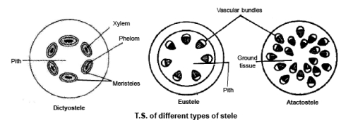

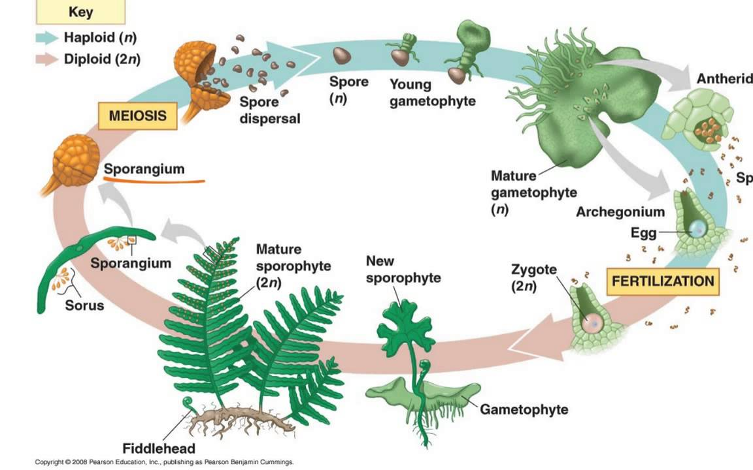
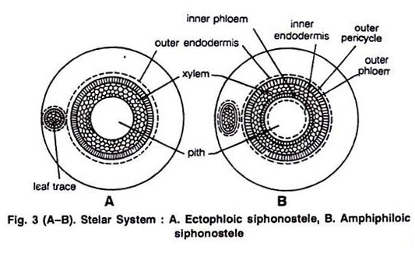
6. The illustration of the life cycle of a primitive vascular plant.

http://www.educreations.com/yt/645144/?ref=ytd

