NAME: RAJI OYINDAMOLA MARIAM
DEPARTMENT: NURSING ( 100 LEVEL)
COLLEGE: MEDICINE AND HEALTH SCIENCES
COURSE: BIO102
MATRIC NUMBER: 19/MHS02/110
ASSIGNMENT
1. How are fungi important to mankind?
Fungi are important to human life on many levels. They influence the well-being of human populations on a large scale because they are part of the nutrient cycle in ecosystems. They also have other ecosystem uses, such as pesticides. Fungi are important decomposers in most ecosystems. Mycorrhizal fungi are essential for the growth of most plants. Fungi, as food, play a role in human nutrition in the form of mushrooms, and also as agents of fermentation in the production of bread, cheeses alcoholic beverages, and numerous other food preparations.
2. Illustrate the cell structure of a unicellular fungus with a well labeled diagram
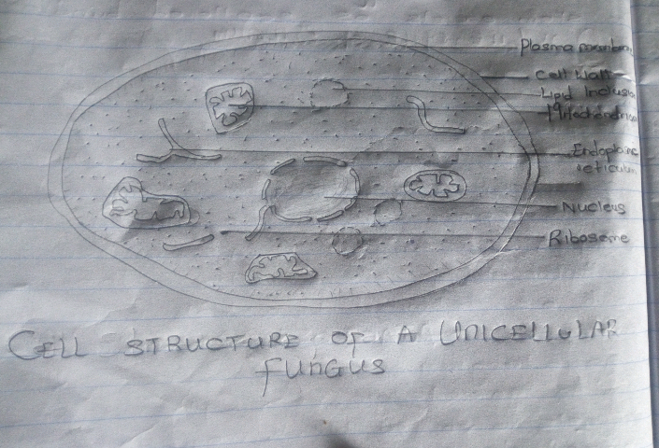

3. Outline the sexual reproduction in typical filamentous forms of fungi
RHIZOPUS STOLONIFER: Sexual reproduction occurs when two mating types of hyphae grow in the same medium chemical reaction in the two mating types of hyphae induces growths perpendicular to the hyphae in opposite directions. These growths are delimited by a wall such that many nuclei are isolated in what is called a gametangium. The two gametangia fuse (plasmogamy) and a zygote is formed which may undergo prolonged dormancy or resting stage. The nuclei in the zygotes fuse in two and undergo meiosis independently.
The zygote germinates under favorable conditions to produce a fruiting which at maturity liberates the haploid spores.
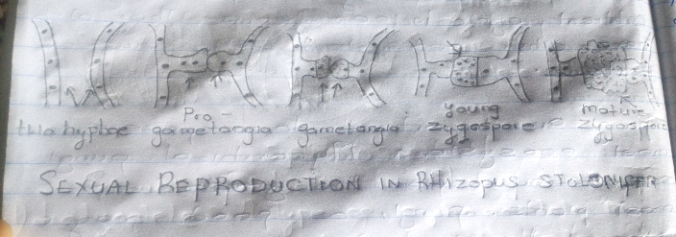

4. How do Bryophytes adapt their environment?
I. They have definite structures for water and nutrient adsorption from the soil; therefore the plant body is divided into two (an aerial portion and a subterranean portion). The subterranean portion is the rhizoid and is not a true root as the case of land plants that are advanced.
II. The aerial portion being exposed to the atmosphere demands some modifications that prevents excessive loss of water through the body surface (i.e. desiccation)
III. Some other modifications that permit elimination of excess water from the plant body and not only exchange of gases between the internal parts of the plant and the atmosphere therefore openings are available on the serial parts of the plant.
5. Describe with illustration the following terminologies
a. Eustele: A stele typical of dicotyledonous plants that consists of vascular bundles of xylem and phloem strands with parenchymal cells between the bundles.
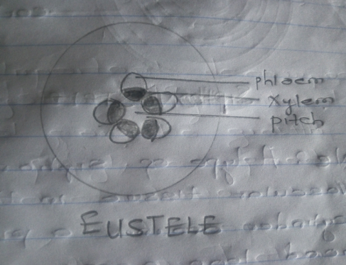

b. Atactostele: A type of eustele, found in monocots, in which the vascular tissue in the stem exists as scattered bundles.
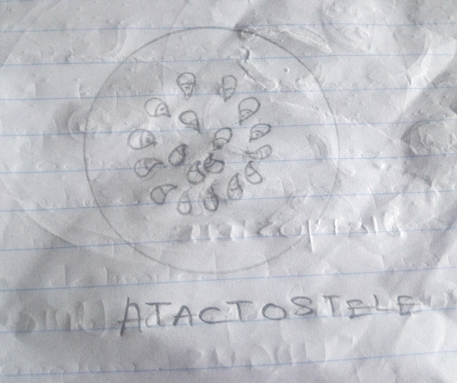

c. Siphonostele: A stele consisting of a core of pith surrounded by concentric layers of xylem and phloem.

d. Dictyostele: A type of siphonostele, in which the vascular tissue in the stem forms a central cylinder around pith, but with closely spaced leaf gaps.
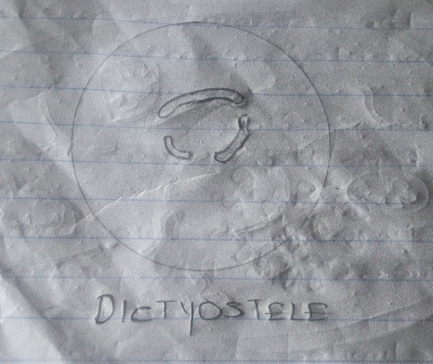

6. Illustrate the life cycle of a primitive vascular plant.

