NAME: OKOLI EMEKA
MATRIC NO: 16/SMS03/018
COURSE CODE: BUS 408
COURSE TITLE: HUMAN RESOURCES MANAGEMENT

- Explain explicitly what industrial relation is? Who are the parties involved and what are their function explain them

Industrial Relation is viewed as the “process by which people and their organizations interact at the place of work to establish the terms and conditions of employment.” The Industrial relations are also called as labour - management, employee employer’s relations. Industrial Relation are characterised by both conflict and co-operations. This is the basis of adverse relationship. So the focus of Industrial Relation is on the study of the attitudes, relationships, practices and procedure developed by the contending parties to resolve or at least minimize conflicts.

The main aspect of Industrial Relations
The main aspects or dimensions of industrial relations are.
- . Labour Relations, i.e. relations between union and management.
- Employer-employees relations, i.e. relations between management and employees.
- Group relations, i.e. relations between various groups of workmen. Community or Public relations, i.e. relations between industry and society
- Promotions and development of healthy labour-managements relations.

The parties involved in industrial relation
- Employee/workers
The workers who provide their services to the organization are an essential resource and contributes to generating the desired output.
Following are some of the reasons for which employees find maintaining sound industrial relations to be useful for them:
- Sharing their views, suggestions and ideas with the management to improve the business operations;
- becoming a part of organizational decision-making and ensuring the betterment of the working conditions
- speaking out their problems and grievances and seeking for the redressal of the same.
- Employers/ Management
Employers are responsible for providing a favourable work environment for the employees. They have many rights and powers like laying off inefficient employees, taking strategic decisions such as mergers, acquisition or shutdown of the organization and adapting technological changes in the operations.
Following are the different ways in which managers can benefit from sound industrial relations in the organization:
- Motivating the employees to give their best and gaining their trust and commitment;
- improving the overall efficiency and ensuring effective communication among the employees and the management;
- dealing with problems of trade union along with negotiation of employment terms and conditions with such employee representative.
- Government
Before the 19th century, the government didn’t use to intervene in the conflicts between the employer and the employee. However, later on, there was a change in the attitude of the government bodies, they started regulating the industrial relations through labour courts and tribunals, for the following reasons:
- Safeguarding the interest of both the parties;
- ensuring that both the employer and the employee, abide by the legal terms and conditions.

Trade Unions
When the workers unite together to form an association and elect a representative among themselves; for the protection of their rights and to raise their demands in front of the management; it is named as a trade union. Listed below are the objectives of such associations:
- Negotiating collectively with the administration for meeting the individual interest of an employee;
- upgrading the status of the employees in the organization;
- demanding better working conditions and higher job security for the workers;
- safeguarding the interest of the employees by demanding a higher level of democratic control over the decision-making at the organizational, corporate and national levels

- What is the indices of employment in Nigeria? Compare it to any African country of your choice and make your recommendation.

INDICE OF EMPLOYMENT IN NIGERIA
Employment Rate in Nigeria averaged 85.42 percent from 2014 until 2018, reaching an all-time high of 93.60 percent in the fourth quarter of 2014 and a record low of 76.90 percent in the third quarter of 2018. Employment Rate in Nigeria decreased to 76.90 percent in the third quarter of 2018 from 77.30 percent in the second quarter of 2018. Employment Rate in Nigeria is expected to be 75.00 percent by the end of this quarter, according to Trading Economics global macro models and analysts’ expectations. Looking forward, we estimate Employment Rate in Nigeria to stand at 76.00 in 12 months’ time. In the long-term, the Nigeria Employment Rate is projected to trend around 78.00 percent in 2021, according to our econometric models.

Employment Rate in Nigeria is expected to be 75.00 percent by the end of this quarter, according to Trading Economics global macro models and analysts’ expectations. Looking forward, we estimate Employment Rate in Nigeria to stand at 76.00 in 12 months’ time. In the long-term, the Nigeria Employment Rate is projected to trend around 78.00 percent in 2021, according to our econometric models.

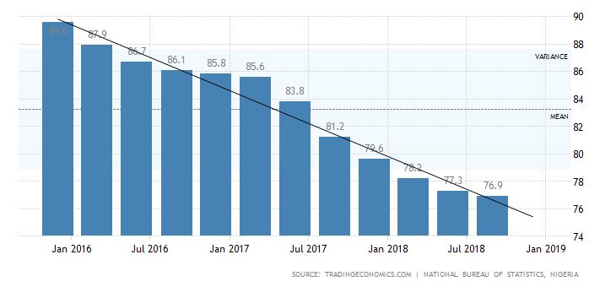
Nigeria Labour | Last | Previous | Highest | Lowest | Unit
Unemployment Rate | 23.10 | 22.70 | 23.10 | 5.10 | percent
Population | 200.00 | 195.87 | 200.00 | 45.14 | Million
Unemployed Persons | 20927.60 | 20343.60 | 20927.60 | 4672.00 | Thousand
Wages High Skilled | 57200.00 | 57200.00 | 57200.00 | 57200.00 | NGN/Month
Wages Low Skilled | 25500.00 | 25500.00 | 25500.00 | 25500.00 | NGN/Month
Youth Unemployment Rate | 36.50 | 38.00 | 38.00 | 11.70 | percent
Living Wage Family | 137600.00 | 135300.00 | 137600.00 | 135300.00 | NGN/Month
Living Wage Individual | 43200.00 | 41800.00 | 43200.00 | 41800.00 | NGN/Month
Minimum Wages | 30000.00 | 30000.00 | 30000.00 | 18000.00 | NGN/Month
Employed Persons | 69542.90 | 69165.60 | 70665.90 | 66951.00 | Thousand
Employment Rate | 76.90 | 77.30 | 93.60 | 76.90 | Percent
INDICE OF EMPLOYMENT IN MOROCCO

Employment Rate in Morocco decreased to 41.20 percent in the first quarter of 2020 from 41.60 percent in the fourth quarter of 2019.

Employment Rate in Morocco averaged 44.67 percent from 1999 until 2020, reaching an all-time high of 48 percent in the first quarter of 1999 and a record low of 40.70 percent in the third quarter of 2017.

Employment Rate in Morocco is expected to be 41.70 percent by the end of this quarter, according to Trading Economics global macro models and analysts’ expectations. Looking forward, it is estimated that Employment Rate in Morocco to stand at 40.10 in 12 months’ time. In the long-term, the Morocco Employment Rate is projected to trend around 41.56 percent in 2021 and 41.60 percent in 2022,

Actual | Previous | Highest | Lowest | Dates | Unit | Frequency
76.90 | 77.30 | 93.60 | 76.90 | 2014 - 2018 | percent | Quarterly

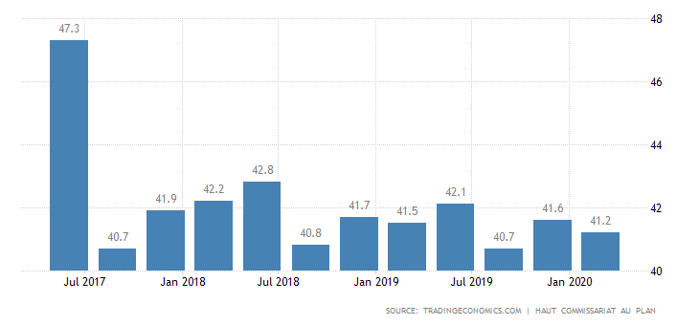

 | Actual | Previous | Highest | Lowest | Dates | Unit | Frequency
 | 41.20 | 41.60 | 48.00 | 40.70 | 1999 - 2020 | percent | Quarterly

Morocco Labour | Last | Previous | Highest | Lowest | Unit
Unemployment Rate | 10.50 | 9.20 | 15.10 | 7.80 | percent
Unemployed Persons | 1292.00 | 1107.00 | 1535.00 | 859.00 | Thousand
Employed Persons | 10957.00 | 10975.00 | 11082.00 | 8577.00 | Thousand
Population | 35.60 | 35.20 | 35.60 | 11.64 | Million
Youth Unemployment Rate | 24.90 | 26.70 | 29.30 | 13.10 | percent
Employment Rate | 41.20 | 41.60 | 48.00 | 40.70 | percent

