Name: Mbadiwe Chukwudike Godfrey
Medicine and surgery
19/MHS01/242
- BIO 102 ASSINGMENT

- How are fungi important to mankind?
- The help in material cycle in the ecosystem
- They are responsible for decay of organic matter in the enivorment
- Fungi such as saccharomyces cerevis are used in food making industry as yeast

- Illustrate the cell structure of a unicellular fungus with a labelled diagram.

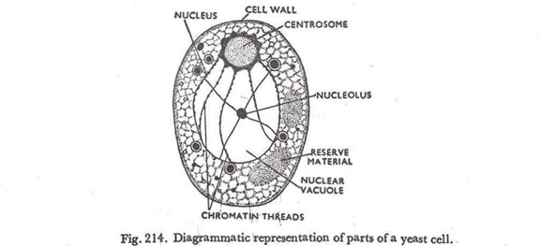
- Outline the sexual reproduction in a typical filamentous form of fungi.
This occurs when two mating types of hyphae grow in the same medium chemical interactions in the two mating types of hyphae induces growth perpendicular to the hyphae in the opposite directions. These growth are delimited by a wall such that many nuclei are isolated in what is called a gametangium.
The two gametangia fuse ( plasmagamy) and a zygote is formed which may undergo prolonged dormancy or resting stage. The nuclei in the zygote fuse in twos and undergo meiosis independently.
The zygote germinates under favourable conditions to produce a fruiting which at maturity liberates the haploid spores.

- How do bryophytes adapt to their environment?
- They have definite structures for water and nutrients absorptions from the soil therefore the plant body is divided into tissues.
- The aerial portion exposed to the atmosphere contains some structure that prevent loss of water to the enivorment
- Describe the followings terminologies
- Eusteles : Herbaceous dicotyledonous plants In which the vascular bundles are discrete, concentric and soilatonar bundles of the xylem and the phloem
- Atactostele : They are found in grasses and many monocotyledonous plants, thry are scattetred . The nature of vascular supply to leaves is also a worthy element of the vascular system.
- Siphonostele : These are leaves in which vascular supply to the leaves is associated with leaf gaps and the conducting cylinder .
- Dictyostele : the vascular cylinder in this stele is broken up into a longitudinal series or network of vascular strands around a central place.
- Illustrate the life cycle of a primitive plant.

