Name: Udoukpo Emem Oliver
Matric Number: 19/MHS06/030
Department: Medical laboratory science
Bio 102 assignment
1.Fungi are important to man for the following reasons;
a.They are responsible for the mediation of the decay of dead organic matter
b.Yeast is important in food industries like bakeries and yogurt making factories
c.Mushrooms are eaten by man
d.Some fungi are parasites to obnoxious pest of man
2. CELL STRUCTURE OF A UNICELLULAR FUNGUS

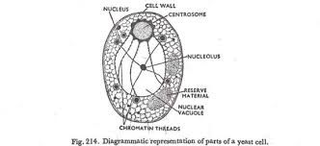

3. Sexual reproduction in a filamentous fungi like Rhizopus stolonifer undergoes the following steps;
a. First, two mating types of hyphae grow in the same medium.
b. A chemical interaction between them causes growth perpendicular to the hyphae in opposite directions, so they can meet with one another.
c. The growths are the delimited by a wall just so the nuclei are isolated in different sex organs called gametangia (plural)
d. The gametangia fuse in a process called plasmogamy and together they form a zygote which may undergo dormancy for a period.
e. The nuclei in the zygote fuse in two and undergoes meiosis independently, it then moves on to germinating under favorable conditions so as to liberate haploid spores at maturity through the production of fruiting.
f. In summary, sexual reproduction in fungi consist of three stages; Plasmogamy, karogamy and meiosis.
4. Bryophytes are available to survive in their habitat via the following;
i. They possess definite structures for water and nutrient absorption from the soil
ii. They also possess a waxy cuticle that keeps them from dying out through the process of desiccation.
iii. They possess gametangia that keeps the plant gamete from drying out.
5. A. Eusteles;a type of stele in which the vascular tissue in the stem forms a central ring of bundles
B. Atactostele; a type of stele found in monocots, in which vascular tissues in the stem exist as scattered bundles.
C. Dictyostele; a type of stele in which the vascular cylinder is broken up into a longitudinal series or network of vascular strands around a pith.
DIAGRAMMATIC ILLUSTRATION OF THE DIFFERENT STELES.
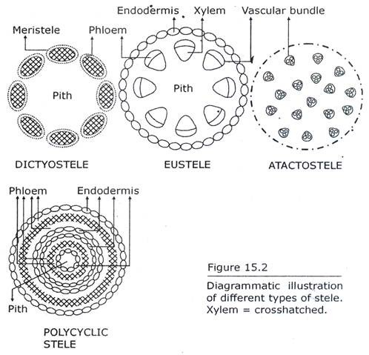

LIFE CYCLE OF A PRIMITIVE VASCULAR PLANT(PSILOTUM)
