NAME: Onyedinma Nzubechukwu Nmesoma
DEPARTMENT: Nursing
MATRIC NO.: 19/MHS02/101
COURSE: BIO 102
ASSIGNMENT
- Fungi are important to man for the following reasons;
- Mushrooms are eaten by man.
- Some fungi are parasites to obnoxious pets of man.
- They are responsible for the mediation of decay of dead organic matter.
- Yeast is important in food industries like bakeries and yogurt making factories.
- CELL STRUCTURE OF UNICELLULAR FUNGUS
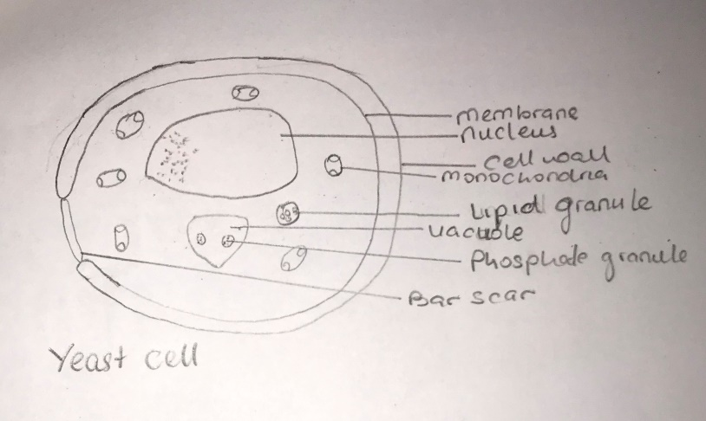

- Sexual reproduction in filamentous fungi like Rhizopus Stolonifer undergoes the following steps;
- Two mating types of hyphae grow in the same medium.
- A chemical interaction between them causes growth perpendicular to the hyphae in the opposite directions, so they can meet with one another.
- The growths are the delimited by a wall just so the nuclei are isolated in differentiated sex organs called gametangia.
- The gamentangia fuse in a process called plasmogamy and together the form a zygote which may undergo dormancy for a period.
- The nuclei in the zygote fuse in twos and undergo meiosis independently, it then moves un to germinating under favourable conditions so as to liberate haploid spores at maturity through the production of a fruiting.
- Sexual reproduction in fungi consists of three stages; plasmogamy, karogamy, and meiosis.
- Brophytes are able to survive in their habitat in the following ways;
- They possess definite structures for water and nutrient absorption from the soil.
- They possess a waxy cuticle that keeps them from drying out through the process of desiccation.
- They possess gametangia that keeps the plant gametes from drying out.
- Descriptions of some terminologies;
- Eusteles:
A type of stele in which the vascular tissue in the stem forms a central ring of bundles around a pith. The vascular bundles are discrete, concentric collateral bundles of xylem and phloem.
- Atactostele:
A type of stele found in monocots in which the vascular tissues in the stem exist as scattered bundles.
- Dictyostele:
A type of stele in which the vascular cylinder is broken up into a longitudinal series or network of vascular strands around a pith.
DIAGRAMATIC ILLUSTRATIONS OF EACH OF THE STELES;
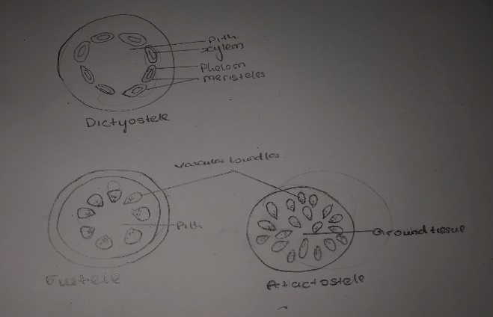

- LIFE CYCLE OF A PRIMITIVE VASCULAR PLANT (PSILOTUM)
