NAME: ADEDAYO-OJO PRISCILLA OLAMIDE
MATRIC NO: 19/MHS01/023
COLLEGE: MEDICAL AND HEALTH SCIENCES
DEPARTMENT: MEDICINE AND SURGERY
BIO 102(ASSIGNMENT)

- IMPORTANCE OF FUNGI TO MANKIND: Although we often think of fungi as organisms that cause disease and rot food, fungi are important to human life on many levels. Together with bacteria, fungi are responsible for breaking down organic matter and releasing carbon, oxygen, nitrogen, and phosphorus into the soil and the atmosphere. Fungi are essential to many household and industrial processes, notably the making of bread, wine, beer, and certain cheeses. They influence the well-being of human populations on a large scale because they are part of the nutrient cycle in ecosystems. Fungi are important decomposers in most ecosystems. Mycorrhizal fungi are essential for the growth of most plants. Fungi, as food, play a role in human nutrition in the form of mushrooms (Nutritional benefits of eating mushrooms. You can't go wrong with mushrooms. They're fat-free, low-sodium, low-calorie, and cholesterol-free. They're also packed with fiber, vitamins, and minerals) and also as agents of fermentation in the production of bread, cheeses, alcoholic beverages, and numerous other food preparations.

- Illustrate the cell structure of a unicellular fungus with a well labeled diagram.
Fungi are eukaryotes and have a complex cellular organization. As eukaryotes, fungal cells contain a membrane-bound nucleus where the DNA is wrapped around histone proteins. A few types of fungi have structures comparable to bacterial plasmids (loops of DNA). In the diagram below, we can see a well labeled diagram of a fungal cell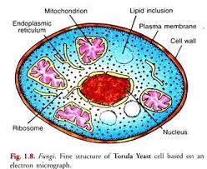
- SEXUAL REPRODUCTION IN A TYPICAL FILAMENTIOUS FORM OF FUNGI: The process of sexual reproduction among the fungi is in many ways unique. Sexual reproduction in the fungi consists of three sequential stages: plasmogamy, karyogamy, and meiosis. Plasmogamy, the fusion of two protoplasts (the contents of the two cells), brings together two compatible haploid nuclei. At this point, two nuclear types are present in the same cell, but the nuclei have not yet fused. Karyogamy results in the fusion of these haploid nuclei and the formation of a diploid nucleus (i.e., a nucleus containing two sets of chromosomes, one from each parent). The cell formed by karyogamy is called the zygote. In most fungi the zygote is the only cell in the entire life cycle that is diploid. The dikaryotic state that results from plasmogamy is often a prominent condition in fungi and may be prolonged over several generations. In the lower fungi, karyogamy usually follows plasmogamy almost immediately. In the more evolved fungi, however, karyogamy is separated from plasmogamy. Once karyogamy has occurred, meiosis (cell division that reduces the chromosome number to one set per cell) generally follows and restores the haploid phase. The haploid nuclei that result from meiosis are generally incorporated in spores called meiospores. Fungi employ a variety of methods to bring together two compatible haploid nuclei (plasmogamy). Some produce specialized sex cells (gametes) that are released from differentiated sex organs called gametangia. In other fungi two gametangia come in contact, and nuclei pass from the male gametangium into the female, thus assuming the function of gametes. In still other fungi the gametangia themselves may fuse in order to bring their nuclei together. Finally, some of the most advanced fungi produce no gametangia at all; the somatic (vegetative) hyphae take over the sexual function, come in contact, fuse, and exchange nuclei. The diploid chromosomes are pulled apart into two daughter cells, each containing a single set of chromosomes (a haploid state). Sexual reproduction, an important source of genetic variability, allows the fungus to adapt to new environments. Whereas nuclear division in other eukaryotes, such as animals, plants, and protists, involves the dissolution and re-formation of the nuclear membrane, in fungi the nuclear membrane remains intact throughout the process, although gaps in its integrity are found in some species. The nucleus of the fungus becomes pinched at its midpoint, and the diploid chromosomes are pulled apart by spindle fibers formed within the intact nucleus. The nucleolus is usually also retained and divided between the daughter cells, although it may be expelled from the nucleus, or it may be dispersed within the nucleus but detectable.

- HOW DO BRYOPHYTES ADAPT TO THEIR ENVIRONMENT? The Bryophytes are a division of plants that includes all non-vascular, land plants and can be split into three groups: mosses, hornworts and liverworts. Although each group is genetically very different they each share some common adaptations which have led to them currently being clumped together as Bryophytes. Two adaptations made the move from water to land possible for Bryophytes: a waxy cuticle and gametangia. The waxy cuticle helped to protect the plants tissue from drying out and the gametangia provided further protection against drying out specifically for the plants gametes. In addition to being non-vascular, Bryophytes have a set of common features that help to distinguish them from all other land plants. Mosses, hornworts and liverworts all reproduce using spores rather than seeds and don’t produce wood, fruit or flowers. Their life-cycle is dominated by a gametophyte generation which provides support and nutrients for the spore producing growth form known as the sporophyte. Some Bryophyte species have evolved special tissue which allows them to transport water and other substances through their tissue. However, the tissue doesn’t contain lignin, an essential protein found in true vascular tissue. This specialized tissue is therefore not considered to be vascular tissue although it does a respectable job of performing a similar function.

- A.) EUSTELES: A type of stele in which the vascular tissue in the stem forms a central ring of bundles around a pitch. The vascular bundles are discrete, concentric collateral bundles of xylem and phloem.

B.) ATACTOSTELE: this is a type of stele found in monocots, in which the vascular tissue in the stem exists as scattered bundles.

C.) DICTYOSTELE: A type of stele found in monocots, in which the vascular cylinder is brokrn up into a longitudinal series or network of vascular strands around a pith.
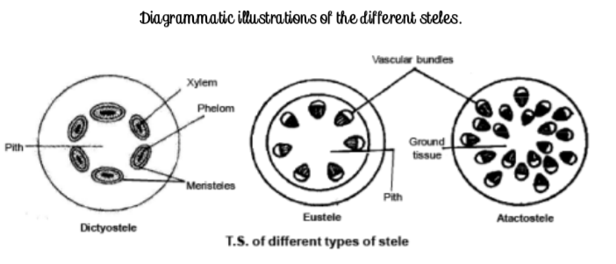
6. The life cycle of seedless vascular plants alternates between a diploid sporophyte and a haploid gametophyte phase. Seedless vascular plants reproduce through unicellular, haploid spores instead of seeds; the lightweight spores allow for easy dispersion in the wind. Seedless vascular plants require water for sperm motility during reproduction and, thus, are often found in moist environments.
- GAMETOPHYTE: a plant (or the haploid phase in its life cycle) that produces gametes by mitosis in order to produce a zygote
- SPOROPHYTE: a plant (or the diploid phase in its life cycle) that produces spores by meiosis in order to produce gametophytes
- TRACHEOPHYTE: any plant possessing vascular tissue (xylem and phloem), including ferns, conifers, and flowering plants
Seedless Vascular Plants
The vascular plants, or tracheophytes, are the dominant and most conspicuous group of land plants. They contain tissue that transports water and other substances throughout the plant. More than 260,000 species of tracheophytes represent more than 90 percent of the earth’s vegetation. By the late Devonian period, plants had evolved vascular tissue, well-defined leaves, and root systems. With these advantages, plants increased in height and size and were able to spread to all habitats.
Seedless vascular plants are plants that contain vascular tissue, but do not produce flowers or seeds. In seedless vascular plants, such as ferns and horsetails, the plants reproduce using haploid, unicellular spores instead of seeds. The spores are very lightweight (unlike many seeds), which allows for their easy dispersion in the wind and for the plants to spread to new habitats. Although seedless vascular plants have evolved to spread to all types of habitats, they still depend on water during fertilization, as the sperm must swim on a layer of moisture to reach the egg. This step in reproduction explains why ferns and their relatives are more abundant in damp environments, including marshes and rainforests. The life cycle of seedless vascular plants is an alternation of generations, where the diploid sporophyte alternates with the haploid gametophyte phase. The diploid sporophyte is the dominant phase of the life cycle, while the gametophyte is an inconspicuous, but still-independent, organism. Throughout plant evolution, there is a clear reversal of roles in the dominant phase of the life cycle.
