OSAGIE EFE VICTORIA MBBS 100L BIO102 ASSIGNMENT 19/MHS01/361

- How are Fungi important to mankind?
Fungi are responsible for the mediation of decay of organic matter. Without Fungi and other microbes, the surface of the earth would have been clogged up with dead matters with all the various elements locked up in them instead of returning into various cycles. Fungi e.g yeast, mushrooms are important in the food industry.
Many species mediate the spoilage of food, wood, clothes etc. Some Fungi are parasites, and some may cause diseases.

- Illustrate the cell structure of a unicellular fungus with a well labelled diagram.

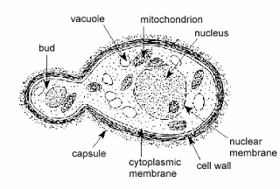

- Outline sexual reproduction in a typical filamentous form of Fungi.
In Rhizopus Stolonifer, sexual reproduction occurs when two mating types of hyphae grow in the same medium. Chemical interaction in the two mating types of hyphae induces growths perpendicular to the hyphae in opposite directions. These growths are delimited by a wall such that many nuclei are isolated in what is called Gametangium. The two gametangia fuse (plasmogamy) and a zygote is formed which may undergo prolonged dormancy or resting stage. The nuclei in the zygotes fuse in twos and undergo meiosis independently. The zygote germinates under favourable conditions to produce a fruiting which at maturity liberates the haploid spores.

- How do Bryophytes adapt to the environment?

- They have definite structures for water and nutrient absorption from the soil: therefore, the plant body is divided into two ( aerial portion and subterranean portion ). The subterranean portion is the rhizoid and is not a true root as the case of land plants that are advanced.
- The aerial portion being exposed to the atmosphere demands some modifications that prevents excessive loss of water through the body surface. (i.e desiccation)
- Some other modification that permit elimination of excess water from the plant body and not only exchange of gasses between the internal parts of the plant and the atmosphere therefore openings are available on the aerial parts of the plant.

- Describe with illustration the following terminologies:
(a) eusteles

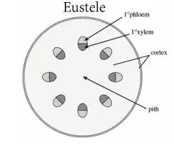

(b) atactostele

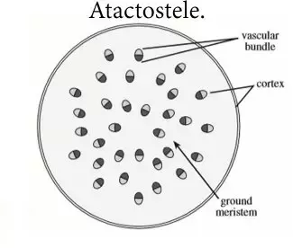

(c)siphonostele
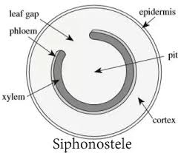

(d) dictyostele

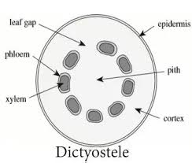

- Illustrate the life cycle of a primitive vascular plant.

