NAME: MOSHOOD IBRAHIM KOLAWOLE
MATRIC NO: 16/SMS03/015
COURSE CODE: BUS 408
COURSE TITLE: HUMAN RESOURCE MANAGEMENT

- Explain explicitly what industrial relation is? Who are the parties involved and what are their function explain them
People in the organizations are no longer considered as the part of machine, they are considered as the resources to the organization having the potential to take organization to a new height. It has been universally realized that in the long run the effectiveness of the organization largely depends upon the people and managing them properly act as a success for the organization.
Industrial relations defines the relationships between employers and employees towards each other in terms of supervision, direction, planning and coordination of organizational activities with minimal human effort and functions, all this is done with an enthusiastic spirit, taking into consideration the safety of all the employees.
Industrial relations can also be term as any kind of relationship that exist between management and employee or among employees and their organization growing out of employment relationship.
The main aspect of Industrial Relations
The main aspects or dimensions of industrial relations are.
- . Labour Relations, i.e. relations between union and management.
- Employer-employees relations, i.e. relations between management and employees.
- Group relations, i.e. relations between various groups of workmen. Community or Public relations, i.e. relations between industry and society
- Promotions and development of healthy labour-managements relations

Parties involves in industrial relations:
- The employees /workers or their representatives
- The employers/management or their representatives
- The labour union or trade union
- The government
- The community/society (the stakeholders)
The employee/worker: his role is to lay down his situation for work, he must be productive and help the organization to maximize profit. He must work to meet the organization objective and expect his/her salary as at when due.
The management/employee: most of their concern is work, he make sure that the workers work to meet the organizational objective He pay the wages/salary of the workers and make sure they are motivated to work and he tries to keep his own side of the collective agreement.
The labour/trade union: the trade union are representative of the workers, who join their association in negotiation with the employer or management. They are well skilled, professional in trade union activities. They act in the interest of their member against the caprice of unscrupulous employer. They the link between the employee and the management in matters that concern the workers such as, demand for better conditions of employment, job security and increase in wages welfare and others.
The government
The government stands as regulator between the employee and the employer, the government makes policies, rules and regulations that must be obeyed by parties such as the condition for employment, minimum wages and wages structure they ensure that there exist industry peace and harmony in the system.

The community/society
The society or communities are the consumers of goods and services produced by worker and the management or organization when there is conflict(strike) between workers and management Production will cease and this will affect the consumer.

- What is the indices of employment in Nigeria? Compare it to any African country of your choice and make your recommendation

INDICE OF EMPLOYMENT IN NIGERIA
Employment Rate in Nigeria is expected to be 75.00 percent by the end of this quarter, according to Trading Economics global macro models and analysts’ expectations. Looking forward, we estimate Employment Rate in Nigeria to stand at 76.00 in 12 months’ time. In the long-term, the Nigeria Employment Rate is projected to trend around 78.00 percent in 2021, according to our econometric models .Employment Rate in Nigeria averaged 85.42 percent from 2014 until 2018, reaching an all-time high of 93.60 percent in the fourth quarter of 2014 and a record low of 76.90 percent in the third quarter of 2018. This page provides - Nigeria Employment Rate- actual values, historical data, forecast, chart, statistics, economic calendar and news. Nigeria Employment Rate - values, historical data and charts - was last updated on May of 2020. Employment Rate in Nigeria decreased to 76.90 percent in the third quarter of 2018 from 77.30 percent in the second quarter of 2018. Employment Rate in Nigeria is expected to be 75.00 percent by the end of this quarter, according to Trading Economics global macro models and analysts’ expectations. Looking forward, we estimate Employment Rate in Nigeria to stand at 76.00 in 12 months’ time. In the long-term, the Nigeria Employment Rate is projected to trend around 78.00 percent in 2021, according to our econometric models.

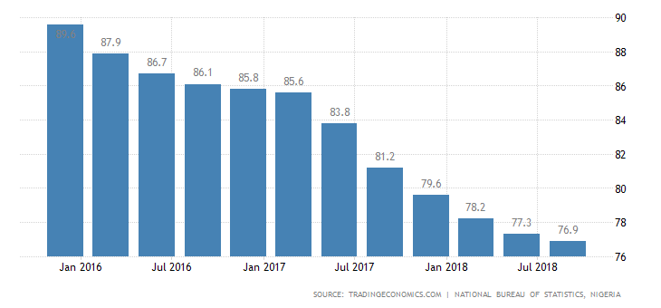
Nigeria Labour | Last | Previous | Highest | Lowest | Unit
Unemployment Rate | 23.10 | 22.70 | 23.10 | 5.10 | percent
Population | 200.00 | 195.87 | 200.00 | 45.14 | Million
Unemployed Persons | 20927.60 | 20343.60 | 20927.60 | 4672.00 | Thousand
Wages High Skilled | 57200.00 | 57200.00 | 57200.00 | 57200.00 | NGN/Month
Wages Low Skilled | 25500.00 | 25500.00 | 25500.00 | 25500.00 | NGN/Month
Youth Unemployment Rate | 36.50 | 38.00 | 38.00 | 11.70 | percent
Living Wage Family | 137600.00 | 135300.00 | 137600.00 | 135300.00 | NGN/Month
Living Wage Individual | 43200.00 | 41800.00 | 43200.00 | 41800.00 | NGN/Month
Minimum Wages | 30000.00 | 30000.00 | 30000.00 | 18000.00 | NGN/Month
Employed Persons | 69542.90 | 69165.60 | 70665.90 | 66951.00 | Thousand
Employment Rate | 76.90 | 77.30 | 93.60 | 76.90 | Percent
Actual | Previous | Highest | Lowest | Dates | Unit | Frequency
76.90 | 77.30 | 93.60 | 76.90 | 2014 - 2018 | percent | Quarterly

INDICES OF EMPLOYMENT IN SOUTH AFRICA

Employment Rate in South Africa remained unchanged at 42.40 percent in the fourth quarter of 2019 from 42.40 percent in the third quarter of 2019

Employment Rate in South Africa averaged 43.16 percent from 2000 until 2019, reaching an all-time high of 46.17 percent in the fourth quarter of 2008 and a record low of 41 percent in the first quarter of 2004. This page provides - South Africa Employment Rate- actual values, historical data, forecast, chart, statistics, economic calendar and news. South Africa Employment Rate - values, historical data and charts - was last updated on May of 2020

Employment Rate in South Africa is expected to be 43.00 percent by the end of this quarter, according to Trading Economics global macro models and analysts’ expectations. Looking forward, we estimate Employment Rate in South Africa to stand at 43.30 in 12 months’ time. In the long-term, the South Africa Employment Rate is projected to trend around 44.20 percent in 2021, according to our econometric models.

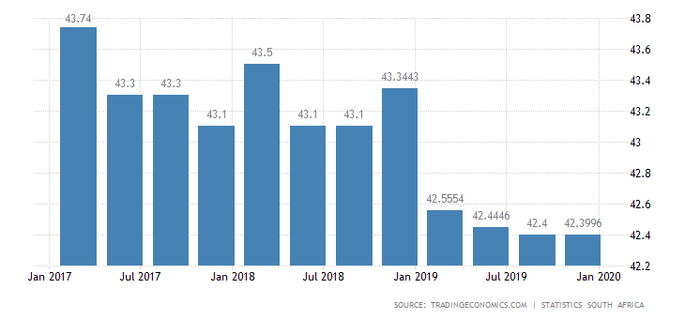

 | Actual | Previous | Highest | Lowest | Dates | Unit | Frequency
 | 42.40 | 42.40 | 46.17 | 41.00 | 2000 - 2019 | percent | Quarterly

South Africa Labour | Last | Previous | Highest | Lowest | Unit
Unemployment Rate | 29.10 | 29.10 | 30.40 | 21.50 | percent
Employed Persons | 10213000.00 | 10142000.00 | 10213000.00 | 3694977.00
Unemployed Persons | 6700.00 | 6700.00 | 6700.00 | 3873.00 | Thousand
Labor Force Participation Rate | 59.80 | 59.90 | 60.80 | 53.60 | percent
Labour Costs | 160.50 | 161.10 | 161.10 | 1.00 | points
Wages | 22500.00 | 21966.00 | 22500.00 | 6742.00 | ZAR/Month
Wages in Manufacturing | 19377.00 | 19122.00 | 19377.00 | 6250.00 | ZAR/Month
Population | 58.80 | 58.78 | 58.80 | 17.46 | Million
Retirement Age Women | 60.00 | 60.00 | 60.00 | 60.00
Retirement Age Men | 60.00 | 60.00 | 65.00 | 60.00
Living Wage Family | 11300.00 | 10700.00 | 11300.00 | 10700.00 | ZAR/Month
Living Wage Individual | 6570.00 | 6140.00 | 6570.00 | 6140.00 | ZAR/Month
Minimum Wages | 20.76 | 20.00 | 20.76 | 20.00 | ZAR/Hour
Wages Low Skilled | 4380.00 | 3960.00 | 4380.00 | 3840.00 | ZAR/Month
Youth Unemployment Rate | 58.10 | 58.20 | 58.20 | 48.80 | percent
Wages High Skilled | 22600.00 | 20300.00 | 22600.00 | 19000.00 | ZAR/Month
Employment Rate | 42.40 | 42.40 | 46.17 | 41.00 | percent

Recommendations
In order for Nigeria to stay above 23% unemployment rate, the government needs to create 3.3 million jobs every year. In the last four years the government had only manage to create 625,000 jobs which is a very disappointing figures given Nigeria resources and status in Africa, 16.2 million people were added to the active workforce in the last 5 years. This edge us to closer to a humongous problems. For the Nigeria government to be able to create 3.3million jobs per year, it need to make the private sector attractive by encouraging foreign direct investment which according to statistics is not going well.
According to the Nigeria economic summit group (NESG) at the moment the country private sector doesn’t have the capacity to absorb the rapidly increasing population of the unemployed in a short period.

