NAME: OLUWANIFEMI ALEXIA ADEOGUN.
MATRIC NO: 19/MHS01/036.
COURSE CODE: BIO102.
DEPARTMENT: MBBS.
1. How are fungi important to mankind?
Ans : a. Fungi are responsible for the mediation of decay of organic matter.
b. yeast are important in the food industry.
c. mushrooms are a source of food to individuals in some societies.
d. without fungi and other microbes, the surface of the Earth would have been clogged up with dead matters with all the various elements locked up in them instead of returning into various cycles.
e. many fungi species mediate the spoilage of wood, food, clothes and paper.
2. Illustrate the cell structure of a unicellular fungus with a well labeled diagram
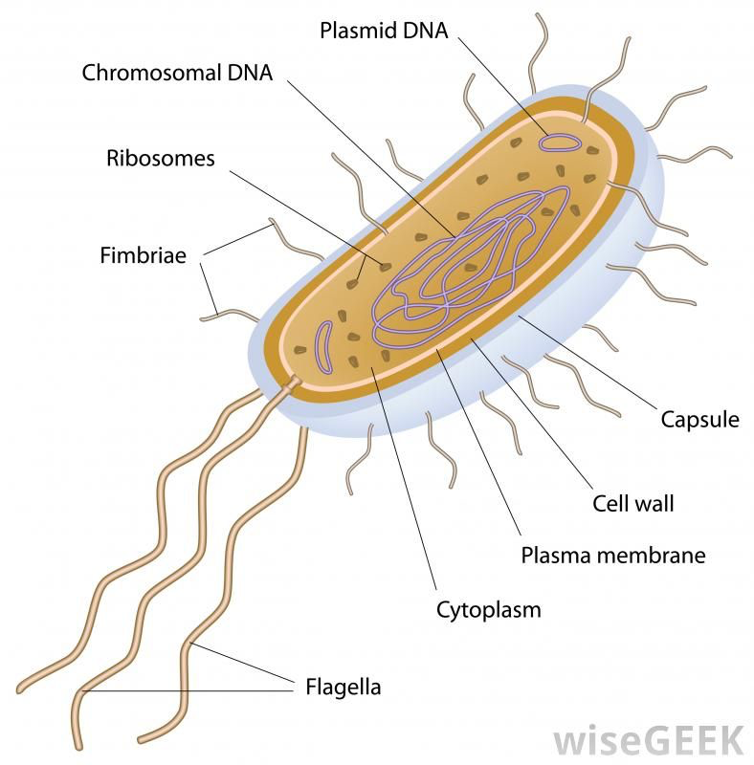
Ans:

3. Sexual reproduction in a filamentous fungi like Rhizopus stolonifer undergoes the following steps;
i. First, two mating types of hyphae grow in the same medium.
ii. A chemical interaction between them causes growth perpendicular to the hyphae in opposite directions, so they can meet with one another.
iii. The growths are the delimited by a wall just so the nuclei are isolated in differentiated sex organs called gametangia (plural).
iv. The gametangia fuse in a process called plasmogamy and together they form a zygote which may undergo dormancy for a period.
v. The nuclei in the zygote fuse in twos and undergo meiosis independently, it then moves on to germinating under favorable conditions so as to liberate haploid spores at maturity through the production of a fruiting.
vi. In summary, sexual reproduction in fungi consists of three stages; plasmogamy, karogamy and meiosis.
4. How do Bryophytes adapt to their environment
Ans: a. They have definite structures for water and nutrient absorption from the soil; therefore the plant body is divided into two (an aerial portion and a subterranean portion).
b. The aerial portion being exposed to the atmosphere demands some modifications that prevent excessive loss of water through the body(i.e. dessication)
c. some other modifiactions that permit elimination of excess water from the plant body and not only exchange of gases between the internal parts of the plant and the atmosphere therefore openings are available on the aerial parts of the plant.
5. A. Eusteles; a type of stele in which the vascular tissue in the stem forms a central ring of bundles around a pith. The vascular bundles are discrete, concentric collateral bundles of xylem and phloem.
B. Atactostele; a type of stele found in monocots, in which the vascular tissue in the stem exists as scattered bundles.
C. Dictyostele; a type of stele in which the vascular cylinder is broken up into a longitudinal series or network of vascular strands around a pith.
Diagrammatic illustrations of the different steles.
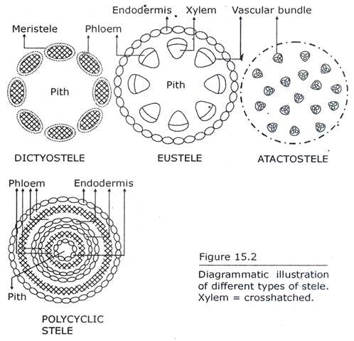

6.Life cycle of a primitive vascular plant(psilotum).
