NAME; Maduka Uchenna Johnpaul
MATRIC NUMBER; 19/MHS0/239
DEPARTMENT; Medicine and Surgery
BIO 102 ASSIGNMENT
- Fungi are important to man for the following reasons;
- They are responsible for the mediation of the decay of dead organic matter.
- Yeast is important in food industries like bakeries and yogurt making factories.
- Mushrooms are eaten by man.
- Some fungi are parasites to obnoxious pests of man.

CELL STRUCTURE OF A UNICELLULAR FUNGUS
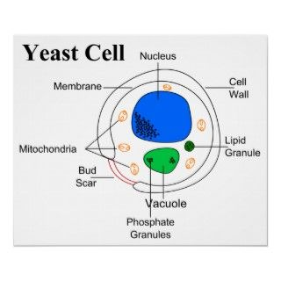
- Sexual reproduction in a filamentous fungi like Rhizopus stolonifer undergoes the following steps;
- First, two mating types of hyphae grow in the same medium.
- A chemical interaction between them causes growth perpendicular to the hyphae in opposite directions, so they can meet with one another.
- The growths are the delimited by a wall just so the nuclei are isolated in differentiated sex organs called gametangia (plural).
- The gametangia fuse in a process called plasmogamy and together they form a zygote which may undergo dormancy for a period.
- The nuclei in the zygote fuse in twos and undergo meiosis independently, it then moves on to germinating under favorable conditions so as to liberate haploid spores at maturity through the production of a fruiting.
- In summary, sexual reproduction in fungi consists of three stages; plasmogamy, karogamy and meiosis.
- Bryophytes are able to survive in their habitat via they following;
- They possess definite structures for water and nutrient absorption from the soil.
- They also possess a waxy cuticle that keeps them from drying out through the process of desiccation
- They possess gametangia that keep the plants gametes from drying out.
- A. Eusteles; a type of stele in which the vascular tissue in the stem forms a central ring of bundles around a pith. The vascular bundles are discrete, concentric collateral bundles of xylem and phloem.
B. Atactostele; a type of stele found in monocots, in which the vascular tissue in the stem exists as scattered bundles.
C. Dictyostele; a type of stele in which the vascular cylinder is broken up into a longitudinal series or network of vascular strands around a pith.
Diagrammatic illustrations of the different steles.
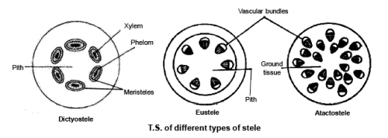

Life cycle of a primitive vascular plant (psilotum)

