Name: Onwuocha Chisom Dianne
Department: Pharmacy
Matric no: 19/MHS11/114
BIO 102 Assignment
- Fungi are important to Man for the following reasons;
  - They are responsible for the mediation of the decay of dead organic matter.
  - They are used to produce antibiotics such as penicillin.
  - They are used in the brewing of alcoholic beverages.
  - Mushrooms are eaten as food by man.
  - They are used for pest control.
  - Yeast is used in the making of bread and other baked pastry.
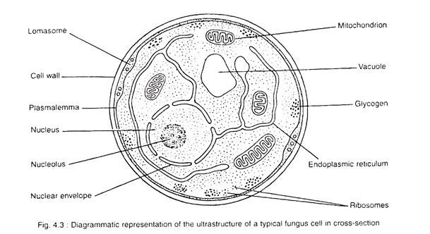
- Sexual reproduction in a filamentous fungi like Rhizipus stolonifera undergoes the following steps:
Two mating types of hyphae grow in the same medium. A chemical reaction between them causes growth perpendicular to the hyphae in opposite so that hey can meet one another. The growths are the delimited by a wall just so the nuclei are isolated in differentiated sex organs called gametangia (plural). The gametangia fuses in a process called plasmogamy and together to hey form zygote which undergoes a dormancy for a period. The nuclei in the zygote fuses in two's and undergoes meiosis independently, it moves on to germinate under favourable conditions so as to liberate haploid spores at maturity through the production of a fruiting.
In summary, sexual reproduction In fungi involves three stages: plasmogamy, karyogamy and meiosis.
- Bryophyte adapt to their environment in the following ways:
  - The presence of the waxy cuticle helps to protect the plants tissue from drying out in terrestrial habitat.
  - Presence of gametangia provide further protection against drying out specifically for gametes, the zygote and the developing sporophytes.
  - They possess definite structure for water and nutrients absorption from the soil.
  - The stomata provide gas exchange between the atmosphere and an internal intercellular space system.
- a. Eustele: is a stele typical of dicotyledonous plant that consists of vascular bundles of xylem and phloem strands with parenchymal cells between the bundles.
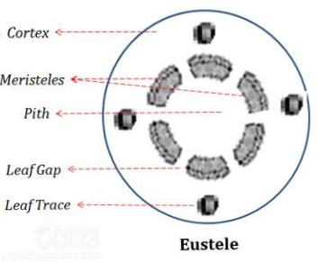
b. Atactostele: a type of stele; found in monocotyledonous, in which the vascular tissues in the stem exists as scattered bundles.
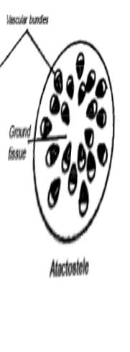
c. Siphonostele: a stele in which the vascular tissues is in the form of a cylinder surrounding the pith, as in the stems of most ferns and other seedless vascular plants.

d. Dictyostele: a type of Siphonostele in which the vascular tissue in the stems forms a central cylinder around the pith, but which closely spaced leaf gap.
