NAME: OSATIMEHIN VICTOR AYOTOMIDE

DEPARTMENT: DENTISTRY

MATRIC NO: 19/MHS09/019

COURSE CODE: BIO 102

ASSIGNMENT

- How are fungi important to mankind?

Fungi are important to man in the following ways:

- They are edible in some parts of the country.

- Yeast is used in the production of bread (makes it to rise)

- They serve as a source of income in other countries

- They recycle the eco-system; by breaking down of complex organic matter

- Fermentation process

2. Illustrate the cell structure of a unicellular fungus with a well labelled diagram

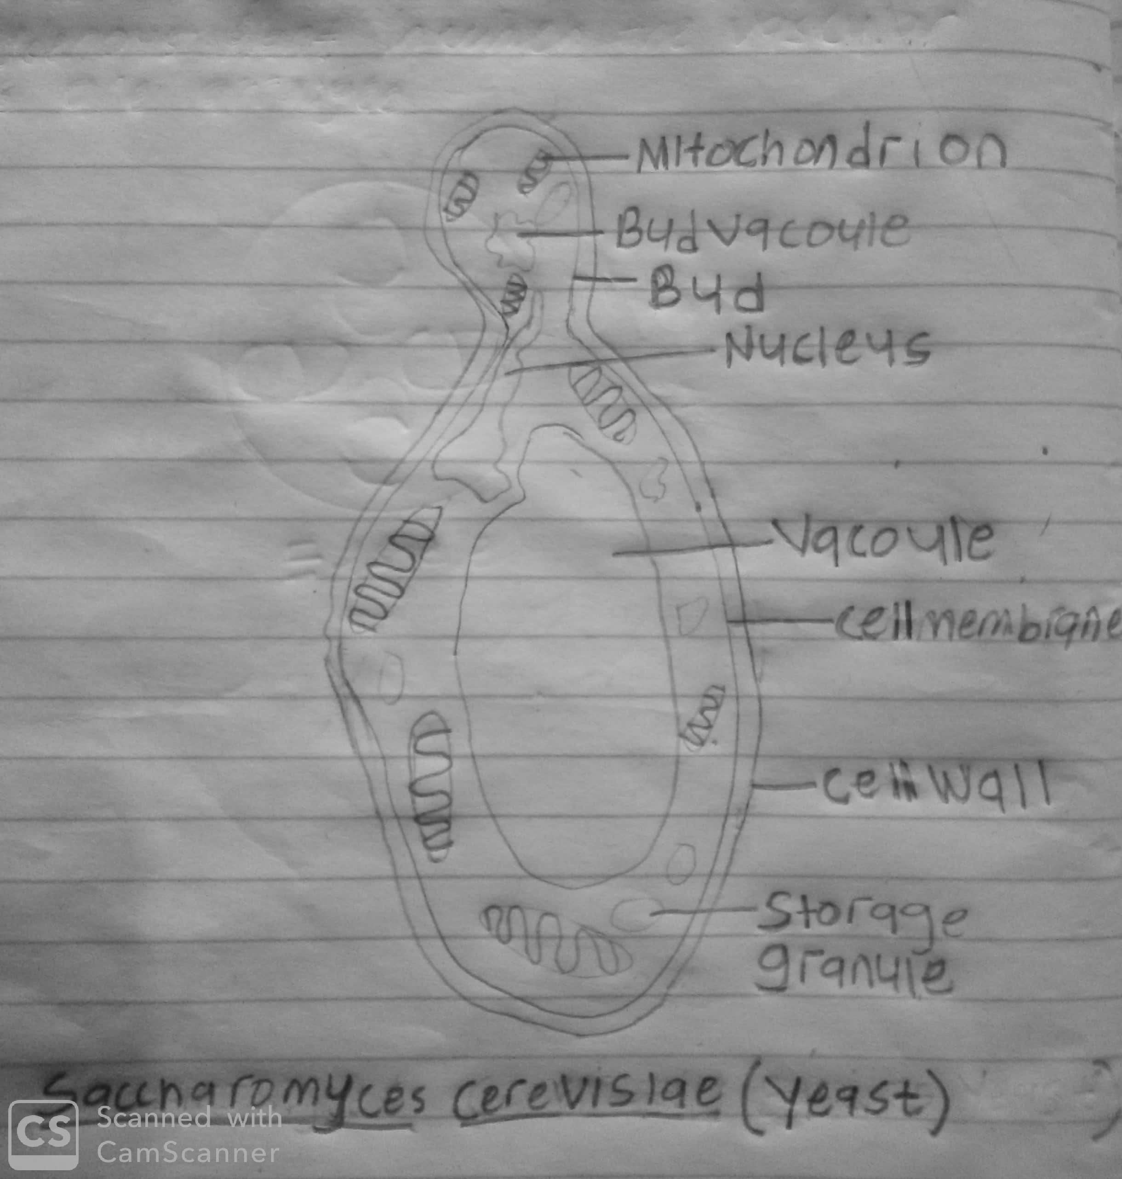

- Outline the sexual reproduction in a typical filamentous form of fungi.

Rhizopusstolonifer is a filamentous fungi that undergo sexual reproduction in the following ways:
- Two mating hyphae grow in the same medium. Chemical interaction in the two mating types of hyphae induces growths perpendicular to the hyphae in opposite directions.
- The two gamentagia fuse (plasmogamy) and a zygote is formed which may undergo prolonged dormancy or resting stage.
- The nuclei in the zygotes fuse in to twos and undergo meiosis independently.
- The zygote germinates under favorable conditions to produce a fruiting which at maturity liberates the haploid spores.

4. How do bryophytes adapt to their environment?

Bryophytes are nonvascular plant that do not have true stems, trueroots, and have no vascular bundles; they adapt to their environment in the following ways:
A.they have definite structure for water and nutrient adsorption from the soil; therefore the plant body is divided into two – (the subterranean portion and the aerial potion). The subterranean portion is the rhizoid and it is not a true root as the case of lands plants are advanced.
B.the aerial portion prevents the loss of excess water through the body surface
c. Opening on the aerial portion permits internal exchange of gasses and other modifications that permit elimination of excess loss of water from the plant.

5. Describe with illustration the following terminologies (a) eusteles. (b) Atactostele. (c) Siphonostele. (d) Dictyostele.
5a. EUSTELES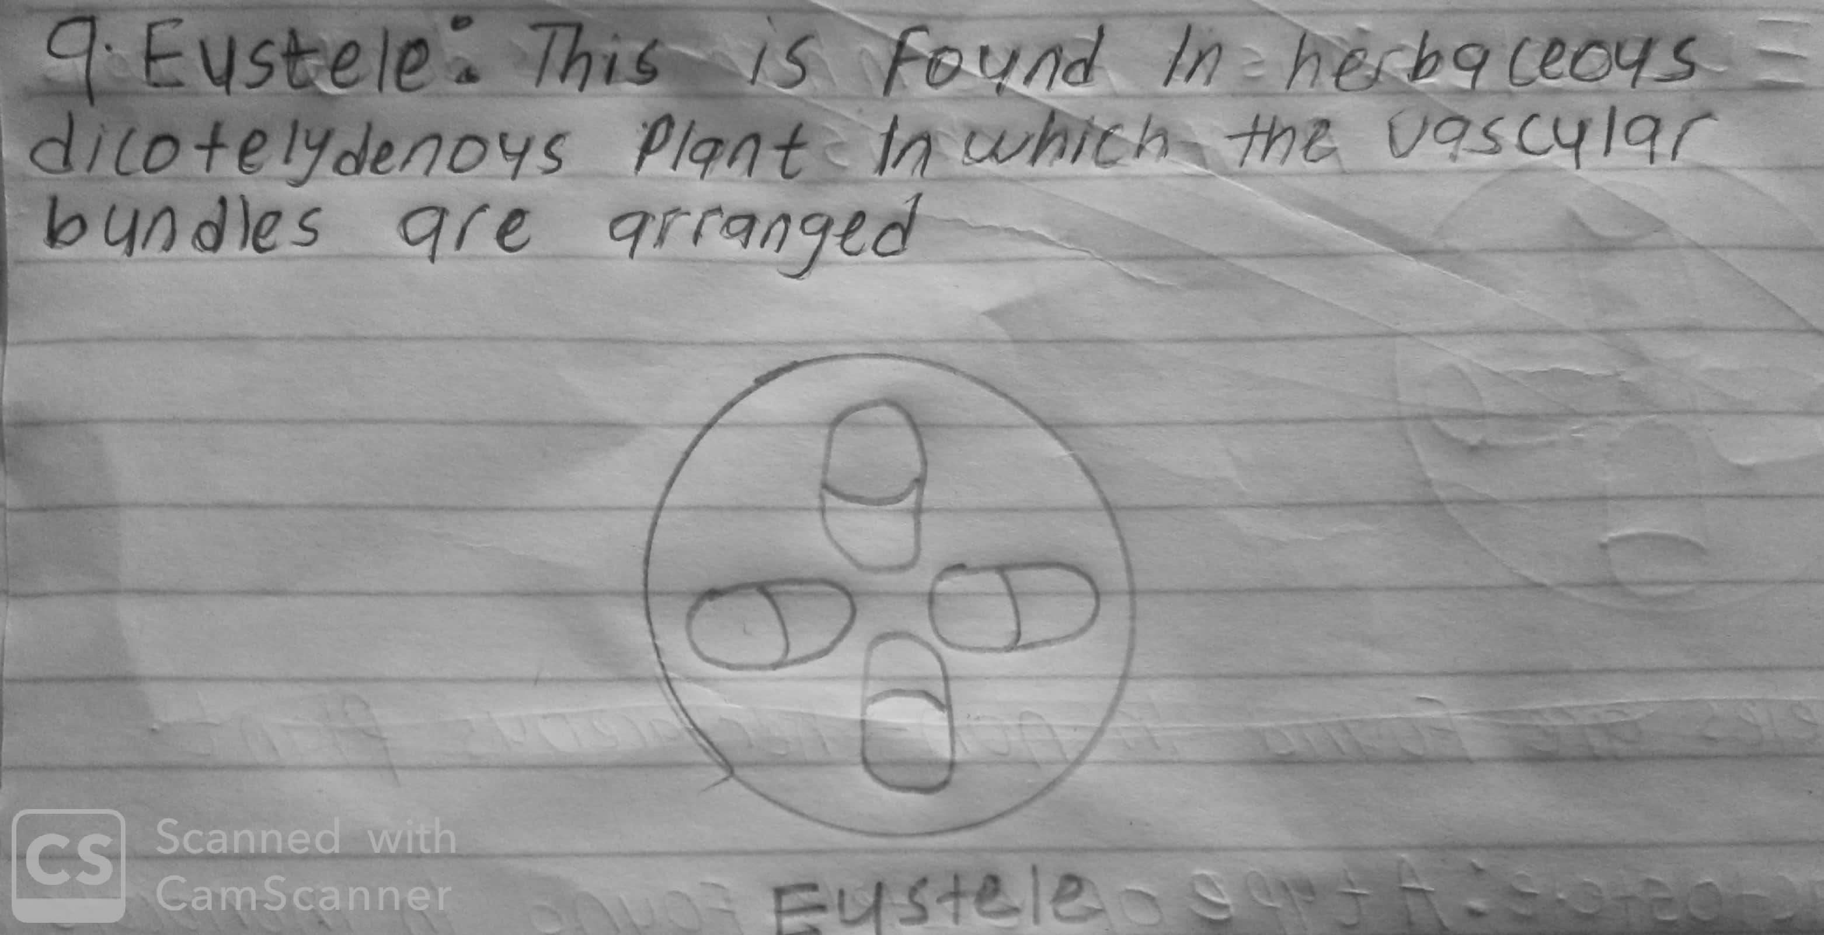

5b. ATACTOSTELE
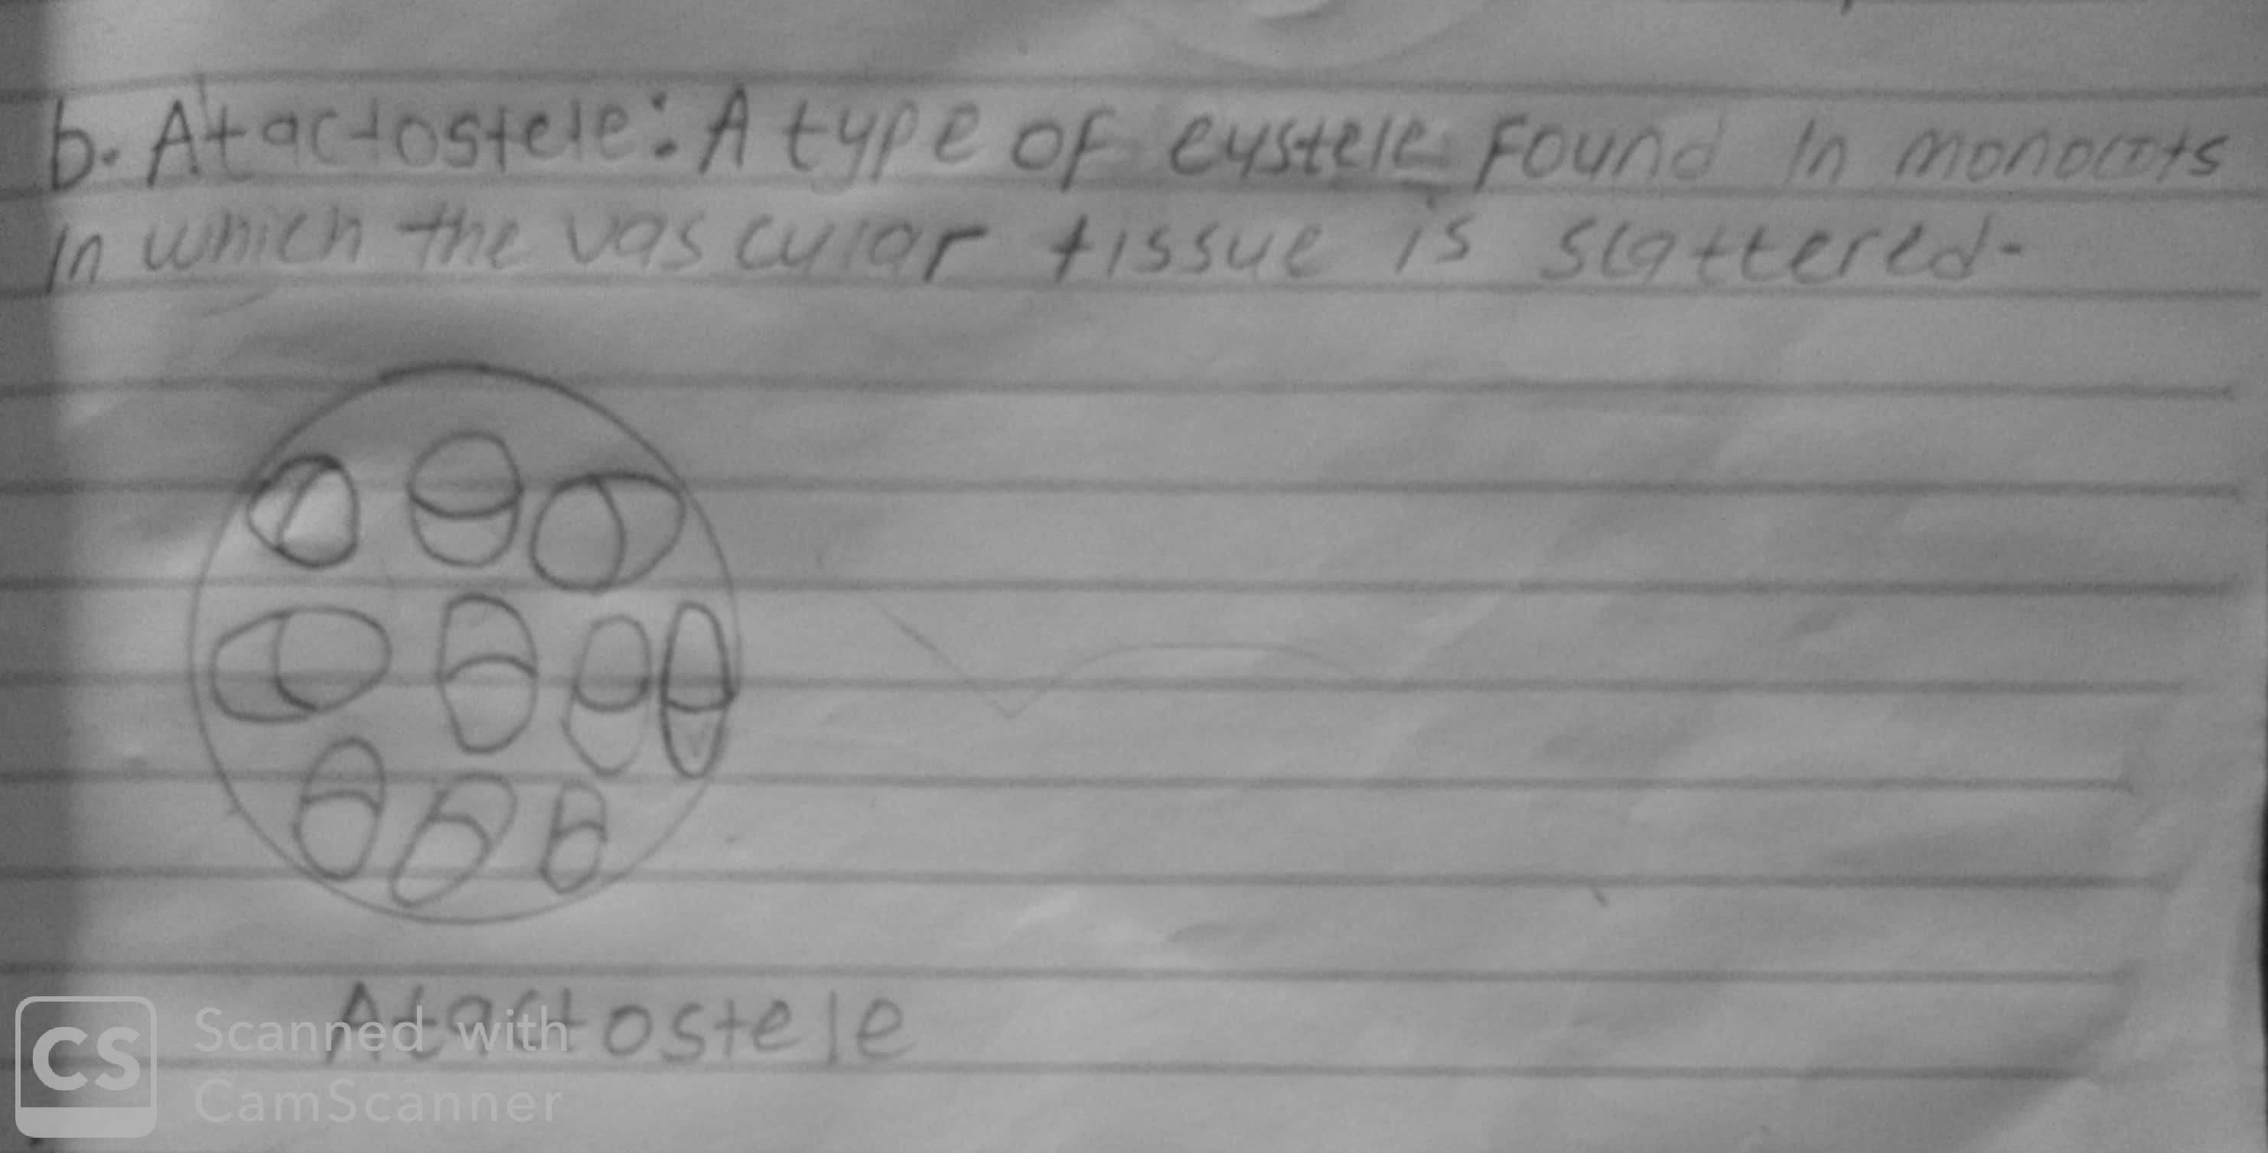

5C. SIPHONOSTELE
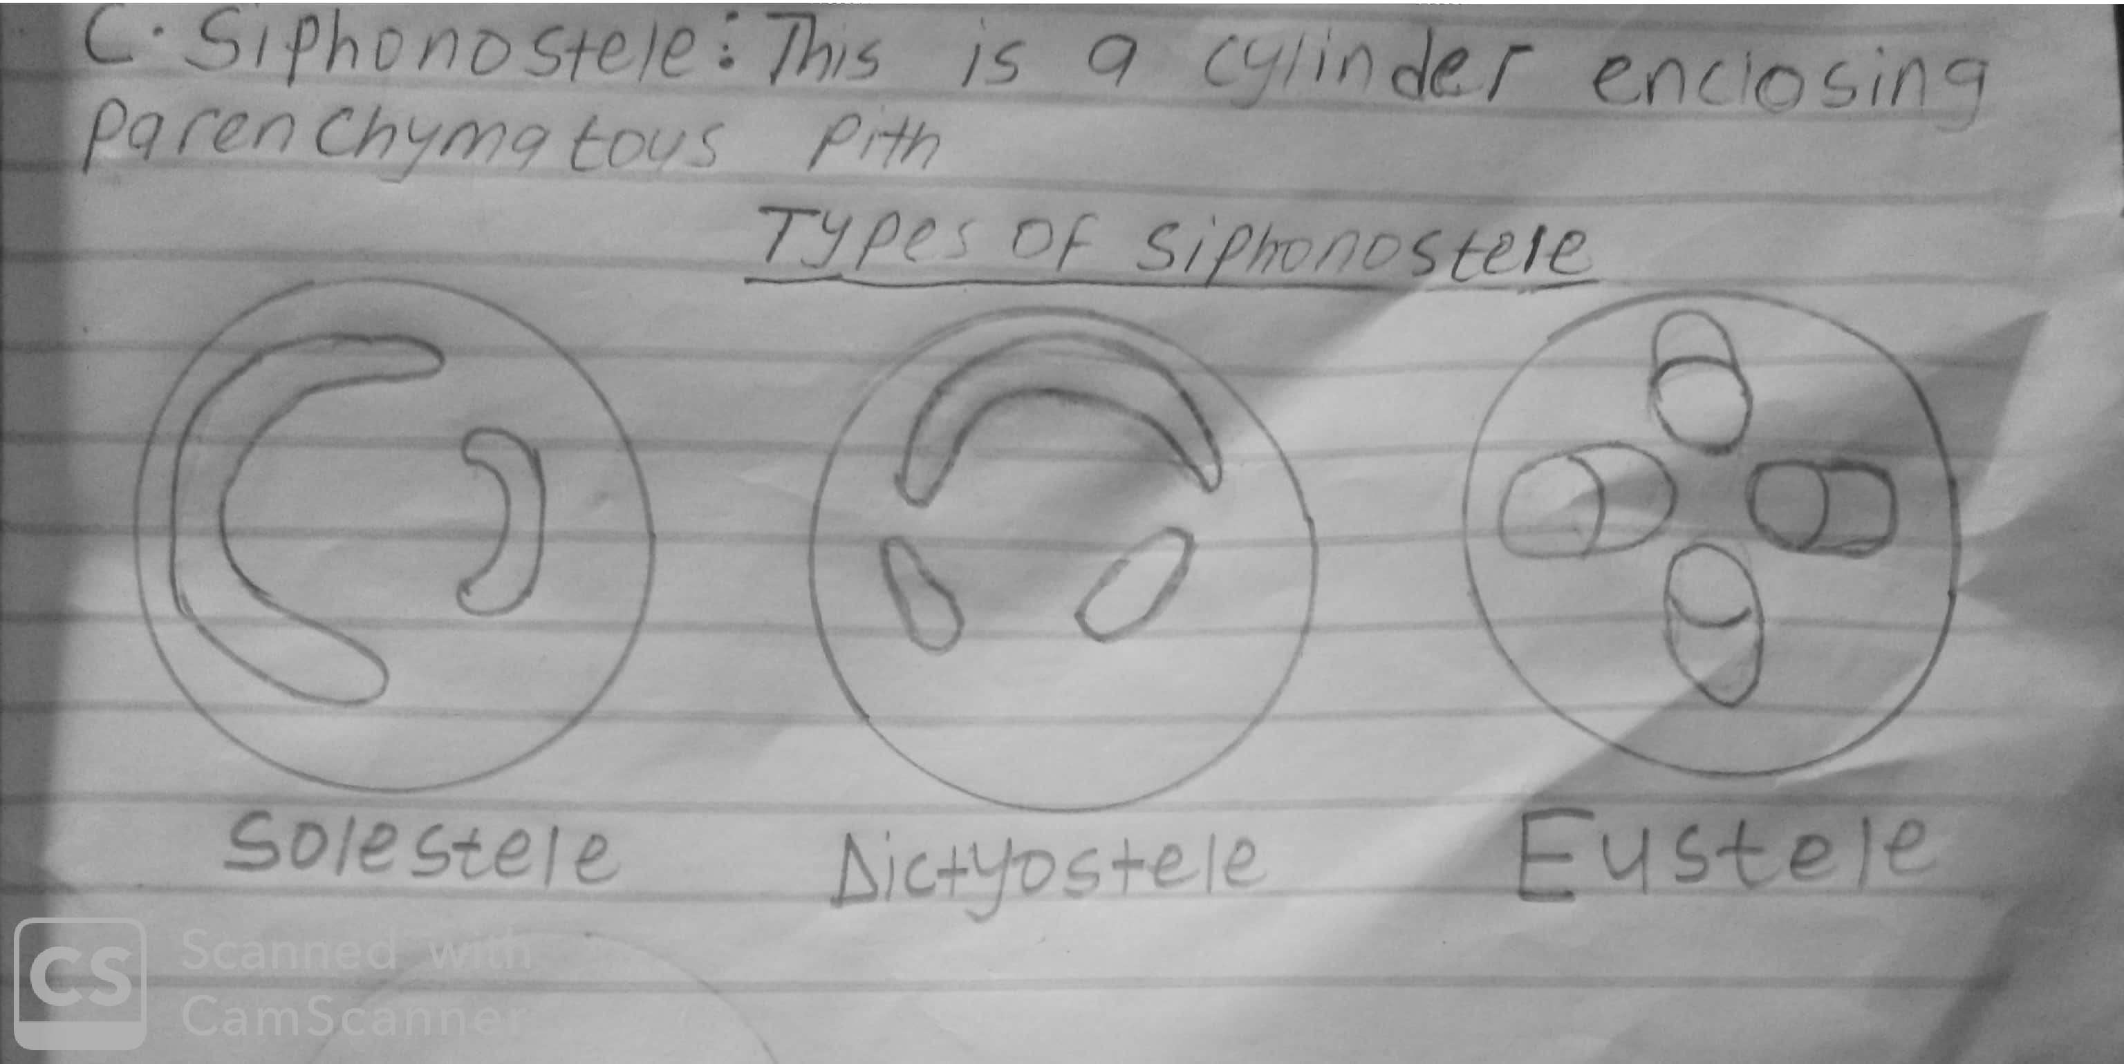

5d. DICTYOSTELE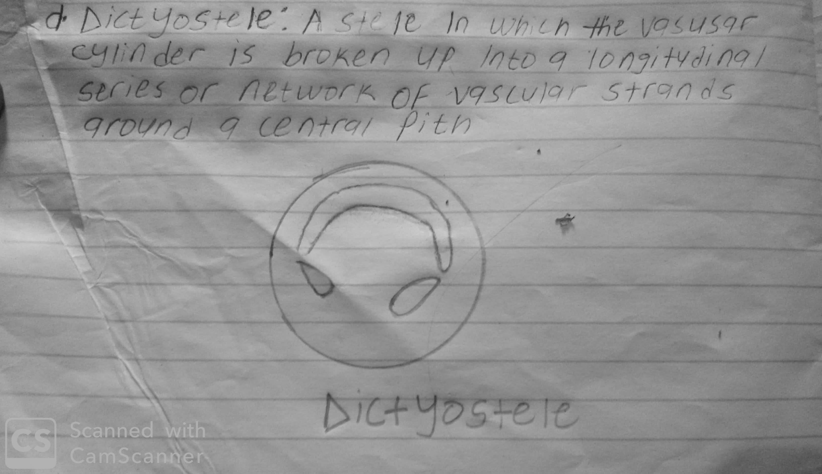

6. Illustrate the life cycle of a primitive vascular plant.